Experiment 9: Pivot table to find the total sale amount region wise, manager wise, sales man wise

Aim
To write a Pandas program to create a pivot table from the sales data and find the total sale amount grouped by region, manager and salesman.

Algorithm
- Start the program.
- Import the pandas library.
- Read the sales data from 'sales_data.csv' into a DataFrame.
- Use pivot_table() with ['Region', 'Manager', 'SalesMan'] as the index, 'Sale_amt' as values and aggfunc as 'sum'.
- Print the resulting pivot table.
- Stop the program.

Program
import pandas as pd

df = pd.read_csv("sales_data.csv")

print("Original sales data:")
print(df)

pivot = pd.pivot_table(df, index=['Region', 'Manager', 'SalesMan'], values='Sale_amt', aggfunc='sum')

print("\nTotal sale amount region wise, manager wise, salesman wise:")
print(pivot)

Input
sales_data.csv containing OrderDate, Region, Manager, SalesMan, Item, Units, Unit_price, Sale_amt columns.

Output
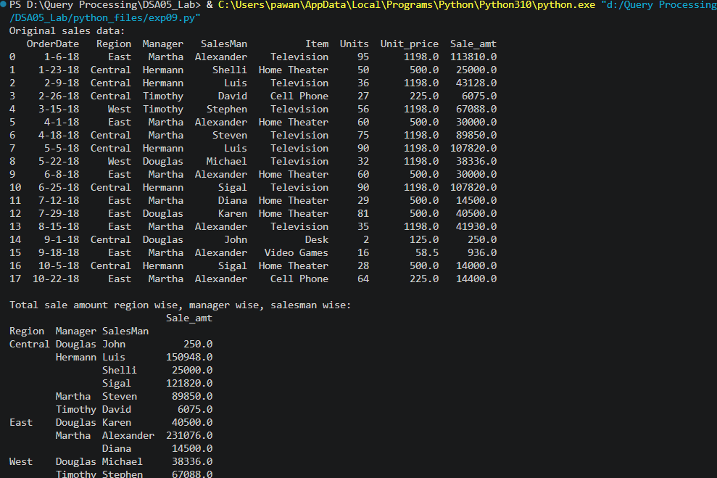

Result
The Python program to pivot table to find the total sale amount region wise, manager wise, sales man wise was executed successfully and the output was verified.

