Experiment 10: Highlight negative numbers red and positive numbers black in a random DataFrame

Aim
To create a DataFrame of ten rows and four columns with random values and write a Pandas program to highlight the negative numbers in red and the positive numbers in black.

Algorithm
- Start the program.
- Import pandas and numpy.
- Create a DataFrame of shape (10, 4) filled with random values (including negative numbers) using numpy.random.
- Define a function that returns the CSS colour 'red' for negative values and 'black' for positive values.
- Apply the function to the DataFrame using the Styler's applymap()/map() method.
- Display the styled DataFrame.
- Stop the program.

Program
import pandas as pd
import numpy as np

np.random.seed(24)

df = pd.DataFrame(np.random.randn(10, 4), columns=list('ABCD'))
df.iloc[3, 3] = np.nan

print("Original DataFrame:")
print(df)

def color_negative_red(val):
color = 'red' if val < 0 else 'black'
return 'color: %s' % color

styled_df = df.style.map(color_negative_red)

print("\nNegative numbers highlighted red, positive numbers highlighted black (styled object created).")
styled_df

Input
None (random values generated within the program using numpy.random with a fixed seed for reproducibility).

Output
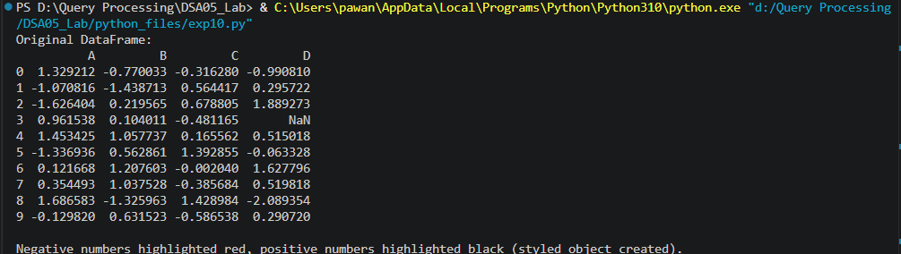

Result
The Python program to highlight negative numbers red and positive numbers black in a random DataFrame was executed successfully and the output was verified.

