Experiment 11: Highlight the NaN values in a random DataFrame

Aim
To create a DataFrame of ten rows and four columns with random values, convert some values to NaN, and write a Pandas program to highlight the NaN values.

Algorithm
- Start the program.
- Import pandas and numpy.
- Create a DataFrame of shape (10, 4) with random values.
- Randomly select a few cells and set their value to NaN.
- Use the Styler's highlight_null() method to highlight NaN cells (e.g. in yellow).
- Display the styled DataFrame.
- Stop the program.

Program
import pandas as pd
import numpy as np

np.random.seed(24)

df = pd.DataFrame(np.random.rand(10, 4), columns=list('ABCD'))

df.iloc[1, 2] = np.nan
df.iloc[4, 0] = np.nan
df.iloc[6, 3] = np.nan
df.iloc[8, 1] = np.nan

print("Original DataFrame with NaN values:")
print(df)

styled_df = df.style.highlight_null(color='yellow')

print("\nNaN values highlighted in yellow (styled object created).")
styled_df

Input
None (random values generated within the program using numpy.random; some values manually set to NaN).

Output

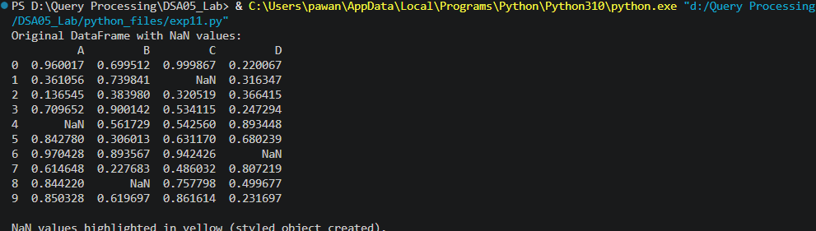

Result
The Python program to highlight the NaN values in a random DataFrame was executed successfully and the output was verified.

