Experiment 12: Set DataFrame background colour black and font colour yellow

Aim
To create a DataFrame of ten rows and four columns with random values and write a Pandas program to set the DataFrame background colour to black and the font colour to yellow.

Algorithm
- Start the program.
- Import pandas and numpy.
- Create a DataFrame of shape (10, 4) with random values.
- Use the Styler's set_properties() method to set the background-color to black and color to yellow.
- Display the styled DataFrame.
- Stop the program.

Program
import pandas as pd
import numpy as np

np.random.seed(24)

df = pd.DataFrame(np.random.rand(10, 4), columns=list('ABCD'))

print("Original DataFrame:")
print(df)

styled_df = df.style.set_properties(**{'background-color': 'black', 'color': 'yellow'})

print("\nDataFrame styled with black background and yellow font (styled object created).")
styled_df

Input
None (random values generated within the program using numpy.random with a fixed seed for reproducibility).

Output
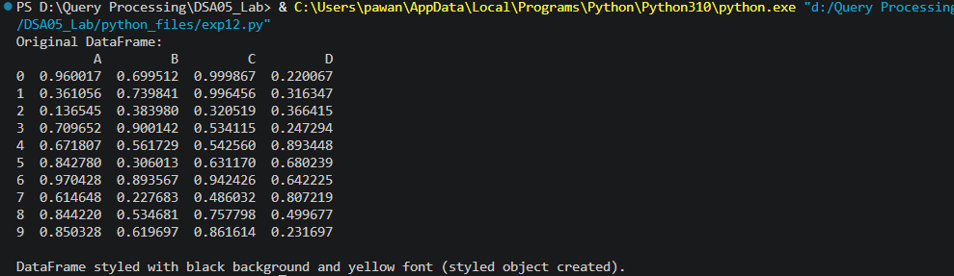

Result
The Python program to set DataFrame background colour black and font colour yellow was executed successfully and the output was verified.

