Experiment 14: Find and replace the missing values which do not have any valuable information

Aim
To write a Pandas program to find and replace the missing values in a given DataFrame that do not carry any valuable information.

Algorithm
- Start the program.
- Import pandas and numpy.
- Create the given DataFrame containing some missing (NaN) values.
- Use the fillna() function to replace the NaN values with a suitable placeholder (e.g. 0).
- Print the DataFrame before and after replacing the missing values.
- Stop the program.

Program
import pandas as pd
import numpy as np

df = pd.DataFrame({
'ord_no': [70001, np.nan, 70002, 70004, np.nan, 70005, np.nan, 70010, 70003, 70012, np.nan, 70013],
'purch_amt': [150.5, 270.65, 65.26, 110.5, 948.5, 2400.6, 5760, 1983.43, 2480.4, 250.45, 75.29, 3045.6],
'ord_date': ['2012-10-05', '2012-09-10', np.nan, '2012-08-17', '2012-09-10', '2012-07-27',
'2012-09-10', '2012-10-10', '2012-10-10', '2012-06-27', '2012-08-17', '2012-04-25'],
'customer_id': [3002, 3001, 3001, 3003, 3002, 3001, 3001, 3004, 3003, 3002, 3001, 3001],
'salesman_id': [5002, 5003, 5001, np.nan, 5002, 5001, 5001, np.nan, 5003, 5002, 5003, np.nan]
})

print("Original DataFrame:")
print(df)

df_filled = df.fillna(0)

print("\nDataFrame after replacing missing values with 0:")
print(df_filled)

Input
A DataFrame of order records (ord_no, purch_amt, ord_date, customer_id, salesman_id) containing some missing values, defined within the program.

Output
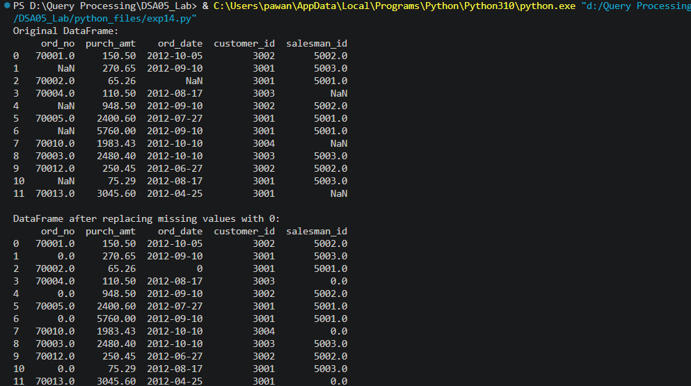

Result
The Python program to find and replace the missing values which do not have any valuable information was executed successfully and the output was verified.

