Experiment 15: Keep the rows with at least 2 NaN values in a given DataFrame

Aim
To write a Pandas program to keep only the rows that contain at least two NaN values in a given DataFrame.

Algorithm
- Start the program.
- Import pandas and numpy.
- Create the given DataFrame containing some missing (NaN) values.
- Count the number of NaN values in each row using isnull().sum(axis=1).
- Filter the DataFrame to keep only rows where this count is >= 2.
- Print the filtered DataFrame.
- Stop the program.

Program
import pandas as pd
import numpy as np

df = pd.DataFrame({
'ord_no': [70001, np.nan, 70002, 70004, np.nan, 70005, np.nan, 70010, 70003, 70012, np.nan, 70013],
'purch_amt': [150.5, 270.65, 65.26, 110.5, 948.5, 2400.6, 5760, 1983.43, 2480.4, 250.45, 75.29, 3045.6],
'ord_date': ['2012-10-05', '2012-09-10', np.nan, '2012-08-17', '2012-09-10', '2012-07-27',
'2012-09-10', '2012-10-10', '2012-10-10', '2012-06-27', '2012-08-17', '2012-04-25'],
'customer_id': [3002, 3001, 3001, 3003, 3002, 3001, 3001, 3004, 3003, 3002, 3001, 3001],
'salesman_id': [5002, 5003, 5001, np.nan, 5002, 5001, 5001, np.nan, 5003, 5002, 5003, np.nan]
})

print("Original DataFrame:")
print(df)

result = df[df.isnull().sum(axis=1) >= 2]

print("\nRows with at least 2 NaN values:")
print(result)

Input
A DataFrame of order records (ord_no, purch_amt, ord_date, customer_id, salesman_id) containing some missing values, defined within the program.

Output
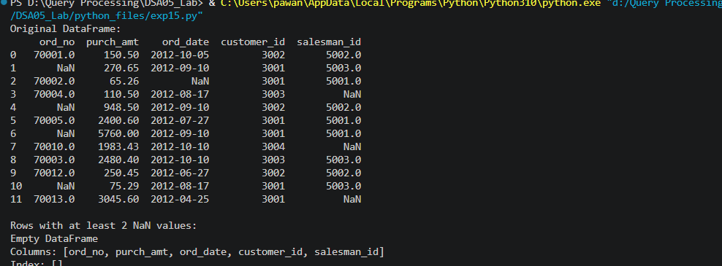

Result
The Python program to keep the rows with at least 2 NaN values in a given DataFrame was executed successfully and the output was verified.

