Experiment 16: Split the dataframe into groups based on school code, check type of GroupBy object

Aim
To write a Pandas program to split a given DataFrame into groups based on the school code and check the type of the resulting GroupBy object.

Algorithm
- Start the program.
- Import the pandas library.
- Create the given student DataFrame with a 'school' column among others.
- Use groupby() on the 'school' column to split the DataFrame into groups.
- Print the type of the object returned by groupby().
- Iterate through the groups and print each group.
- Stop the program.

Program
import pandas as pd

df = pd.DataFrame({
'school_code': ['s001', 's002', 's003', 's001', 's002', 's004'],
'class': ['V', 'V', 'VI', 'VI', 'V', 'VI'],
'name': ['Alberto Franco', 'Gino Mcneill', 'Ryan Parkes', 'Eesha Hinton', 'Gino Mcneill', 'David Parkes'],
'date_Of_Birth': ['15/05/2002', '17/05/2002', '16/02/1999', '25/09/1998', '11/05/2002', '15/09/1997'],
'age': [12, 12, 13, 13, 14, 12],
'height': [173, 192, 186, 167, 151, 159],
'weight': [35, 32, 33, 30, 31, 32],
'address': ['street1', 'street2', 'street3', 'street1', 'street2', 'street4']
})

print("Original DataFrame:")
print(df)

grouped = df.groupby('school_code')

print("\nType of the GroupBy object:")
print(type(grouped))

print("\nGroups based on school code:")
for name, group in grouped:
print("\nSchool code:", name)
print(group)

Input
A student DataFrame with columns school_code, class, name, date_Of_Birth, age, height, weight, address, defined within the program.

Output
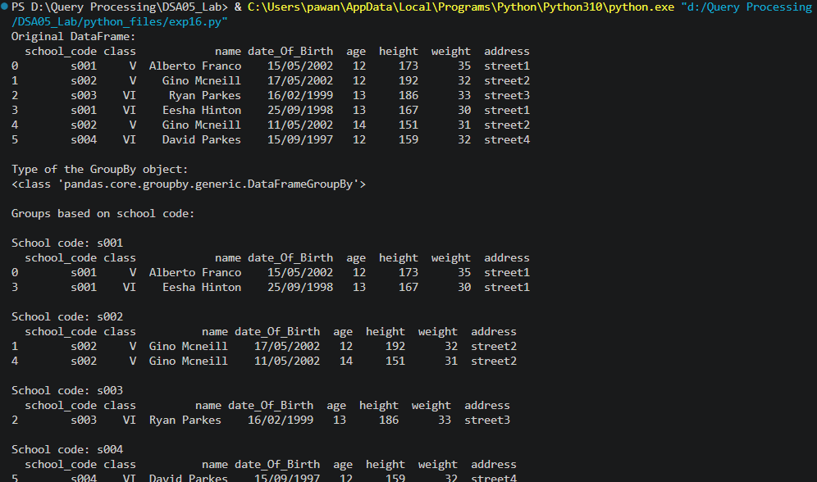

Result
The Python program to split the dataframe into groups based on school code, check type of GroupBy object was executed successfully and the output was verified.

