Experiment 17: Split dataframe by school code and get mean, min, max value of age for each school

Aim
To write a Pandas program to split a given DataFrame by school code and compute the mean, minimum and maximum value of age for each school.

Algorithm
- Start the program.
- Import the pandas library.
- Create the given student DataFrame.
- Group the DataFrame by 'school_code'.
- Apply the agg() function on the 'age' column with functions mean, min and max.
- Print the resulting summary DataFrame.
- Stop the program.

Program
import pandas as pd

df = pd.DataFrame({
'school_code': ['s001', 's002', 's003', 's001', 's002', 's004'],
'class': ['V', 'V', 'VI', 'VI', 'V', 'VI'],
'name': ['Alberto Franco', 'Gino Mcneill', 'Ryan Parkes', 'Eesha Hinton', 'Gino Mcneill', 'David Parkes'],
'date_Of_Birth': ['15/05/2002', '17/05/2002', '16/02/1999', '25/09/1998', '11/05/2002', '15/09/1997'],
'age': [12, 12, 13, 13, 14, 12],
'height': [173, 192, 186, 167, 151, 159],
'weight': [35, 32, 33, 30, 31, 32],
'address': ['street1', 'street2', 'street3', 'street1', 'street2', 'street4']
})

print("Original DataFrame:")
print(df)

result = df.groupby('school_code')['age'].agg(['mean', 'min', 'max'])

print("\nMean, min and max value of age for each school:")
print(result)

Input
A student DataFrame with columns school_code, class, name, date_Of_Birth, age, height, weight, address, defined within the program.

Output
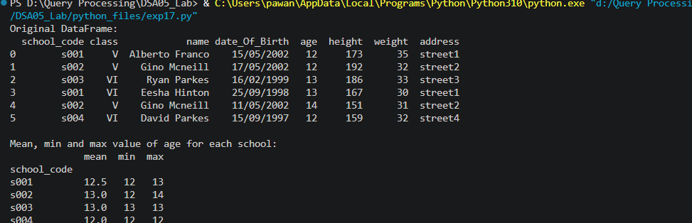

Result
The Python program to split dataframe by school code and get mean, min, max value of age for each school was executed successfully and the output was verified.

