Experiment 18: Split the given dataframe into groups based on school code and class

Aim
To write a Pandas program to split a given DataFrame into groups based on both the school code and the class.

Algorithm
- Start the program.
- Import the pandas library.
- Create the given student DataFrame.
- Use groupby() with a list of columns ['school_code', 'class'] to split the DataFrame into groups.
- Iterate through the groups and print each group.
- Stop the program.

Program
import pandas as pd

df = pd.DataFrame({
'school_code': ['s001', 's002', 's003', 's001', 's002', 's004'],
'class': ['V', 'V', 'VI', 'VI', 'V', 'VI'],
'name': ['Alberto Franco', 'Gino Mcneill', 'Ryan Parkes', 'Eesha Hinton', 'Gino Mcneill', 'David Parkes'],
'date_Of_Birth': ['15/05/2002', '17/05/2002', '16/02/1999', '25/09/1998', '11/05/2002', '15/09/1997'],
'age': [12, 12, 13, 13, 14, 12],
'height': [173, 192, 186, 167, 151, 159],
'weight': [35, 32, 33, 30, 31, 32],
'address': ['street1', 'street2', 'street3', 'street1', 'street2', 'street4']
})

print("Original DataFrame:")
print(df)

grouped = df.groupby(['school_code', 'class'])

print("\nGroups based on school code and class:")
for name, group in grouped:
print("\nGroup:", name)
print(group)

Input
A student DataFrame with columns school_code, class, name, date_Of_Birth, age, height, weight, address, defined within the program.

Output
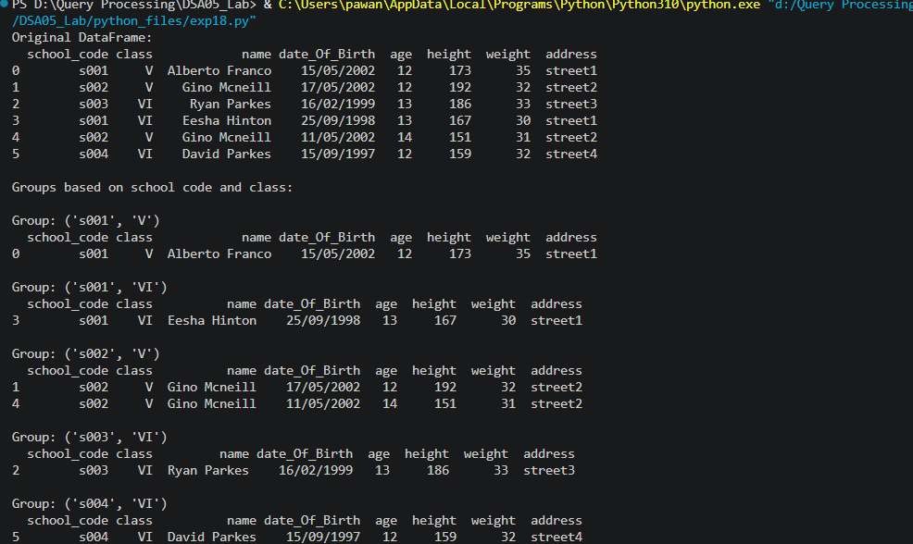

Result
The Python program to split the given dataframe into groups based on school code and class was executed successfully and the output was verified.

