Experiment 19: Display the dimensions/shape of the World alcohol consumption dataset and extract column names

Aim
To write a Pandas program to display the dimensions (shape) of the World alcohol consumption dataset and extract the column names from the dataset.

Algorithm
- Start the program.
- Import the pandas library.
- Read the World alcohol consumption dataset from 'world_alcohol.csv' into a DataFrame.
- Use the shape attribute to obtain the number of rows and columns.
- Use the columns attribute to extract the column names.
- Print the shape and the column names.
- Stop the program.

Program
import pandas as pd

df = pd.read_csv("world_alcohol.csv")

print("World alcohol consumption dataset (first 5 rows):")
print(df.head())

print("\nShape of the dataset (rows, columns):")
print(df.shape)

print("\nColumn names of the dataset:")
print(df.columns.tolist())

Input
world_alcohol.csv - World alcohol consumption dataset with columns Year, WHO region, Country, Beverage Types, Display Value.

Output
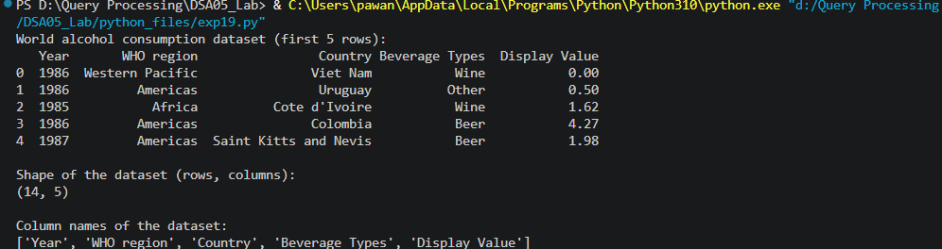

Result
The Python program to display the dimensions/shape of the World alcohol consumption dataset and extract column names was executed successfully and the output was verified.

