Experiment 20: Find the index of a given substring of a DataFrame column

Aim
To write a Pandas program to find the index position of a given substring within a specified DataFrame column.

Algorithm
- Start the program.
- Import the pandas library.
- Create a DataFrame with a text column.
- Use the str.find() method on the column to locate the position of the given substring in each entry.
- Print the resulting Series of index positions (-1 if not found).
- Stop the program.

Program
import pandas as pd

df = pd.DataFrame({
'name': ['Alberto Franco', 'Gino Mcneill', 'Ryan Parkes', 'Eesha Hinton', 'Gino Mcneill', 'David Parkes']
})

print("Original DataFrame:")
print(df)

substring = "ar"
df['index_of_substring'] = df['name'].str.find(substring)

print(f"\nIndex position of substring '{substring}' in each row of the name column:")
print(df)

Input
A DataFrame containing a text column (e.g. 'name'), and the target substring to search for, defined within the program.

Output
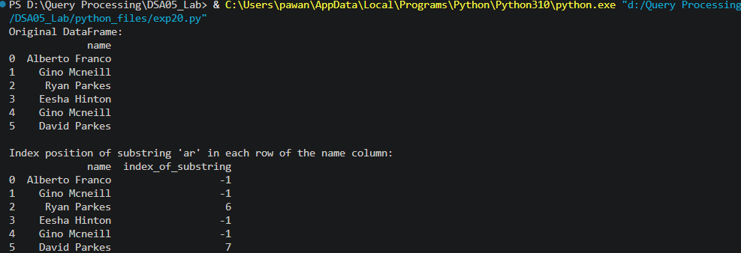

Result
The Python program to find the index of a given substring of a DataFrame column was executed successfully and the output was verified.

