Experiment 21: Swap the cases of a specified character column in a given DataFrame

Aim
To write a Pandas program to swap the case (upper/lower) of every character in a specified column of a given DataFrame.

Algorithm
- Start the program.
- Import the pandas library.
- Create a DataFrame with a text column.
- Use the str.swapcase() method on the specified column.
- Print the DataFrame with the case-swapped column.
- Stop the program.

Program
import pandas as pd

df = pd.DataFrame({
'name': ['Alberto Franco', 'Gino Mcneill', 'Ryan Parkes', 'Eesha Hinton', 'Gino Mcneill', 'David Parkes']
})

print("Original DataFrame:")
print(df)

df['name_swapcase'] = df['name'].str.swapcase()

print("\nDataFrame with swapped case column:")
print(df)

Input
A DataFrame containing a character/text column (e.g. 'name'), defined within the program.

Output
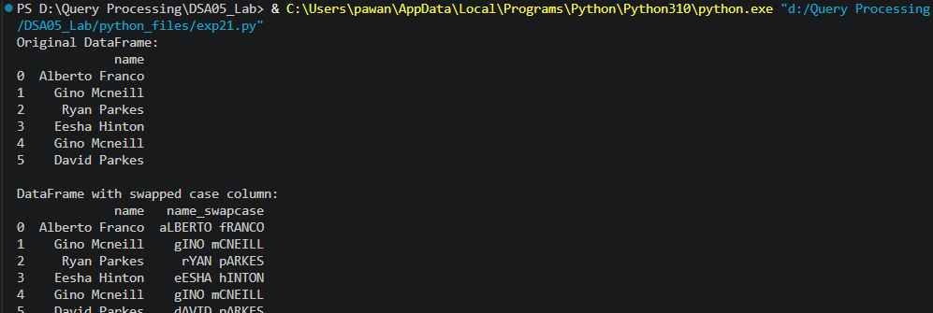

Result
The Python program to swap the cases of a specified character column in a given DataFrame was executed successfully and the output was verified.

