Experiment 22: Draw a line with suitable label in the x axis, y axis and a title

Aim
To write a Python program to draw a line graph with suitable labels for the x-axis, y-axis and a title.

Algorithm
- Start the program.
- Import the matplotlib.pyplot module.
- Define the lists of x and y values to be plotted.
- Use the plot() function to draw the line.
- Set the x-axis label, y-axis label and the title using xlabel(), ylabel() and title().
- Display the plot using show().
- Stop the program.

Program
import matplotlib.pyplot as plt

x = [1, 2, 3, 4, 5]
y = [2, 4, 6, 8, 10]

plt.plot(x, y, marker='o', color='blue')
plt.xlabel('X axis')
plt.ylabel('Y axis')
plt.title('Sample Line Graph')
plt.show()

Input
Two lists of numeric values for the x-axis and y-axis, defined within the program.

Output
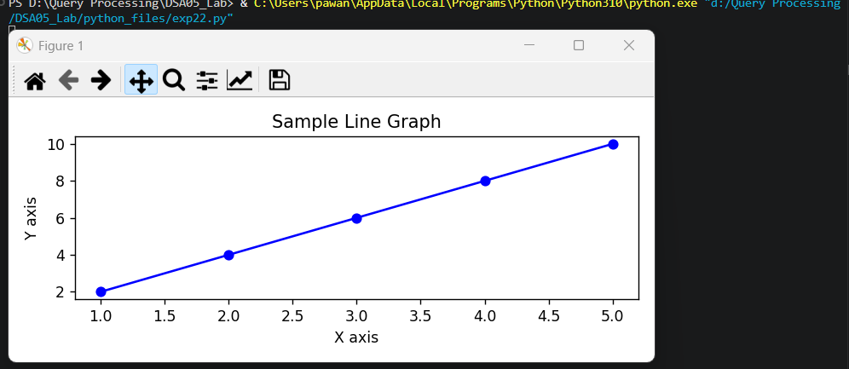

Result
The Python program to draw a line with suitable label in the x axis, y axis and a title was executed successfully and the output was verified.

