Experiment 23: Draw a line using given axis values taken from a text file, with suitable labels

Aim
To write a Python program to draw a line graph using x and y axis values read from a text file, with suitable labels for the axes and a title.

Algorithm
- Start the program.
- Import numpy and matplotlib.pyplot.
- Read the x and y values from 'test.txt' using numpy.loadtxt() with unpack=True.
- Plot the values using the plot() function.
- Set the x-axis label, y-axis label and title.
- Display the plot using show().
- Stop the program.

Program
import numpy as np
import matplotlib.pyplot as plt

x, y = np.loadtxt('test.txt', delimiter=' ', unpack=True)

plt.plot(x, y, marker='o', color='green')
plt.xlabel('X axis')
plt.ylabel('Y axis')
plt.title('Line graph from test.txt')
plt.show()

Input
test.txt containing pairs of x and y values, one pair per line (e.g. '1 2', '2 4', '3 1').

Output
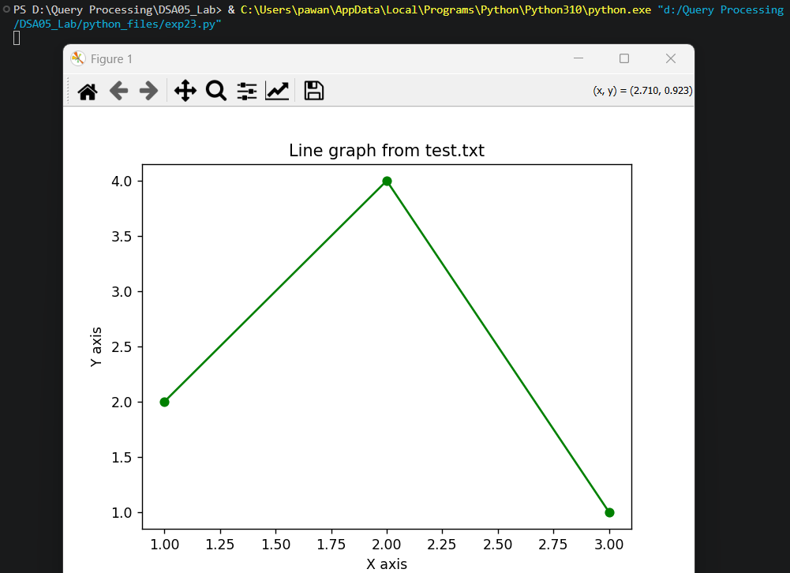

Result
The Python program to draw a line using given axis values taken from a text file, with suitable labels was executed successfully and the output was verified.

