Experiment 24: Draw line charts of the financial data of Alphabet Inc.

Aim
To write a Python program to draw line charts of the financial data (Open, High, Low, Close) of Alphabet Inc. between October 3, 2016 and October 7, 2016.

Algorithm
- Start the program.
- Import pandas and matplotlib.pyplot.
- Read the financial data from 'fdata.csv' with the Date column parsed as the index.
- Plot the DataFrame directly using the plot() function, which draws a line for each numeric column.
- Set the title and axis labels for the chart.
- Display the plot using show().
- Stop the program.

Program
import pandas as pd
import matplotlib.pyplot as plt

df = pd.read_csv('fdata.csv', index_col='Date', parse_dates=True)

print("Financial data of Alphabet Inc.:")
print(df)

df.plot(figsize=(8, 5), marker='o')
plt.xlabel('Date')
plt.ylabel('Price')
plt.title('Alphabet Inc. Financial Data (Oct 3 - Oct 7, 2016)')
plt.tight_layout()
plt.show()

Input
fdata.csv containing Date, Open, High, Low, Close columns for Alphabet Inc. between 03-10-2016 and 07-10-2016.

Output
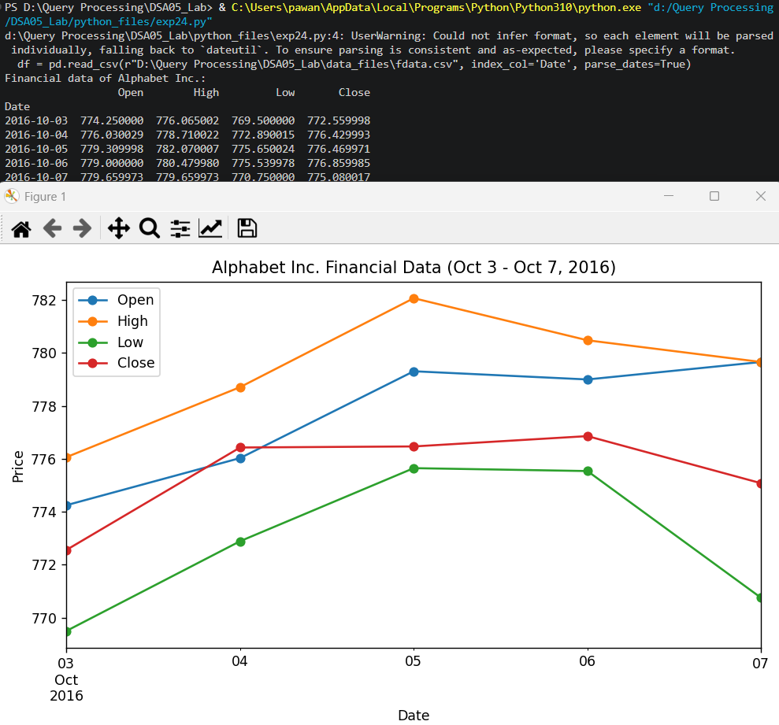

Result
The Python program to draw line charts of the financial data of Alphabet Inc. was executed successfully and the output was verified.

