Experiment 25: Plot two or more lines with legends, different widths and colors

Aim
To write a Python program to plot two or more lines on the same axes with legends, different line widths and different colors.

Algorithm
- Start the program.
- Import the matplotlib.pyplot module.
- Define the x values and the corresponding y values for each line.
- Plot each line using plot(), specifying a distinct color, line width and label for each.
- Add axis labels, a title and display the legend using legend().
- Display the plot using show().
- Stop the program.

Program
import matplotlib.pyplot as plt

x = [1, 2, 3, 4, 5]
y1 = [2, 4, 6, 8, 10]
y2 = [1, 3, 5, 7, 9]

plt.plot(x, y1, color='blue', linewidth=2, label='Line 1')
plt.plot(x, y2, color='red', linewidth=3, label='Line 2')
plt.xlabel('X axis')
plt.ylabel('Y axis')
plt.title('Two Lines with Legends')
plt.legend()
plt.show()

Input
Lists of x values and two corresponding sets of y values, defined within the program.

Output
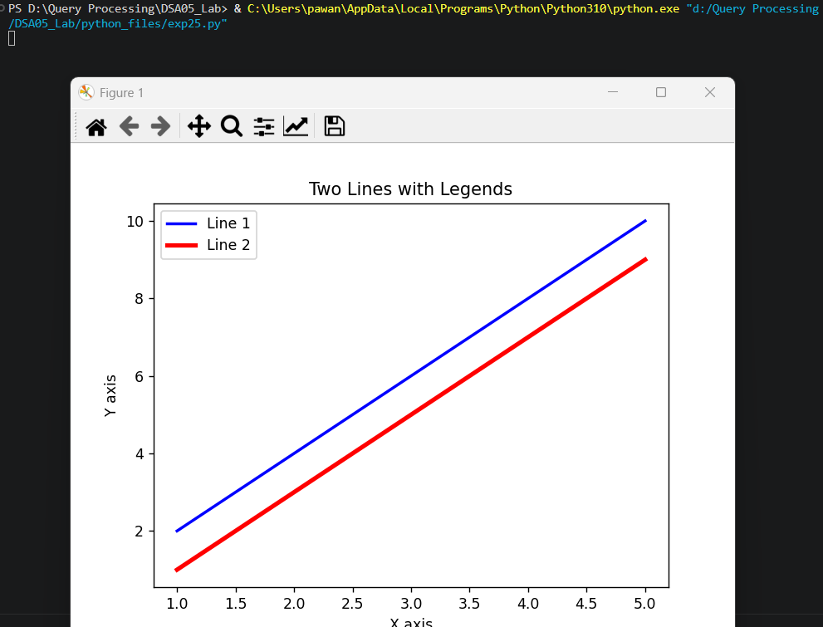

Result
The Python program to plot two or more lines with legends, different widths and colors was executed successfully and the output was verified.

