Experiment 27: Display a bar chart of the popularity of programming languages

Aim
To write a Python program to display a bar chart of the popularity of programming languages using the given sample data.

Algorithm
- Start the program.
- Import the matplotlib.pyplot module.
- Define the list of programming languages and their corresponding popularity values.
- Use the bar() function to draw the bar chart.
- Label the x-axis, y-axis and set a title.
- Display the plot using show().
- Stop the program.

Program
import matplotlib.pyplot as plt

languages = ['Java', 'Python', 'PHP', 'JavaScript', 'C#', 'C++']
popularity = [22.2, 17.6, 8.8, 8, 7.7, 6.7]

plt.bar(languages, popularity, color='skyblue')
plt.xlabel('Programming Language')
plt.ylabel('Popularity (%)')
plt.title('Popularity of Programming Languages')
plt.show()

Input
Lists 'Programming languages' (Java, Python, PHP, JavaScript, C#, C++) and 'Popularity' (22.2, 17.6, 8.8, 8, 7.7, 6.7) as given in the sample data.

Output
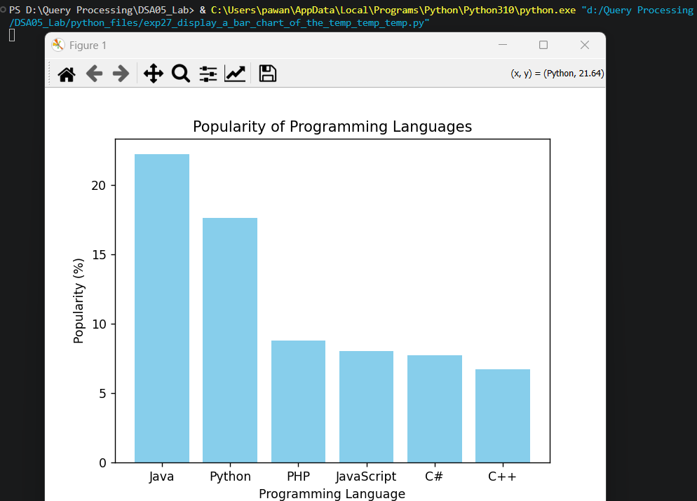

Result
The Python program to display a bar chart of the popularity of programming languages was executed successfully and the output was verified.

