Experiment 29: Display a bar chart of the popularity of programming languages using different color for each bar

Aim
To write a Python program to display a bar chart of the popularity of programming languages, using a different color for each individual bar.

Algorithm
- Start the program.
- Import the matplotlib.pyplot module.
- Define the list of programming languages and their corresponding popularity values.
- Define a list of colors, one for each bar.
- Use the bar() function, passing the color list to the color argument.
- Label the axes and set a title.
- Display the plot using show().
- Stop the program.

Program
import matplotlib.pyplot as plt

languages = ['Java', 'Python', 'PHP', 'JavaScript', 'C#', 'C++']
popularity = [22.2, 17.6, 8.8, 8, 7.7, 6.7]
colors = ['red', 'green', 'blue', 'orange', 'purple', 'brown']

plt.bar(languages, popularity, color=colors)
plt.xlabel('Programming Language')
plt.ylabel('Popularity (%)')
plt.title('Popularity of Programming Languages (Multi-color)')
plt.show()

Input
Lists 'Programming languages', 'Popularity' and a list of distinct colors for each bar, defined within the program.

Output
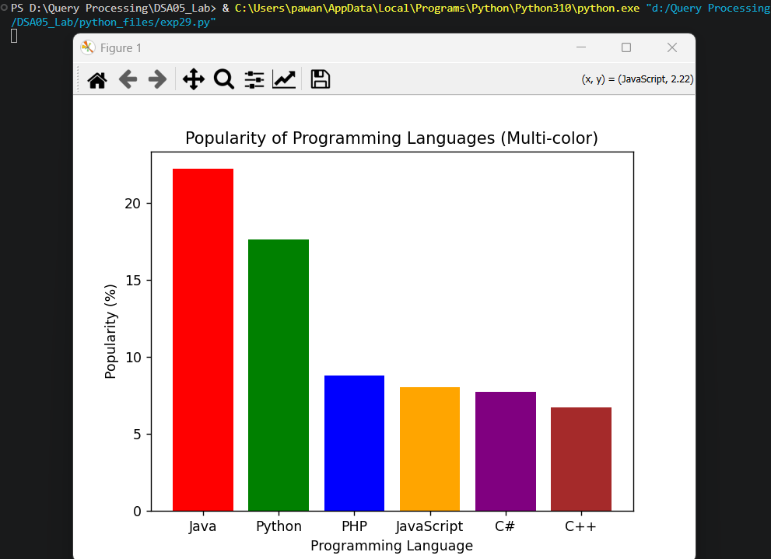

Result
The Python program to display a bar chart of the popularity of programming languages using different color for each bar was executed successfully and the output was verified.

