Experiment 30: Create bar plot of scores by group and gender

Aim
To write a Python program to create a bar plot of scores by group and gender, using multiple X values on the same chart for men and women.

Algorithm
- Start the program.
- Import numpy and matplotlib.pyplot.
- Define the mean scores for men and women for each group.
- Compute the x-axis positions and set a suitable bar width.
- Plot the men's bars and women's bars side by side using bar(), offsetting the x positions.
- Add axis labels, a title, x-tick labels for the groups and a legend.
- Display the plot using show().
- Stop the program.

Program
import numpy as np
import matplotlib.pyplot as plt

means_men = (22, 30, 35, 35, 26)
means_women = (25, 32, 30, 35, 29)

n_groups = len(means_men)
index = np.arange(n_groups)
bar_width = 0.35

plt.bar(index, means_men, bar_width, color='blue', label='Men')
plt.bar(index + bar_width, means_women, bar_width, color='pink', label='Women')

plt.xlabel('Group')
plt.ylabel('Scores')
plt.title('Scores by Group and Gender')
plt.xticks(index + bar_width / 2, ('G1', 'G2', 'G3', 'G4', 'G5'))
plt.legend()
plt.tight_layout()
plt.show()

Input
Tuples means_men = (22, 30, 35, 35, 26) and means_women = (25, 32, 30, 35, 29), as given in the sample data.

Output
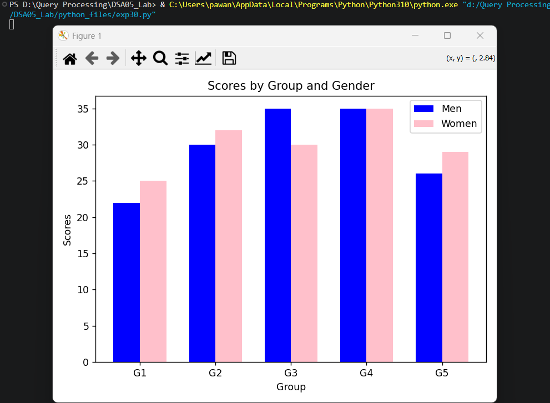

Result
The Python program to create bar plot of scores by group and gender was executed successfully and the output was verified.

