Experiment 32: Draw a scatter graph taking a random distribution in X and Y

Aim
To write a Python program to draw a scatter graph by taking a random distribution of values in X and Y and plotting them against each other.

Algorithm
- Start the program.
- Import numpy and matplotlib.pyplot.
- Generate random values for X and Y using numpy.random.
- Use the scatter() function to plot X against Y.
- Label the axes and set a title.
- Display the plot using show().
- Stop the program.

Program
import numpy as np
import matplotlib.pyplot as plt

np.random.seed(19680801)
x = np.random.randn(100)
y = np.random.randn(100)

plt.scatter(x, y, color='blue')
plt.xlabel('X - random distribution')
plt.ylabel('Y - random distribution')
plt.title('Scatter Graph of Random Distribution')
plt.show()

Input
None (random X and Y values generated within the program using numpy.random with a fixed seed).

Output
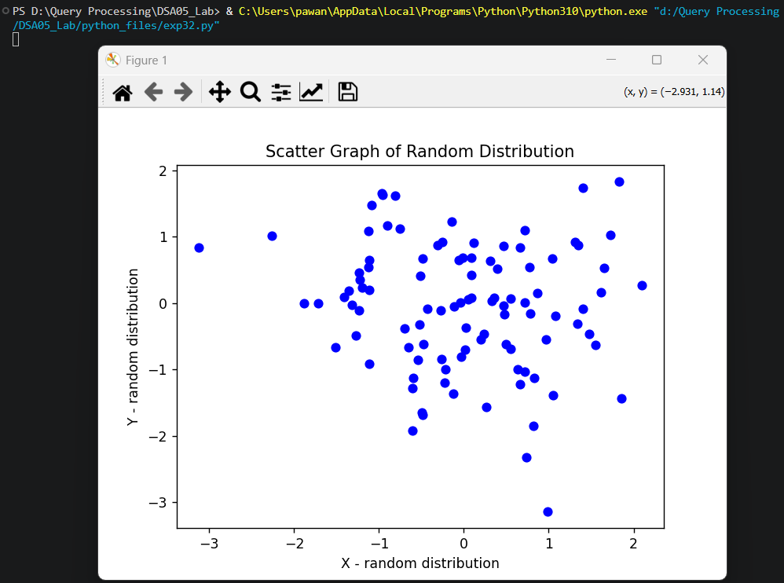

Result
The Python program to draw a scatter graph taking a random distribution in X and Y was executed successfully and the output was verified.

