Experiment 34: Draw a scatter plot using random distributions to generate balls of different sizes

Aim
To write a Python program to draw a scatter plot using random distributions to generate points (balls) of different sizes.

Algorithm
- Start the program.
- Import numpy and matplotlib.pyplot.
- Generate random values for X, Y and an array of random sizes for the markers.
- Use the scatter() function, passing the sizes array to the 's' parameter.
- Label the axes and set a title.
- Display the plot using show().
- Stop the program.

Program
import numpy as np
import matplotlib.pyplot as plt

np.random.seed(19680801)
x = np.random.rand(50)
y = np.random.rand(50)
colors = np.random.rand(50)
sizes = 1000 * np.random.rand(50)

plt.scatter(x, y, c=colors, s=sizes, alpha=0.5)
plt.xlabel('X - random distribution')
plt.ylabel('Y - random distribution')
plt.title('Scatter Plot with Balls of Different Sizes')
plt.show()

Input
None (random X, Y, colour and size values generated within the program using numpy.random with a fixed seed).

Output
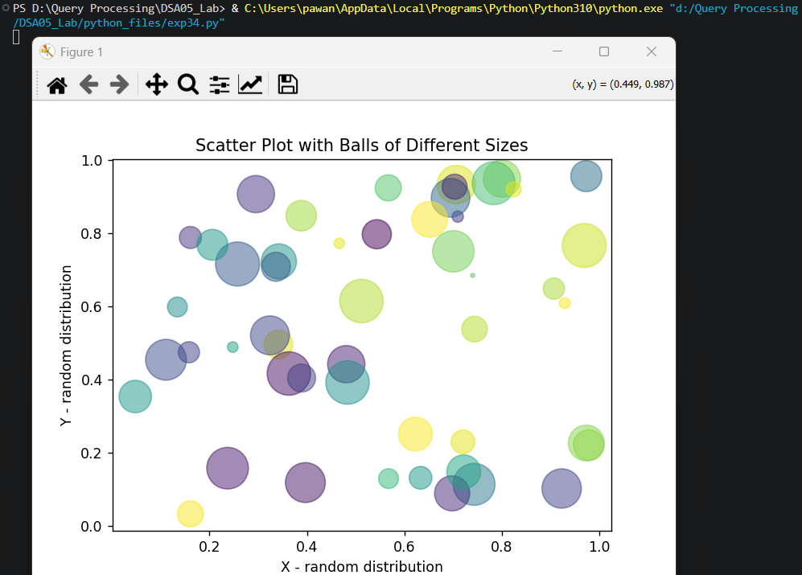

Result
The Python program to draw a scatter plot using random distributions to generate balls of different sizes was executed successfully and the output was verified.

