Experiment 35: Draw a scatter plot comparing two subject marks of Mathematics and Science

Aim
To write a Python program to draw a scatter plot comparing the Mathematics and Science marks of 10 students, using the given sample data.

Algorithm
- Start the program.
- Import the matplotlib.pyplot module.
- Define the lists math_marks, science_marks and marks_range as given in the sample data.
- Use the scatter() function to plot math_marks against science_marks.
- Label the axes and set a title.
- Set the axis tick marks using marks_range.
- Display the plot using show().
- Stop the program.

Program
import matplotlib.pyplot as plt

math_marks = [88, 92, 80, 89, 100, 80, 60, 100, 80, 34]
science_marks = [35, 79, 79, 48, 100, 88, 32, 45, 20, 30]
marks_range = [10, 20, 30, 40, 50, 60, 70, 80, 90, 100]

plt.scatter(math_marks, science_marks, color='purple')
plt.xlabel('Mathematics Marks')
plt.ylabel('Science Marks')
plt.title('Comparison of Mathematics and Science Marks')
plt.xticks(marks_range)
plt.yticks(marks_range)
plt.show()

Input
Lists math_marks, science_marks and marks_range for 10 students, as given in the sample data.

Output
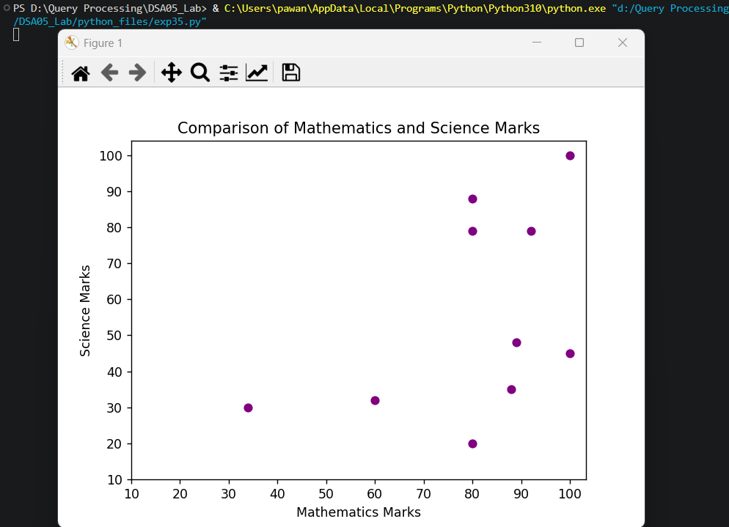

Result
The Python program to draw a scatter plot comparing two subject marks of Mathematics and Science was executed successfully and the output was verified.

