Experiment 36: Draw a scatter plot for three different groups comparing weights and heights

Aim
To write a Python program to draw a scatter plot for three different groups, comparing the weights and heights of individuals in each group.

Algorithm
- Start the program.
- Import numpy and matplotlib.pyplot.
- Define or randomly generate weight and height data for three groups.
- Use the scatter() function three times (once per group), assigning a distinct color and label to each.
- Label the axes, set a title and display the legend.
- Display the plot using show().
- Stop the program.

Program
import numpy as np
import matplotlib.pyplot as plt

np.random.seed(42)

weight1, height1 = 60 + 5 * np.random.randn(20), 160 + 8 * np.random.randn(20)
weight2, height2 = 75 + 6 * np.random.randn(20), 170 + 7 * np.random.randn(20)
weight3, height3 = 90 + 7 * np.random.randn(20), 180 + 6 * np.random.randn(20)

plt.scatter(weight1, height1, color='red', label='Group 1')
plt.scatter(weight2, height2, color='green', label='Group 2')
plt.scatter(weight3, height3, color='blue', label='Group 3')

plt.xlabel('Weight')
plt.ylabel('Height')
plt.title('Scatter Plot of Weights and Heights for Three Groups')
plt.legend()
plt.show()

Input
Weight and height values for three groups of individuals, randomly generated within the program using numpy.random with a fixed seed.

Output
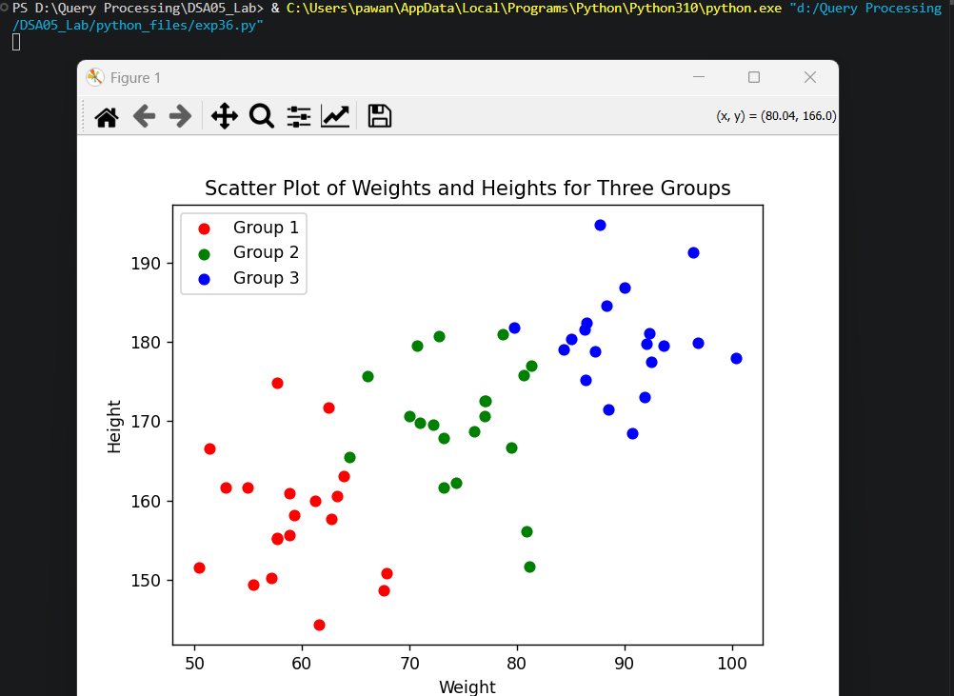

Result
The Python program to draw a scatter plot for three different groups comparing weights and heights was executed successfully and the output was verified.

