Experiment 37: Create a dataframe from a dictionary and display it

Aim
To write a Pandas program to create a DataFrame from a given dictionary and display it.

Algorithm
- Start the program.
- Import the pandas library.
- Define the dictionary of data as given in the sample data.
- Use pd.DataFrame() to convert the dictionary into a DataFrame.
- Print/display the DataFrame.
- Stop the program.

Program
import pandas as pd

data = {'X': [78, 85, 96, 80, 86], 'Y': [84, 94, 89, 83, 86], 'Z': [86, 97, 96, 72, 83]}

df = pd.DataFrame(data)

print("DataFrame created from dictionary:")
print(df)

Input
Dictionary {'X':[78,85,96,80,86], 'Y':[84,94,89,83,86], 'Z':[86,97,96,72,83]} as given in the sample data.

Output
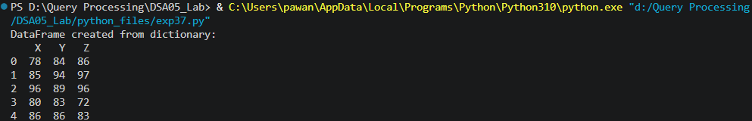

Result
The Python program to create a dataframe from a dictionary and display it was executed successfully and the output was verified.

