Experiment 38: Create and display a DataFrame from a specified dictionary data which has the index labels

Aim
To write a Pandas program to create and display a DataFrame from a specified dictionary of data, using the given list as custom index labels.

Algorithm
- Start the program.
- Import pandas and numpy.
- Define the exam_data dictionary and the labels list as given in the sample data.
- Use pd.DataFrame(exam_data, index=labels) to create the DataFrame with the custom index.
- Print/display the DataFrame.
- Stop the program.

Program
import pandas as pd
import numpy as np

exam_data = {
'name': ['Anastasia', 'Dima', 'Katherine', 'James', 'Emily', 'Michael', 'Matthew', 'Laura', 'Kevin', 'Jonas'],
'score': [12.5, 9, 16.5, np.nan, 9, 20, 14.5, np.nan, 8, 19],
'attempts': [1, 3, 2, 3, 2, 3, 1, 1, 2, 1],
'qualify': ['yes', 'no', 'yes', 'no', 'no', 'yes', 'yes', 'no', 'no', 'yes']
}
labels = ['a', 'b', 'c', 'd', 'e', 'f', 'g', 'h', 'i', 'j']

df = pd.DataFrame(exam_data, index=labels)

print("DataFrame with custom index labels:")
print(df)

Input
Dictionary exam_data (name, score, attempts, qualify) and list labels = ['a'..'j'], as given in the sample data.

Output
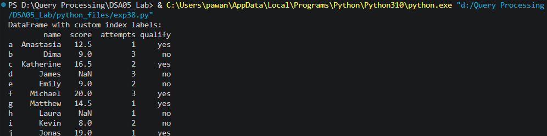

Result
The Python program to create and display a DataFrame from a specified dictionary data which has the index labels was executed successfully and the output was verified.

