Experiment 40: Select the 'name' and 'score' columns from the given DataFrame

Aim
To write a Pandas program to select only the 'name' and 'score' columns from a given DataFrame.

Algorithm
- Start the program.
- Import pandas and numpy.
- Create the exam_data DataFrame with the given labels as index.
- Select the required columns using double square brackets, df[['name', 'score']].
- Print the resulting DataFrame.
- Stop the program.

Program
import pandas as pd
import numpy as np

exam_data = {
'name': ['Anastasia', 'Dima', 'Katherine', 'James', 'Emily', 'Michael', 'Matthew', 'Laura', 'Kevin', 'Jonas'],
'score': [12.5, 9, 16.5, np.nan, 9, 20, 14.5, np.nan, 8, 19],
'attempts': [1, 3, 2, 3, 2, 3, 1, 1, 2, 1],
'qualify': ['yes', 'no', 'yes', 'no', 'no', 'yes', 'yes', 'no', 'no', 'yes']
}
labels = ['a', 'b', 'c', 'd', 'e', 'f', 'g', 'h', 'i', 'j']

df = pd.DataFrame(exam_data, index=labels)

print("Original DataFrame:")
print(df)

result = df[['name', 'score']]

print("\n'name' and 'score' columns:")
print(result)

Input
Dictionary exam_data (name, score, attempts, qualify) and list labels = ['a'..'j'], as given in the sample data.

Output
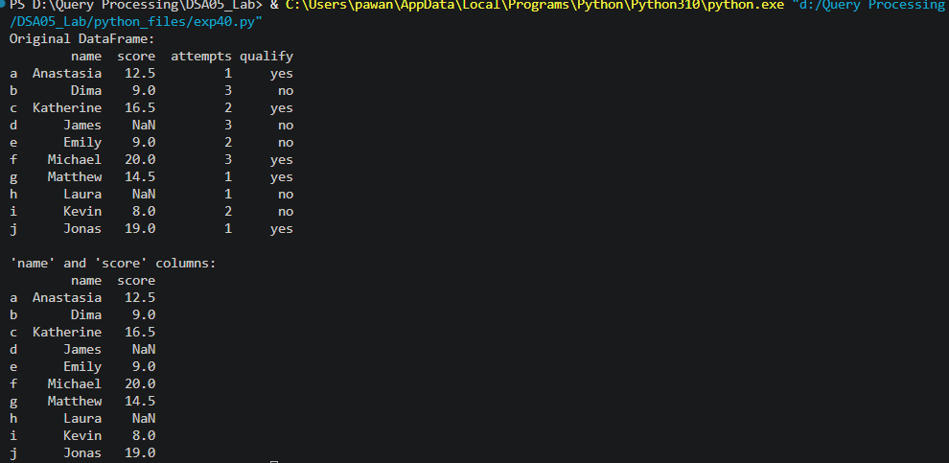

Result
The Python program to select the 'name' and 'score' columns from the given DataFrame was executed successfully and the output was verified.

