**CS551 Advanced Software Engineering**

**Challenge -2**

**Report**

**Submitted by**: PG - 3

**Team Members:** Suresh Yarra(Class id:48), Prudhvi Raj Atluri(Class id: 3), Anil Kanth Nelluri (Class ID: 28), Shravan Kumar (Class ID: 8)

1. **Design:**

**(a)** **Architecture Diagram**

Architecture Diagram shown below specific tradeoffs in the structure of our architecture used in our project.

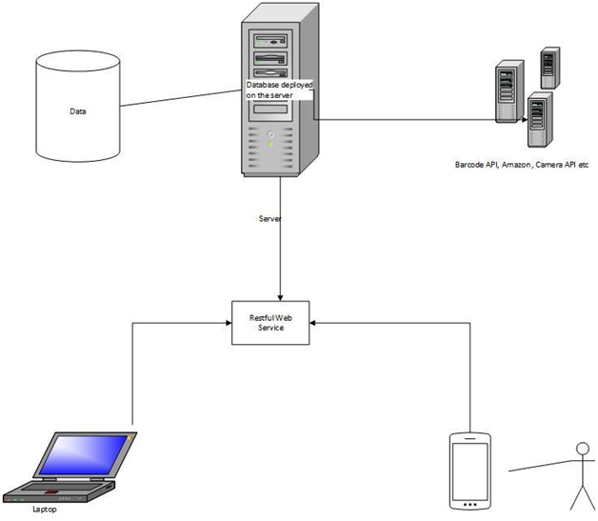

This is our structure of architecture diagram.

**(b)** **Class Diagram:**

The representation provided below is our class diagram.

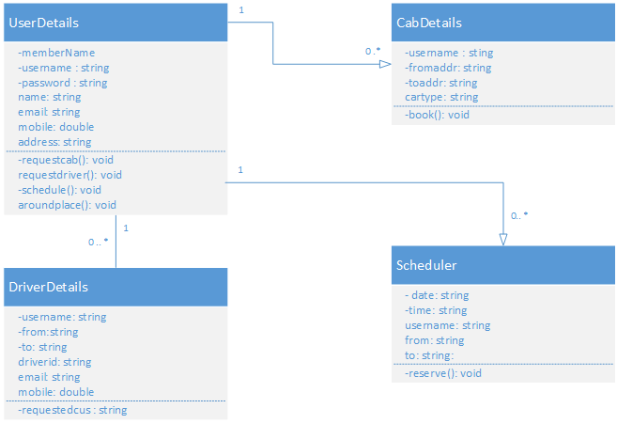

**2.** **WebServices:**

**a.** **Web services:**

1. **Own Services:**

We developed few services on our own,. We developed our own services in WCF C# for user registration, login and necessary validations and for cab booking and driver requesting and scheduled rides of a customer. We also developed a service for Future rides and schedule pickups, where user will book a ride from his or her current location, once transaction is completed data will be pushed to data base of that particular booking using web services.

my service URL are

* <http://kc-sce-cs551.kc.umkc.edu/aspnet_client/Group3/C2/ASEService/ASEService/Service1.svc/get/>
* <http://kc-sce-cs551.kc.umkc.edu/aspnet_client/Group3/C2/ASEC2Insert/ASEC2Insert/Service1.svc/insertuser/>
* http://kc-sce-cs551.kc.umkc.edu/aspnet_client/Group3/C2/ASEService/ASEService/Service1.svc/insertcab/

1. **Existing API’s:**

To fulfill our application requirements we used some of the existing API’s, those are

* Places API: we used google Places API to show, the nearest places (like ATM’s, bank, hospital, police, bars etc) around your radius limit of 500, 1000, 1500 and 5000.
* Maps API: used google Maps to locates the places, show to user, getting directions while requesting a cab. auto complete address while entering the address.
* Speech Recognition API: we used speech recognition api to give the username and and fields in the application. and we provided a box which converts all your speech into text then user can copy and text to someone.
* QR Code API: we generated QR code for our mobile application, Where mobile application is deployed in a server, it generates a QR code, If users scans the QR code it will redirect to the application .

**b.** **Databases:**

1. Own data Model:

We created a MS SQL database for user registration login and validation, cab requests , driver requests and also to store the scheduler requests. which will be used when user want to schedule a ride from his or her location. As soon as user makes a transaction and submit his request, data of that particular entry will be recorded in database. if a user needs a cab service his/her entered data will entered into a databaase.

**c.** **Mobile User Interface:**

We designed our application front end using html, jquery and CSS and we are using phone gap to build our application to make it available for android and ios devices. The application that we developed can also be used as a web application in local browser.

**3.** **ScreenShots of Features:**

**this is our site home page**

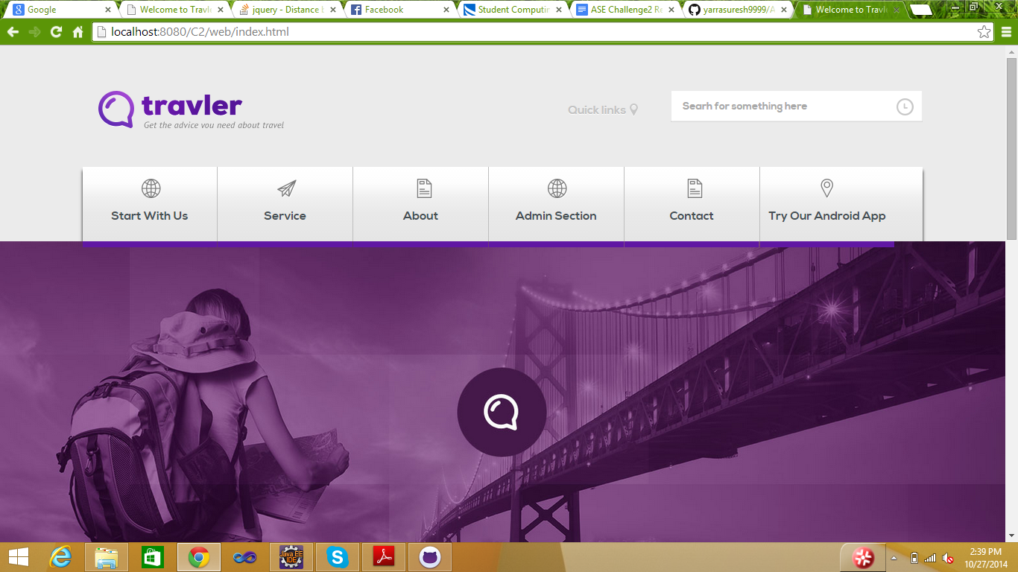

**Service page:**

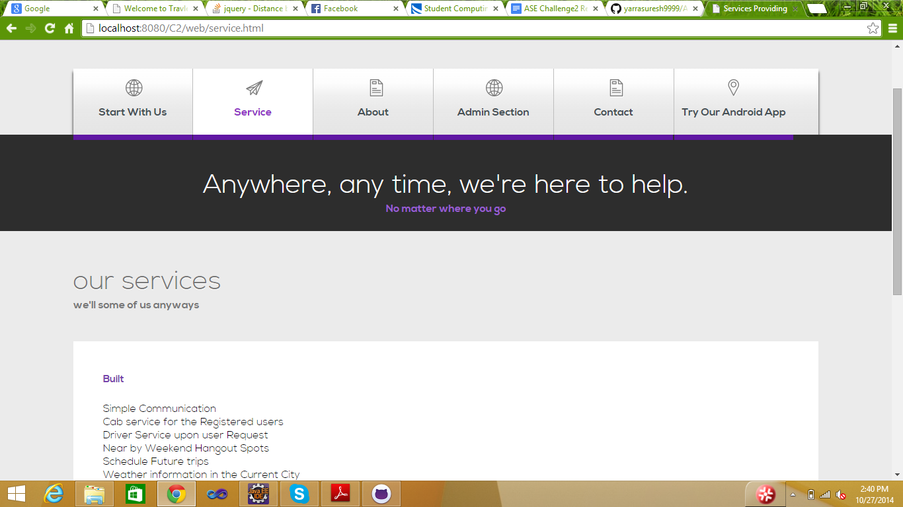

Administrator home page:

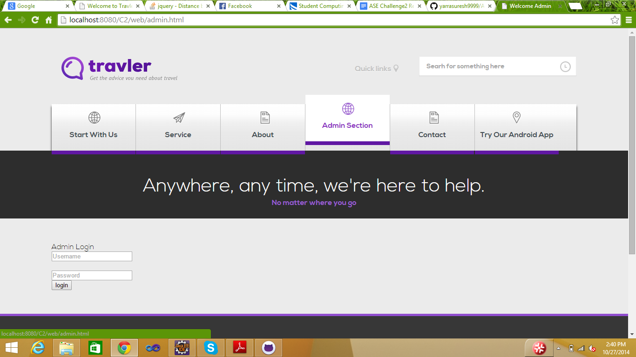

contact us page:

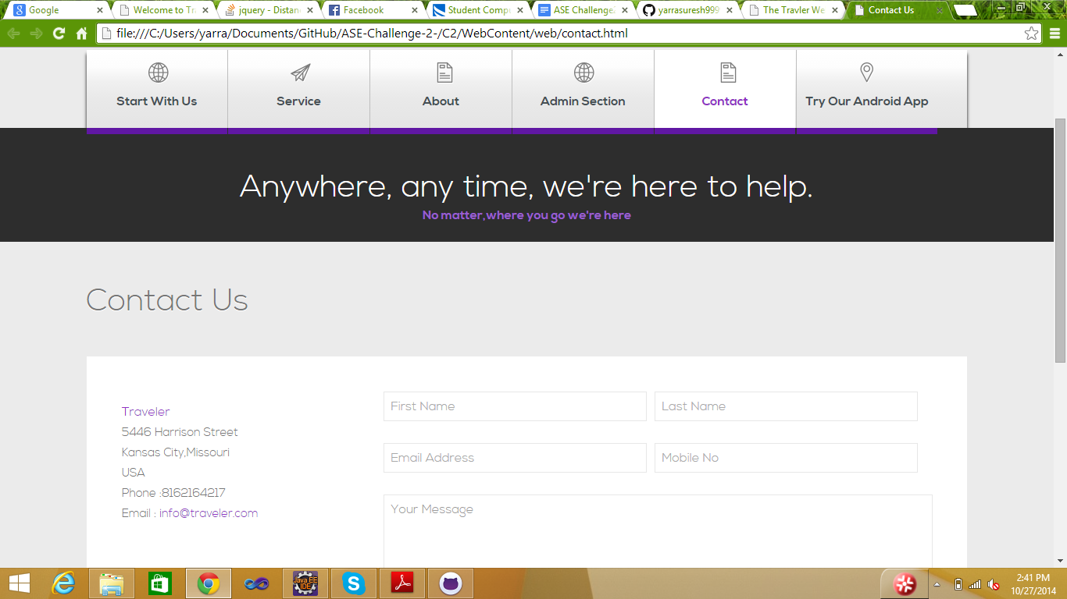

try our andorid app:

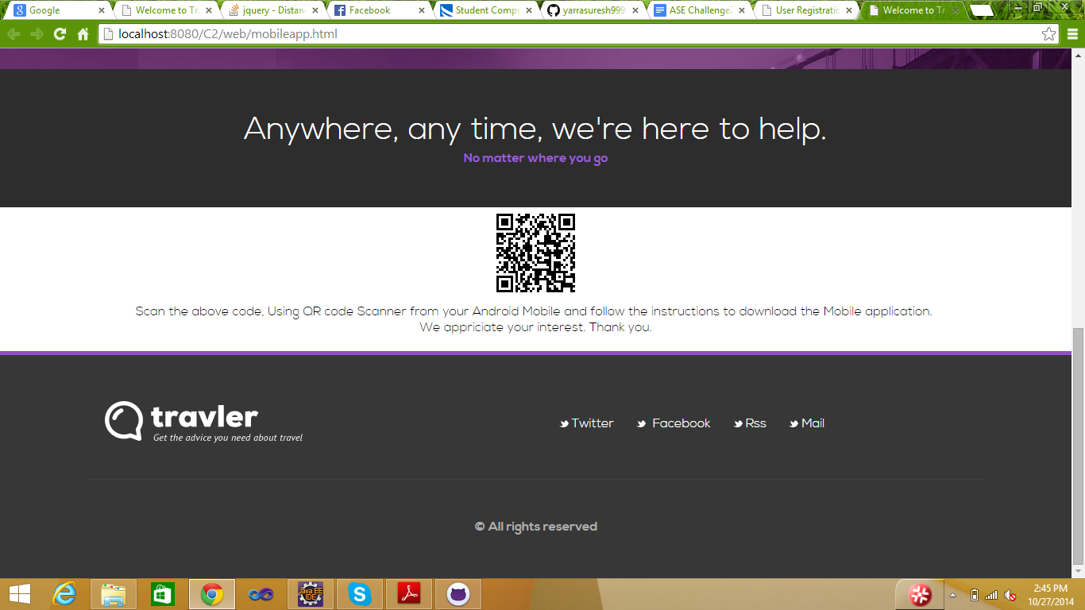

this is user login page, user can speaks, what ever he speaks will be displayed as username and proceds.

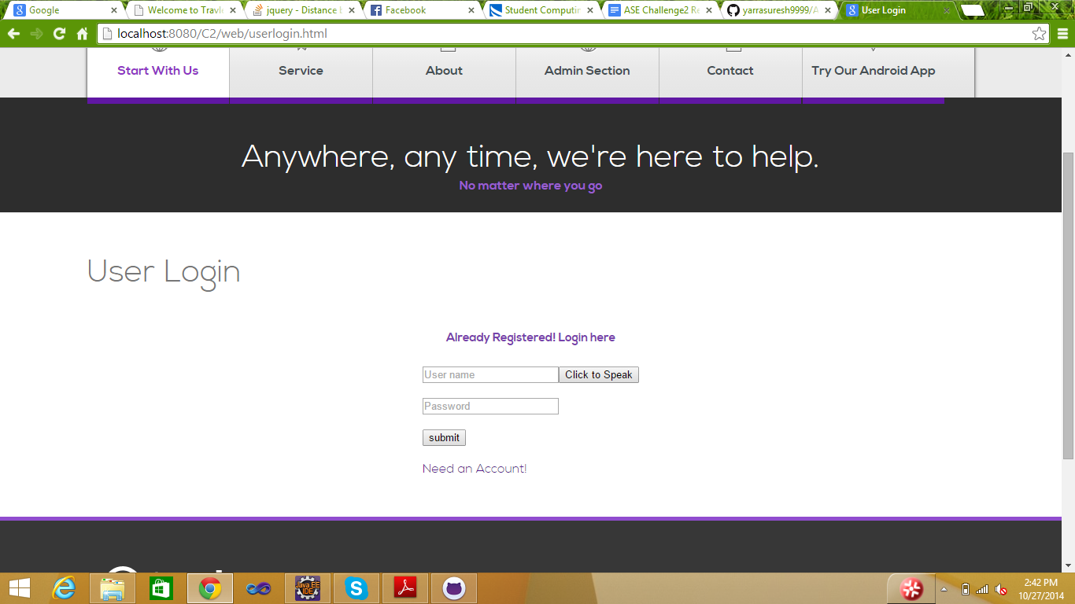

registration page:

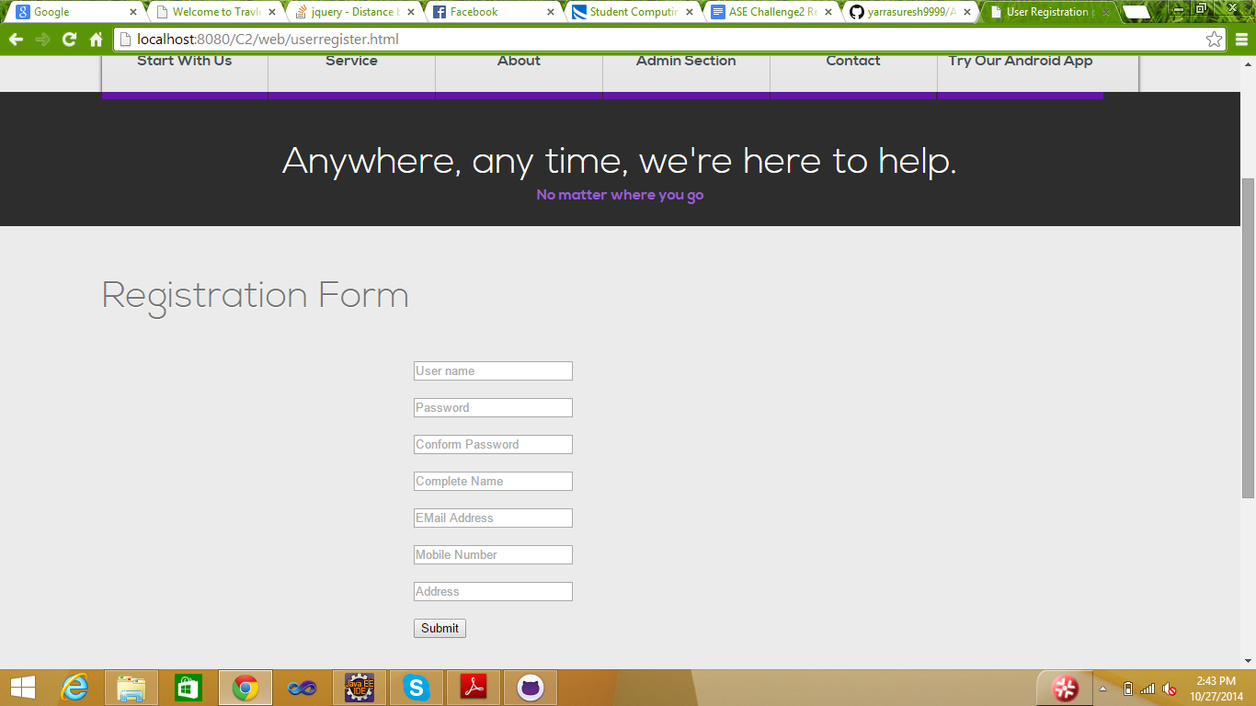

user home page

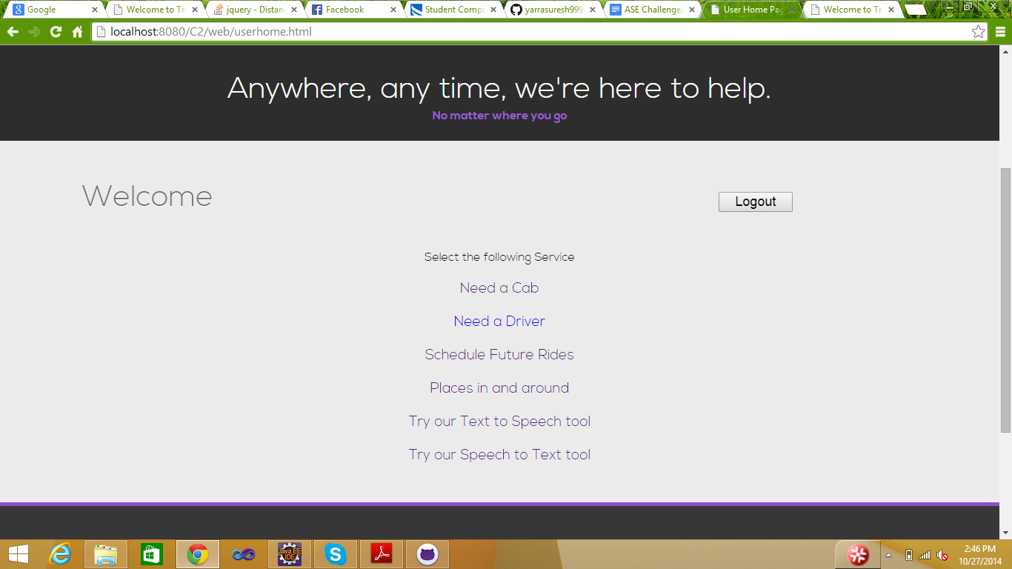

places in and around your current location: this page shows the atms in the radius around 1500.

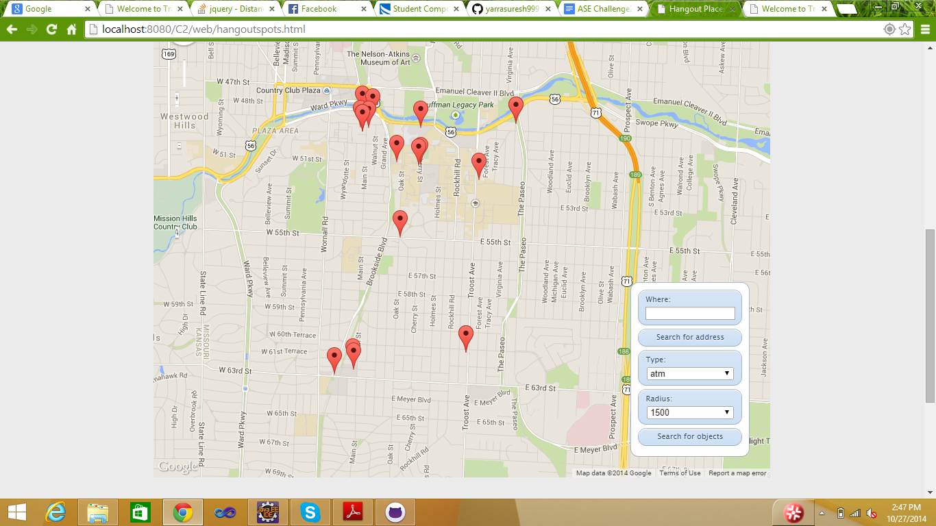

cab request page:

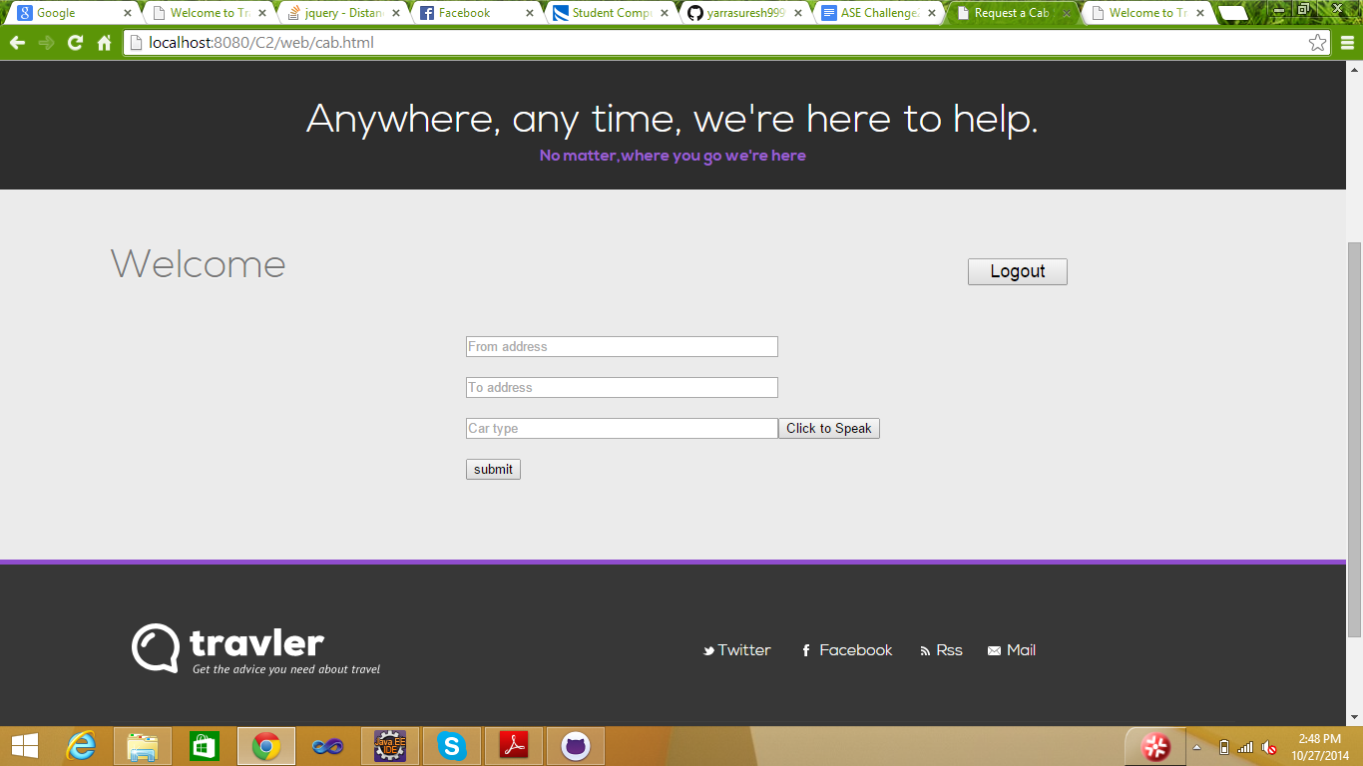

Schedule a Ride:

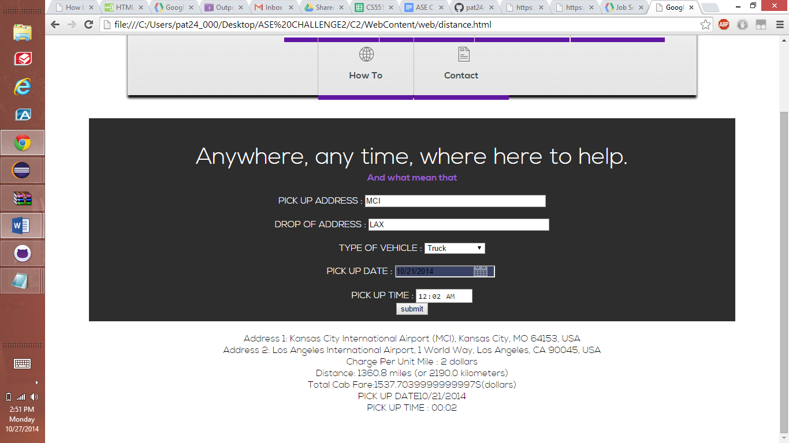

this page converts whatever you entered will converts to speech

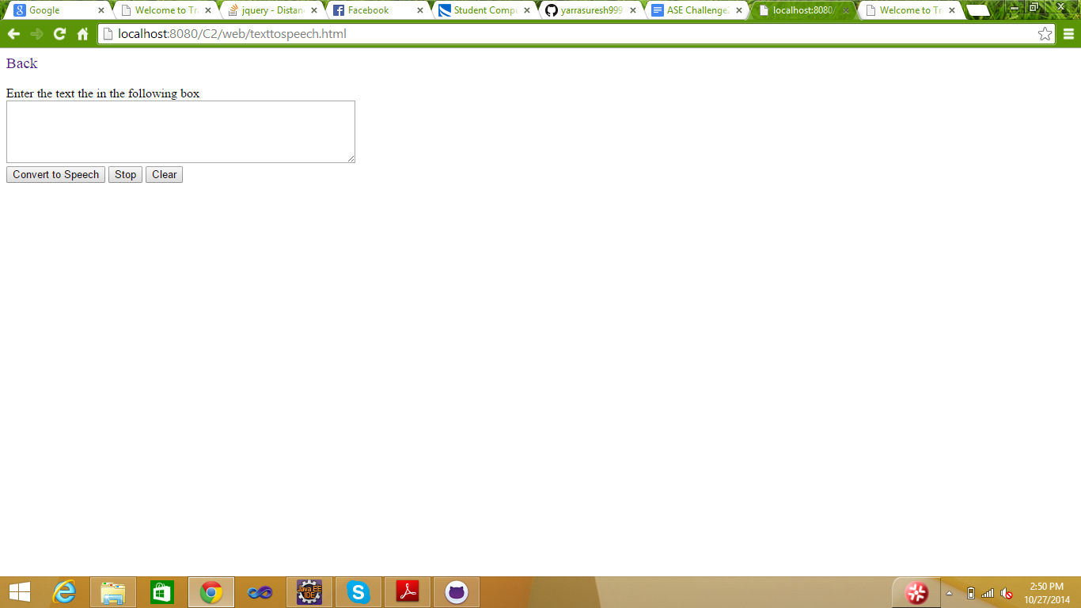

this page , recognizes the speech and converts into text, user can copy and send as a text

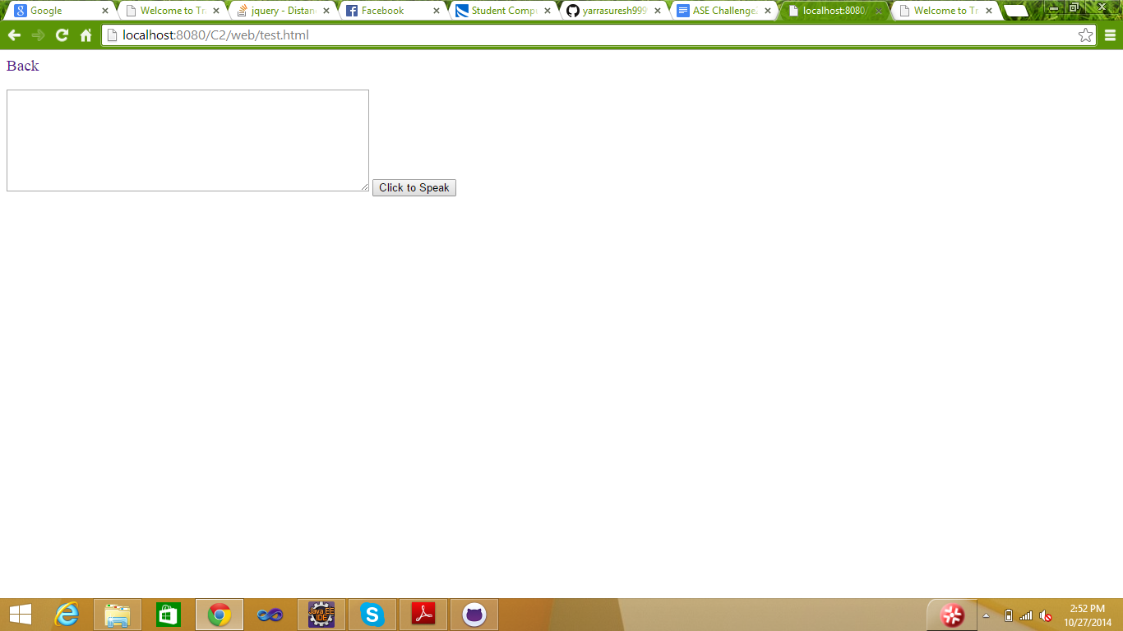

admin service are

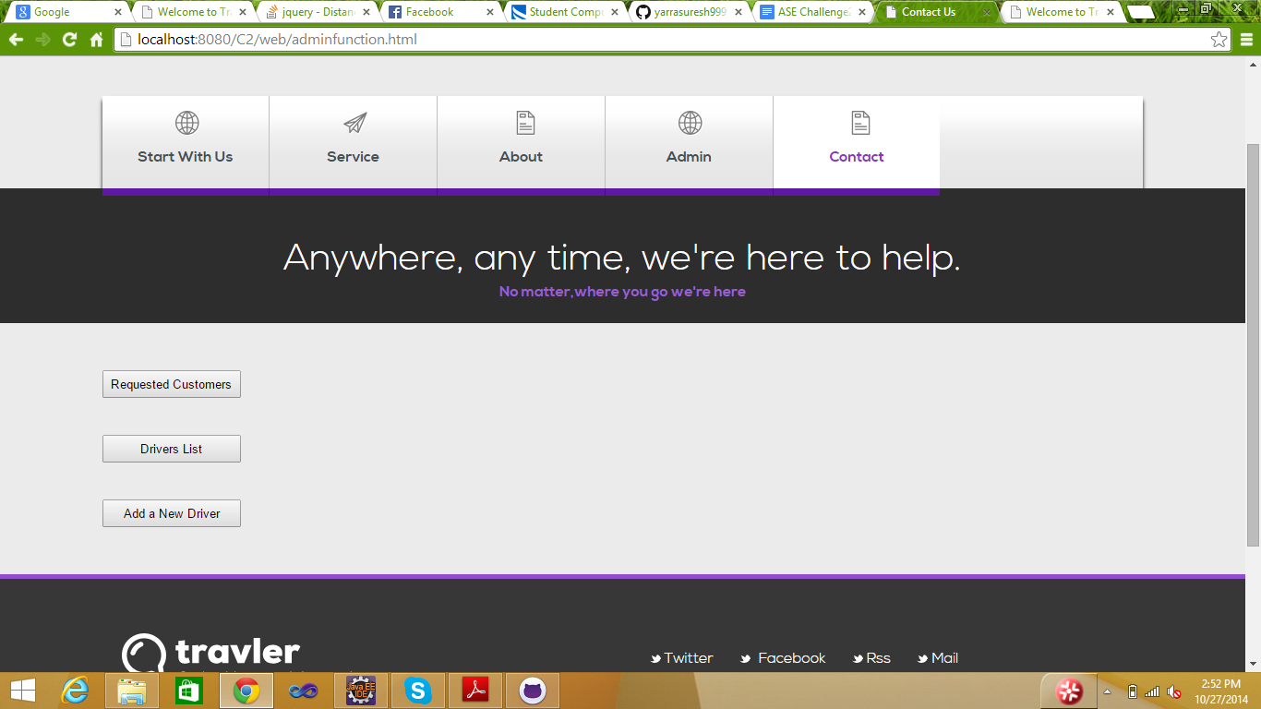

**4.** **Web Service URL:**

We developed an C# web service with database, which was deployed on the serever “KC-SCE-CS551.kc.umkc.edu” , the service URL is

* <http://kc-sce-cs551.kc.umkc.edu/aspnet_client/Group3/C2/ASEService/ASEService/Service1.svc/get/>
* <http://kc-sce-cs551.kc.umkc.edu/aspnet_client/Group3/C2/ASEC2Insert/ASEC2Insert/Service1.svc/insertuser/>
* <http://kc-sce-cs551.kc.umkc.edu/aspnet_client/Group3/C2/ASEService/ASEService/Service1.svc/insertcab/>

**5.** **Github Url:**

Our project Github link is :

<https://github.com/yarrasuresh9999/ASE-Challenge-2->

**6.** **Limitations:**

Scheduling ride was one our feature and interface for monitoring the request for scheduled rides are not implemented as of now because of the time constraint, once monitoring is available we can also keep track of the requests and turn of the flag once request is fulfilled.

**7.** **References:**

* <https://dvcs.w3.org/hg/speech-api/raw-file/tip/speechapi.html>
* C# Restful web service <http://msdn.microsoft.com/en-us/library/dd203052.aspx>
* <https://developers.google.com/places/documentation/> Google places API
* Google calendar API <https://developers.google.com/google-apps/calendar/>
* Google Scheduling API https://developers.google.com/coordinate/schedule.