Project Report I

By

Naveen Jetty

Narendra Ambati

Sarath Chandra Bandaru

Suresh Yarra

**Framework Specification**

1. **System Architecture Diagram**



1. **Domain Model**
   1. **Data Sources**

**Yahoo Finance**

Yahoo Finance is website which provides financial stock quotes related to US market. It consists of data like Previous close, Open price, Bid, Ask, 1 year Target Estimate, Day’s Range, 52wk Range, Volume, Average Volume, Market Cap etc.

* 1. **Glue Logic**

We are trying implement Speech-to-text, Text-to-speech and Tradeoff Analytics Services.

1. **Application Specification**
2. **System Specification** 
   1. IBM Bluemix Platforms
   2. Watson Services: Speech to Text, Text to Speech and Tradeoff Analytics
   3. Mobile Platform: Andriod
3. **Watson Services Used:** 
   1. **Speech-to-Text:**

The feature of this Bluemix Service is take audio input from the user and produce text as output. The process is when service is about to start listening to audio it opens a socket connection Bluemix application. The application gets "GET" request and starts multi part POST requests to 'speech to text' service. The service provides convertion.

**URL:** http://speech-to-text-kdmsg8.mybluemix.net/

* 1. **Text-to-Speech:**

This service does the process in two steps

1. It saves the text to .wav or .ogg format.

2. Next it plays the audio file by VLC media player or Audacity audio player.

**URL:** http://text-to-speech-java-suresh.mybluemix.net/

* 1. **Tradeoff Analytics:**

This selection is done in four steps:

-You should specify the options and objective from the options.

-Track each option towards the objective.

-In Order to skip some options use filters.

-Upon evaluating processed options select a desire option.

**URL:** http://tradeoff-analytics-java-projectkdm.mybluemix.net/

1. **Activity Diagram:**

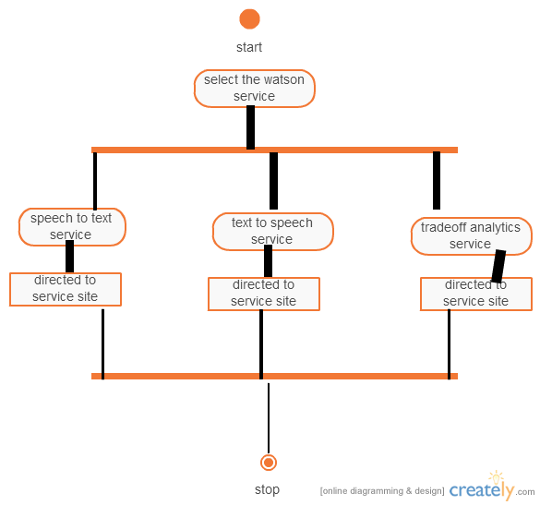

1. **Implementation**

**Main Page**

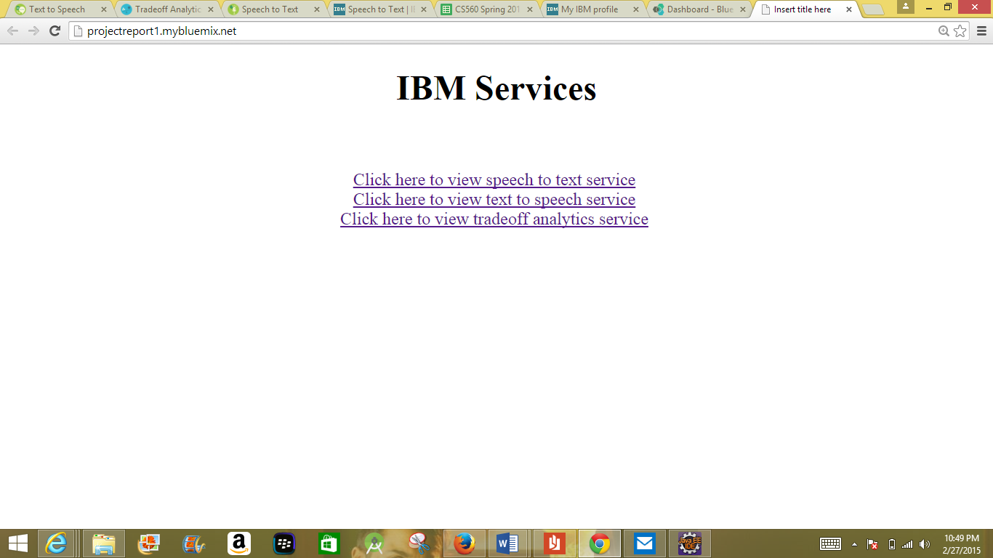

**Speech-to-Text Service:**

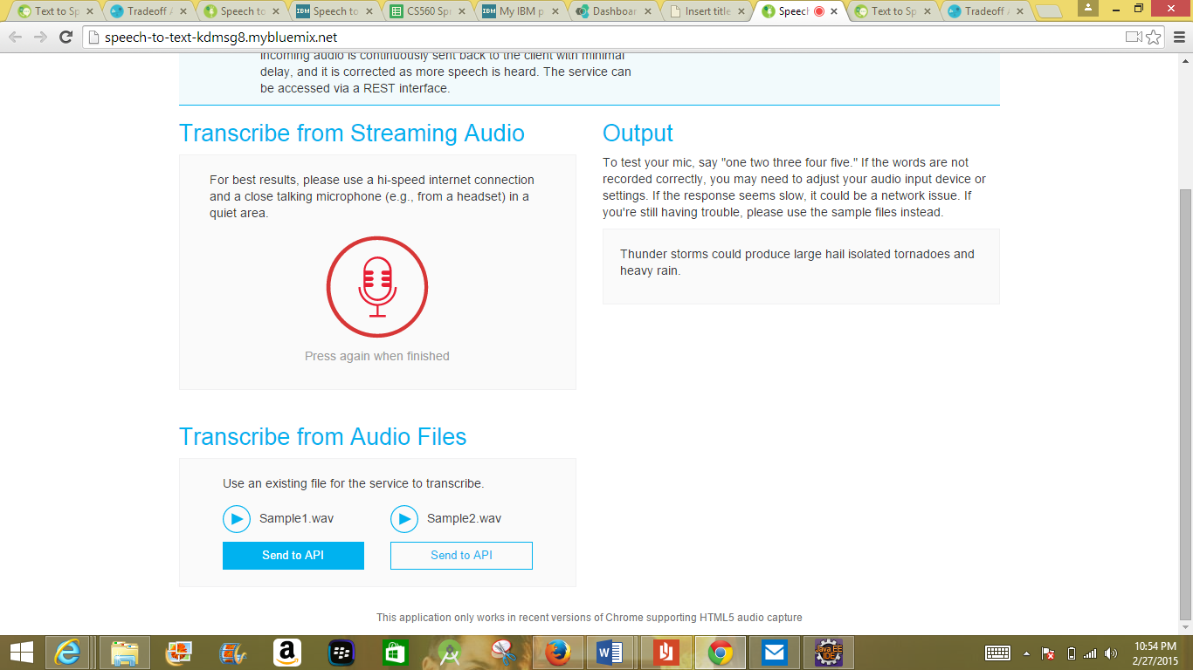

**Text-to-Speech Service:**

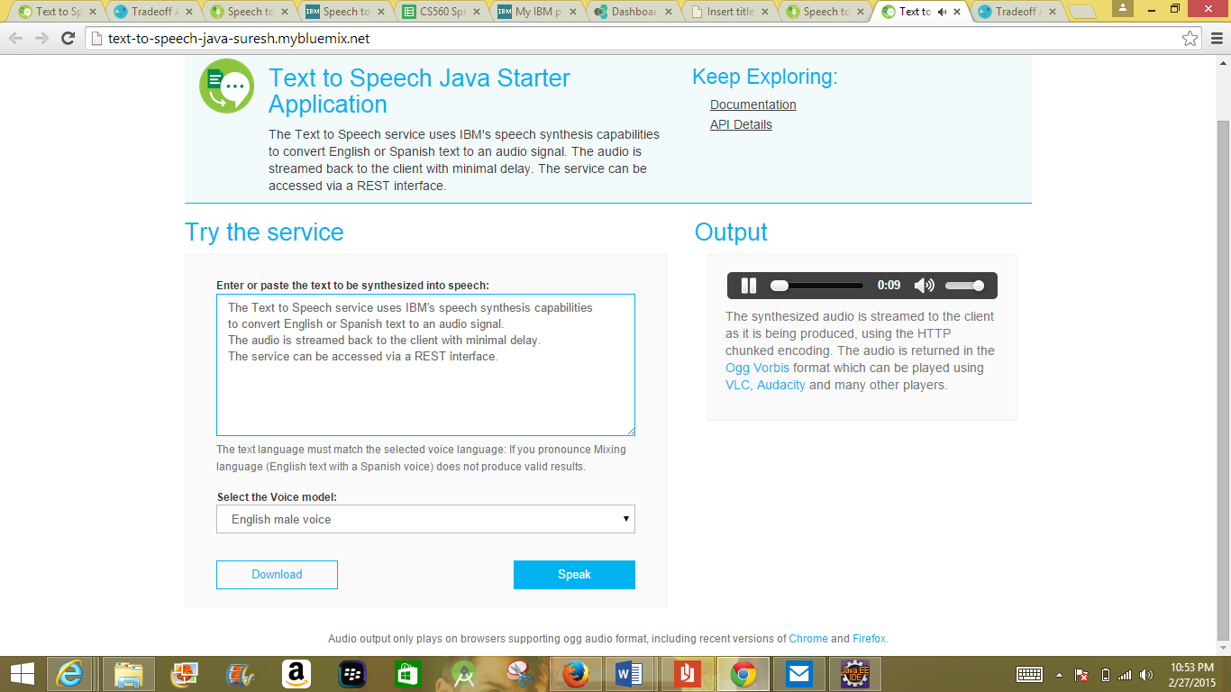

**Tradeoff Analytics:**

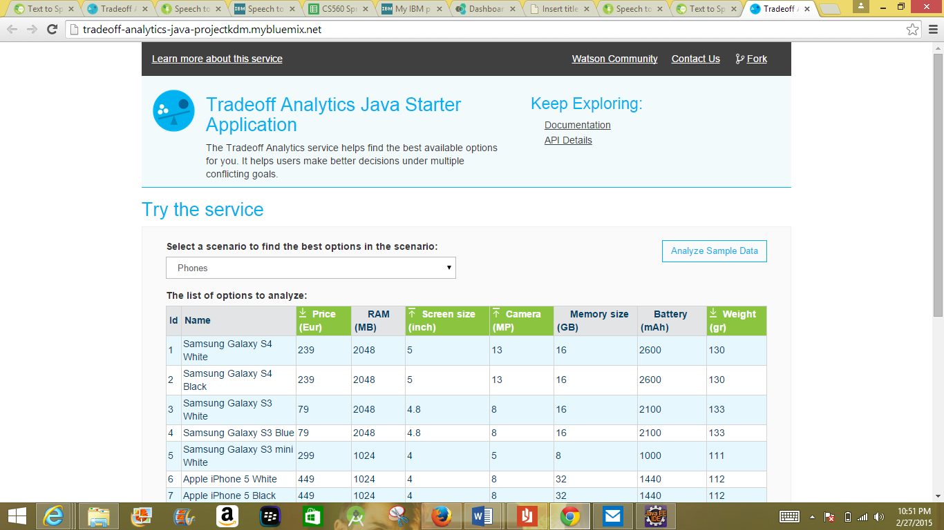 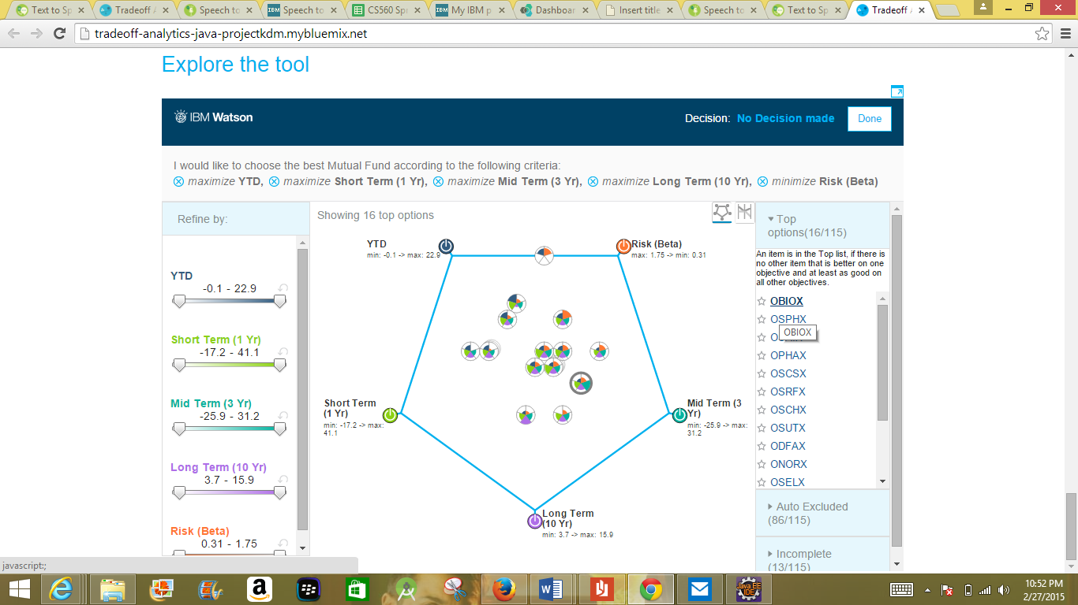 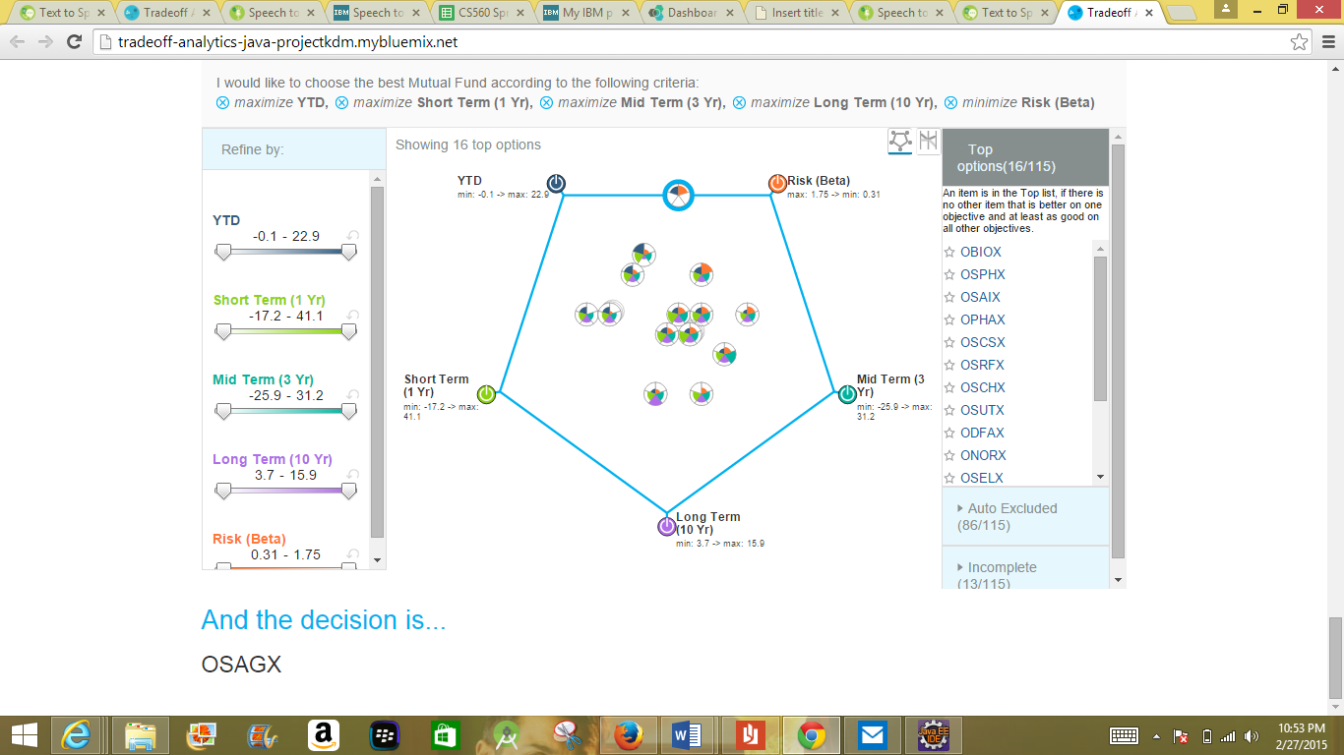

1. **Project Management: report your project progress and plan** 
   1. **Project Timelines, Members, Task Responsibility**
      1. **Work completed:**
         1. **Description**

We have learned how to use Watson services, how to develop a android application and How to collect online stock data from different websites.

* + - 1. **Responsibility** 
         1. Implementation of Text-to Speech, Speech-to-Text Services-Suresh Yerra
         2. Implementation of Tradeoff Analytics-Sarath
         3. Collection of Stock Data-Naveen Jetty
         4. Filtering Stock Data and Analysis of different stock websites to obtain different stock analytics-Narendra Ambati
      2. **Time taken** 
         1. Implementation of Text-to-Speech-10 hours
         2. Implementation of Speech-to-Text-3 hours
         3. Implementation of Tradeoff Analytics-13 hours
         4. Collection of stock data-13 hours
         5. Filtering of stock data and analysis of different stock websites-13 hours
      3. **Contributions**
         1. Narendra Ambati-25%
         2. Sarath-25%
         3. Suresh Yarra-25%
         4. Naveen Jetty-25%
    1. **Work to be completed**
       1. **Description**

We are trying to develop mobile application to take input in the form of speech and convert it to text using speech to text watson service, Get the data from the database based in the Text , Analyze the Data using Tradeoff Analytics.

* + - 1. **Responsibility**
         1. Loading of Data into Cloudera and Database Design-Naveen Jetty
         2. Developing different analytic algorithms-Sarath
         3. Implementing mobile application with combination of three Watson services-Suresh Yarra
         4. Implementation of java application to collect live stock data and update the database-Narendra Ambati
      2. **Time to be taken**
         1. Loading of Data into Cloudera and Database Design-20 hours
         2. Developing different analytic algorithms-20 hours
         3. Implementing mobile application with combination of three Watson services-20 hours
         4. Implementation of java application to collect live stock data and update the database-20 hours