COMP7017 – Deep Learning Project Report

Student 1
Name: ________________________
Email: ________________________

Student 2
Name: ________________________
Email: ________________________

1. Introduction

This report covers the design, training, and evaluation of a Convolutional Neural Network (CNN) for classifying hand-drawn doodles from Google’s QuickDraw dataset. QuickDraw stores millions of drawings across hundreds of categories, each as a 28×28 grayscale image.

We selected Project A (Image Classification with a 2D CNN) and chose 10 categories: apple, bicycle, cat, dog, fish, house, star, tree, umbrella, and sun. These categories provide a range of difficulty. Some are visually distinct (bicycle, star) while others share similar features (cat and dog both have four legs, a round head, and a body at 28×28 resolution). This mix tests the model’s ability to discriminate between both easy and hard classes.

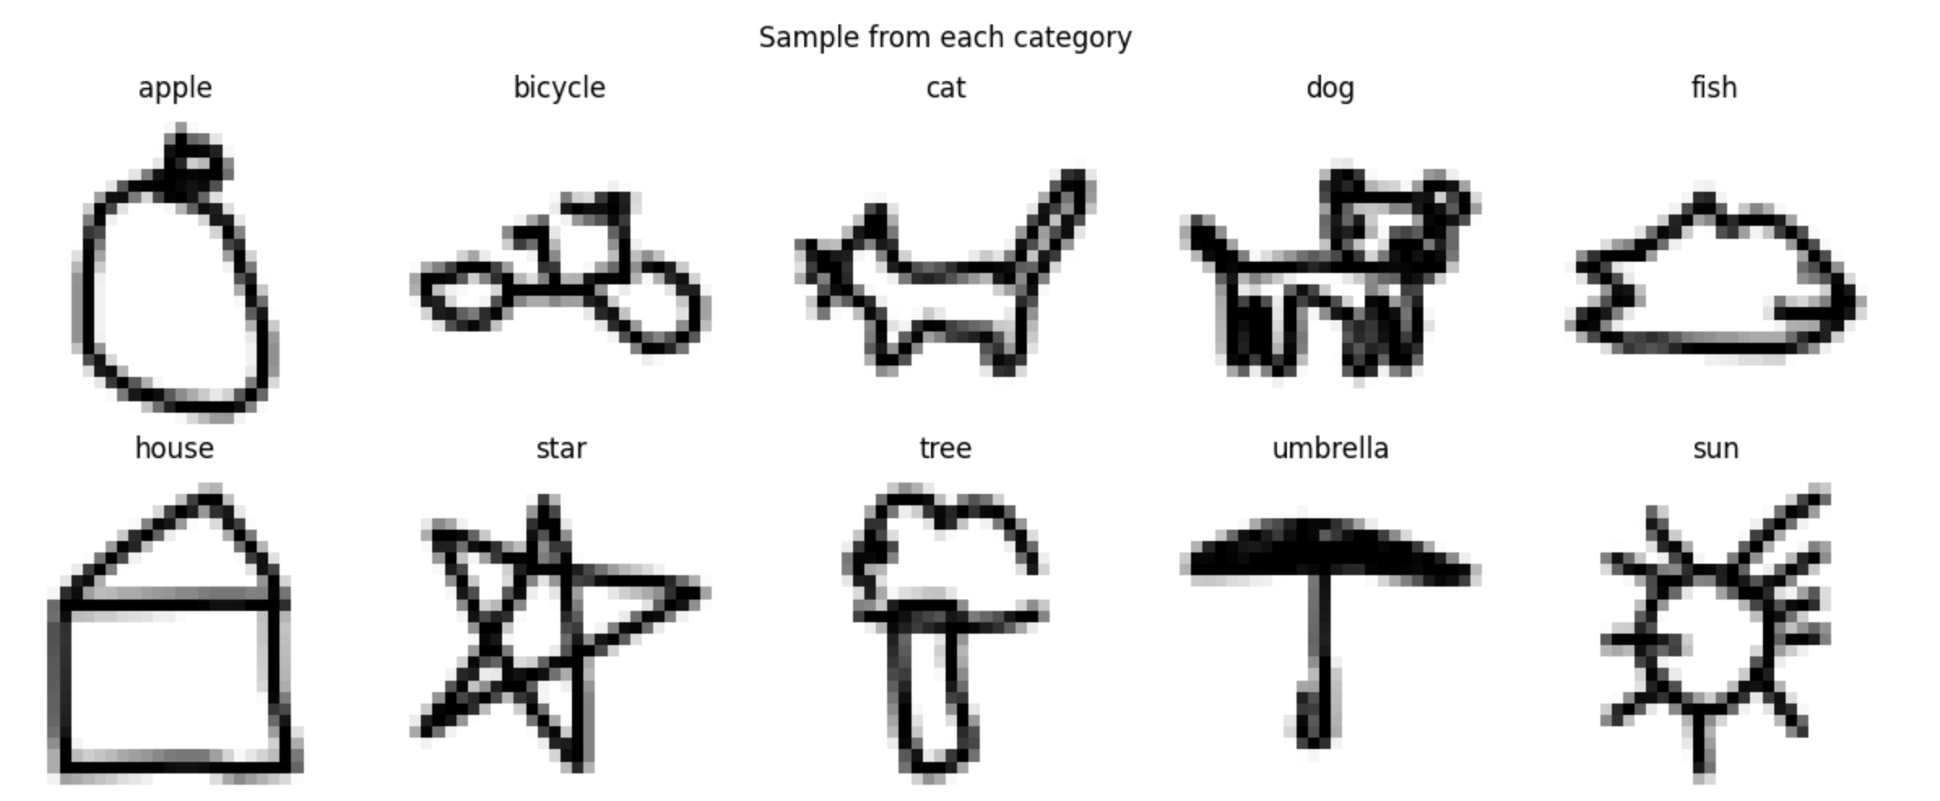Figure 1.1: Sample drawings from each of the 10 QuickDraw categories.

Image classification is a core application of deep learning, as covered in Lecture 8. CNNs are suited to this task because convolutional filters detect spatial features such as edges, curves, and shapes. Weight sharing across the filters acts as regularisation, reducing the number of learnable parameters compared to fully connected networks. Max-pooling then sub-samples the feature maps, preserving salient features while reducing dimensionality. Classification is performed by flattening the pooled feature maps and feeding them into dense layers with a softmax output, as described in Lecture 9.

Our approach was progressive. We first built a small model to visualise each layer of the CNN pipeline. We then ran three rounds of experiments, each addressing problems found in the previous round. All techniques, including convolutional layers, max-pooling, flattening, dense layers, softmax, and the Adam optimiser, come directly from Lectures 8 and 9. The model was built with Keras and TensorFlow.

2. Methodology

Pre-processing

Each category’s data is a NumPy array of flattened 784-length vectors. We reshaped these to 28×28×1 to match the input format for Keras Conv2D layers, consistent with the single-channel grayscale representation from Lecture 8. We used 10,000 samples per class (100,000 total). We initially used 5,000 per class but doubled this during fine-tuning to address overfitting (see Section 3).

We split the data into 80% training, 18% test, and 2% validation using scikit-learn’s train_test_split function. Labels were one-hot encoded with OneHotEncoder. A normalisation layer adapted to the training data’s statistics served as the first layer of every model, scaling pixel values for effective gradient descent.

Small Model (Baseline)

We started with a model: a normalisation layer, one Conv2D layer (5 filters, 3×3 kernel, stride 1, ReLU), one MaxPooling2D (2×2, stride 1), Flatten, Dense(50, ReLU), and Dense(10, softmax). We trained for 5 epochs with batch size 32, Adam optimiser, and categorical crossentropy loss. This small model let us trace a single image through each layer. We visualised the 5 feature maps, the effect of max-pooling on spatial dimensions, the flattened vector, and the final softmax probabilities. The filters learned to detect edges and curves in the doodle drawings.

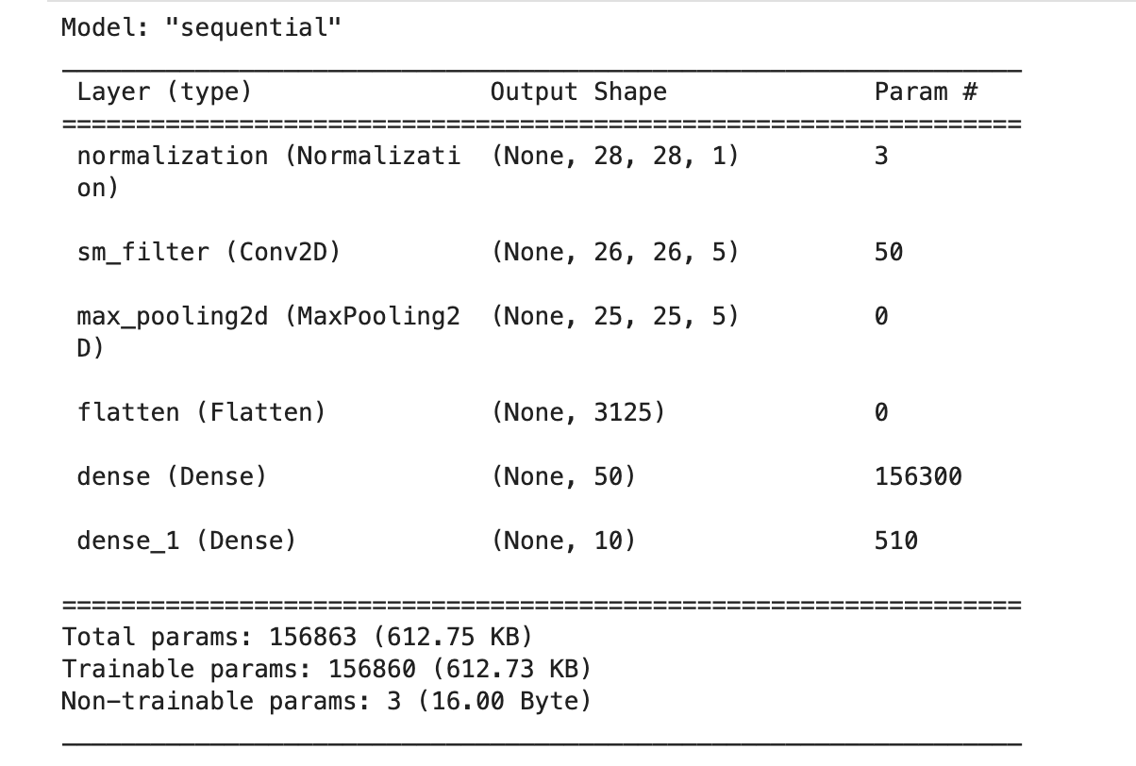

Figure 2.1: Full pipeline visualisation from the small model, showing an image traced through each layer.
Final Model Architecture

Following the LeNet-5 pattern from Lecture 9, we extended the baseline with a second convolutional block. The final model consists of: Normalisation (28×28×1), Conv2D with 32 filters of 3×3 stride 1 ReLU (output 26×26×32), MaxPooling2D 2×2 stride 2 (output 13×13×32), Conv2D with 64 filters of 3×3 stride 1 ReLU (output 11×11×64), MaxPooling2D 2×2 stride 2 (output 5×5×64), Dropout(0.3), Flatten (output 1600), Dense(128, ReLU), Dropout(0.5), Dense(64, ReLU), Dropout(0.5), and Dense(10, softmax).

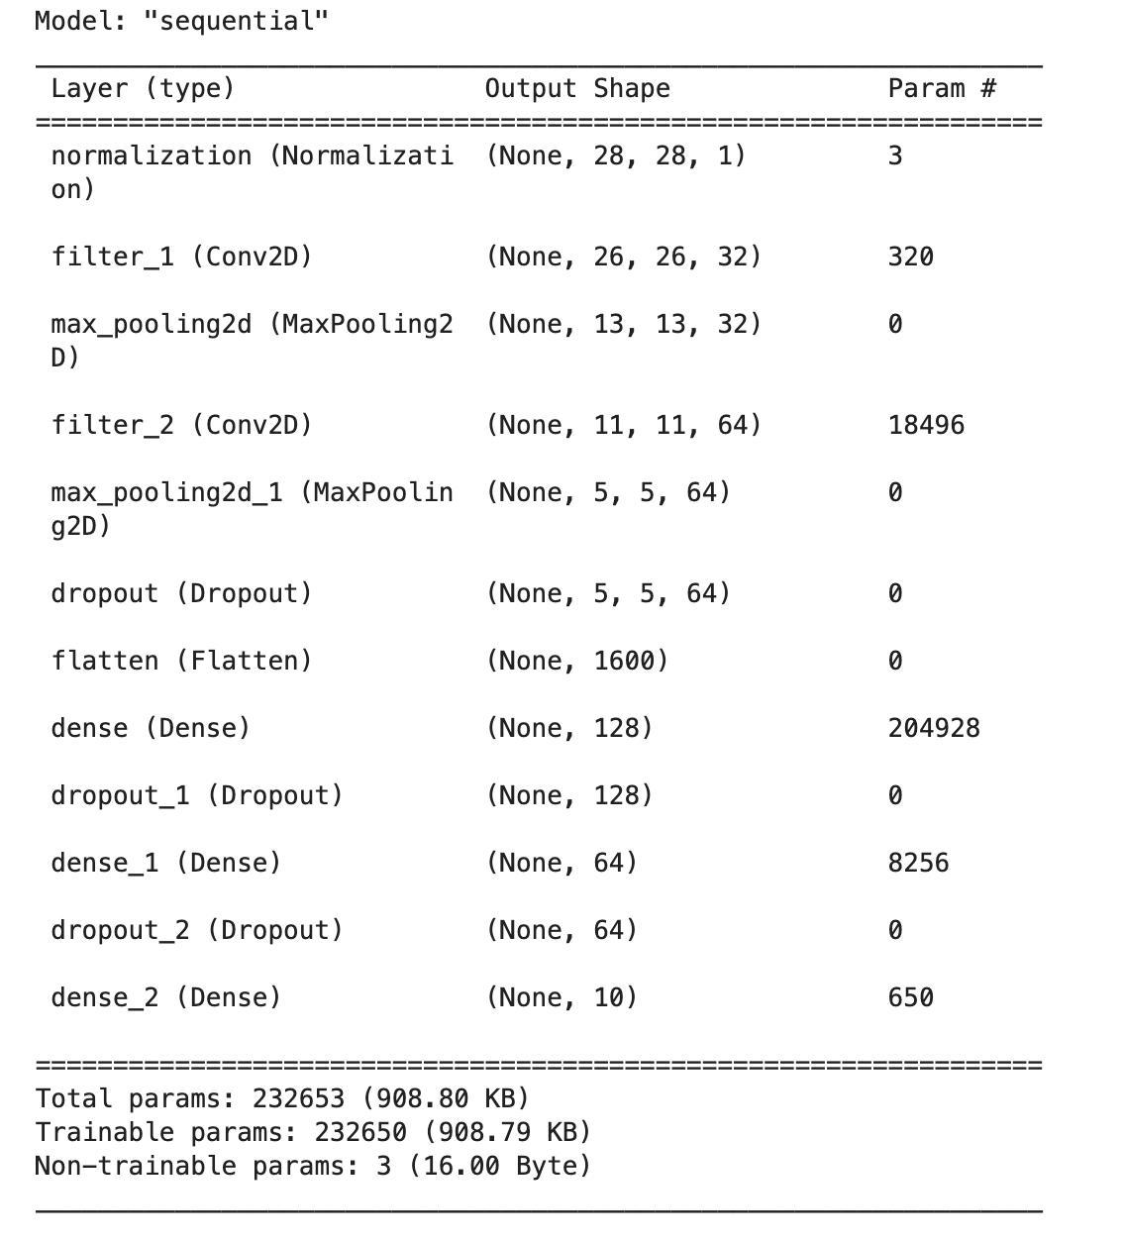
Figure 2.3: model.summary() showing layer types, output shapes, and parameter counts.

The filter count progresses from 32 to 64. Earlier layers detect low-level features such as edges and strokes. Deeper layers combine these into complex patterns such as shapes and curves, requiring more filters. The two dense layers (128, 64) follow the LeNet-5 pattern of two fully connected layers before the output. Max-pooling stride of 2 halves spatial dimensions at each stage, reducing learnable parameters as discussed in Lecture 8. The flatten layer converts the 5×5×64 feature maps into a 1600-element vector for the dense layers.

Hyperparameter Choices

Kernel size (3×3): This is the standard kernel size used in VGG and other architectures from Lecture 9. Optimiser (Adam): Adam adapts learning rates per parameter, making it effective without manual tuning. Loss function (categorical crossentropy): Standard for multi-class classification with one-hot encoded labels. Batch size (32): Provides stable gradients while fitting in GPU memory. Activation functions: ReLU for all hidden layers (as per lectures), softmax for the output layer to produce a probability distribution over 10 classes.

Dropout rates (0.3 after convolutions, 0.5 before dense outputs): Post-convolution dropout is lower because convolutional layers have fewer parameters due to weight sharing (Lecture 8), making them less prone to overfitting than dense layers. We added dropout after observing overfitting in Experiment 1.

Early stopping: We used the Keras EarlyStopping callback, monitoring validation loss with patience of 5 epochs and automatic restoration of the best weights. This replaced our initial approach of training for a fixed 100 epochs, which caused overfitting.

3. Results

Experiment 1: 100 epochs, 5,000 samples per class

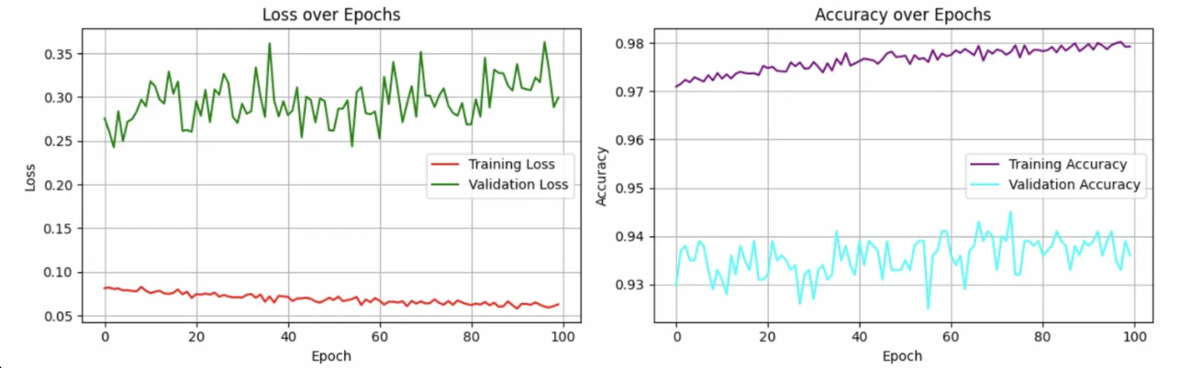
The two-block model trained for 100 epochs. Training accuracy reached 97-98%. Validation accuracy plateaued at 93-94%. The training curves showed overfitting: validation loss was noisy and trending upward after epoch 25, while training loss kept decreasing. The gap between training and validation accuracy widened over time, confirming the model was memorising training data.

Figure 3.1: Experiment 1 training curves showing overfitting after ~25 epochs.

Per-class accuracy ranged from 84.8% (cat) to 98.3% (bicycle). The confusion matrix showed 107 cats misclassified as dogs and 89 dogs as cats.

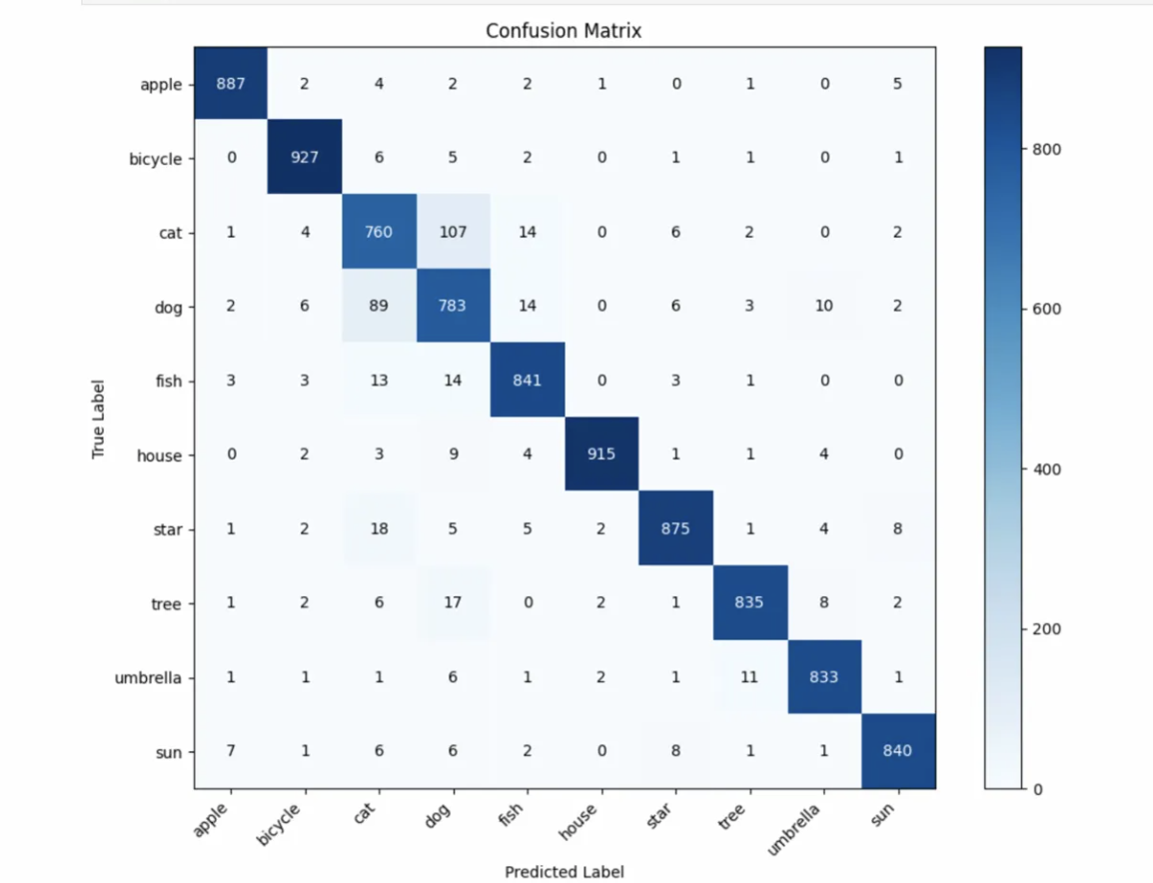

Figure 3.2: Experiment 1 confusion matrix (5,000 samples per class, 100 epochs).

Experiment 2: Early stopping, 10,000 samples per class, increased dropout

Three changes addressed the overfitting. We doubled training data to 10,000 per class. We added early stopping (patience 5, monitoring validation loss). We increased post-convolution dropout from 0.25 to 0.3 and added a second dense layer (64 neurons) with dropout 0.5.

Early stopping halted training at epoch 11. Both losses decreased together with no divergence. Validation accuracy (~95%) exceeded training accuracy (~93-94%). This inversion is expected with dropout: dropout deactivates random neurons during training, making it harder, but is turned off during validation.

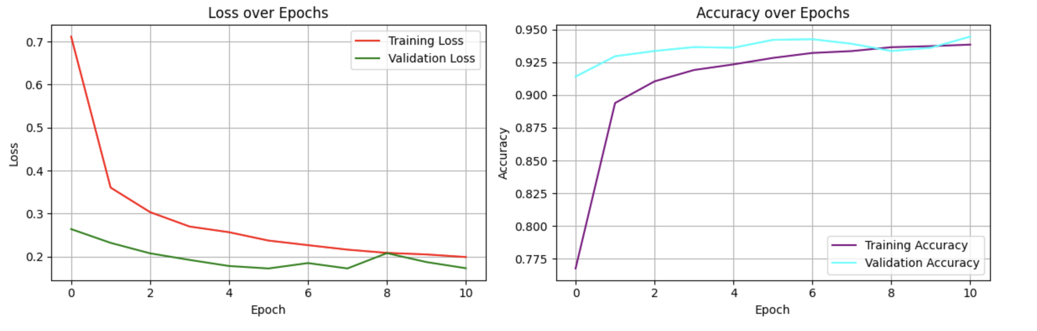
Figure 3.3: Experiment 2 training curves. No overfitting. Validation accuracy exceeds training accuracy due to dropout.

Test accuracy was 94% across 18,000 test samples. Weighted F1-score was 0.94. Per-class accuracy ranged from 85.3% (cat) to 98.0% (bicycle). The confusion matrix showed 256 cats predicted as dogs and 118 dogs predicted as cats. Cat/dog confusion remained the primary source of error.

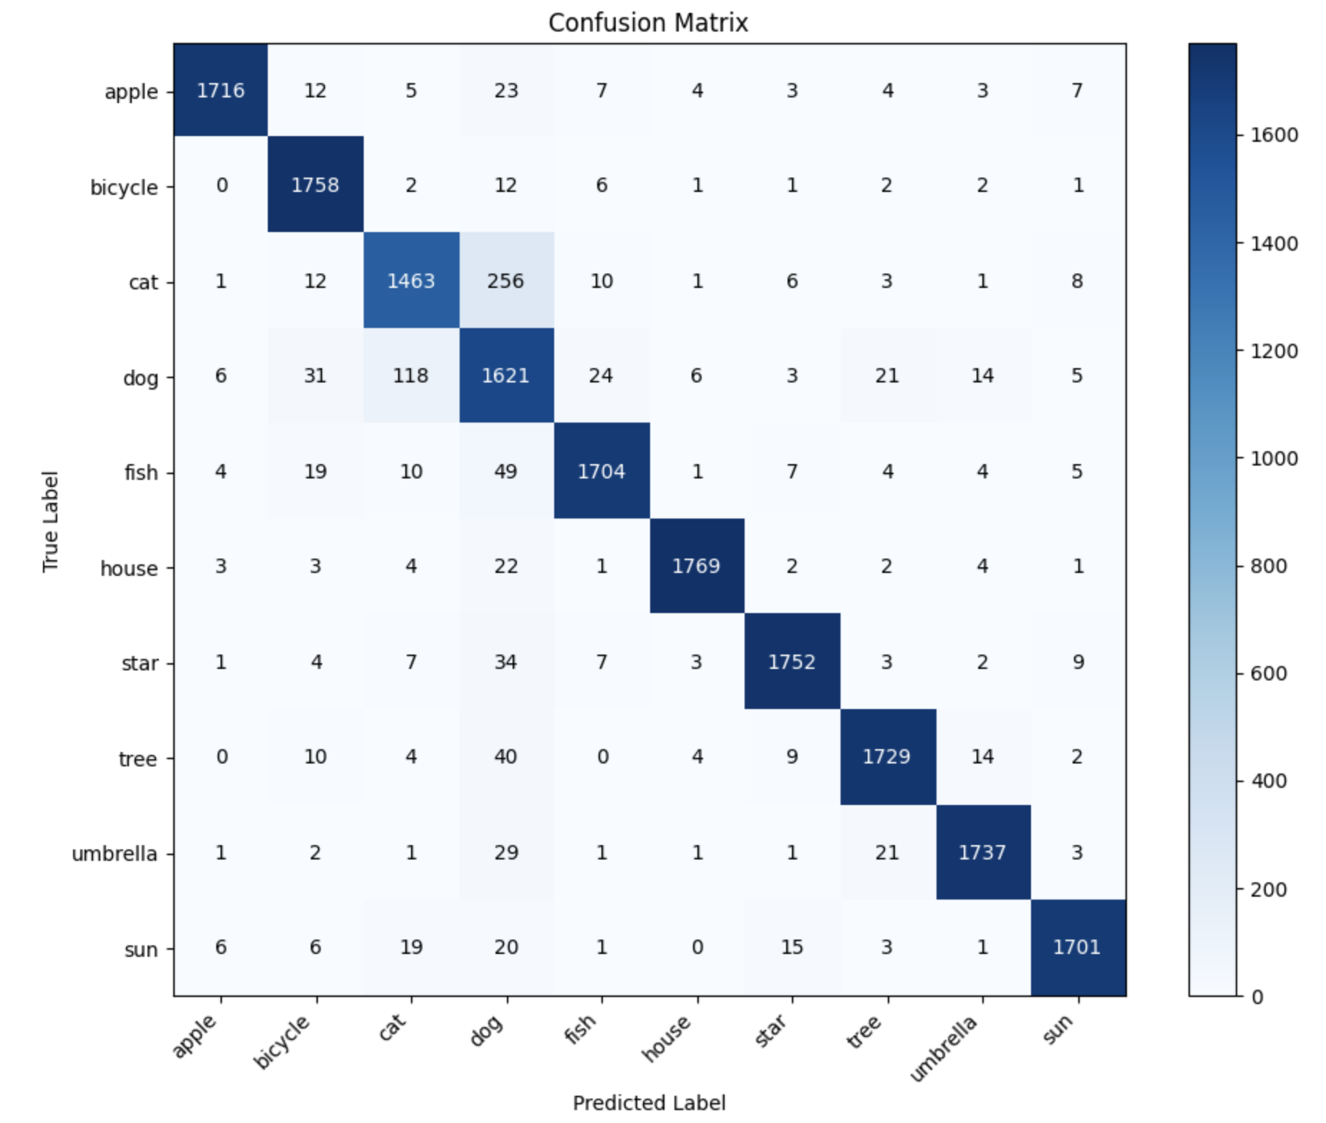

Figure 3.4: Experiment 2 confusion matrix. Cat/dog mutual misclassification is the dominant error.

Experiment 3: Three convolutional blocks, 5×5 first kernel

We added a third convolutional block (128 filters, 3×3) and changed the first layer to 5×5 with same padding, following LeNet-5’s original design. The larger first kernel captures broader spatial features. The model converged faster (early stopping at epoch 12). The confusion matrix was identical to Experiment 2: same cat/dog numbers, same per-class accuracies, same 94% overall. Adding complexity produced no accuracy gain. This proved the ceiling is a data limitation at 28×28 resolution, not a model capacity problem.

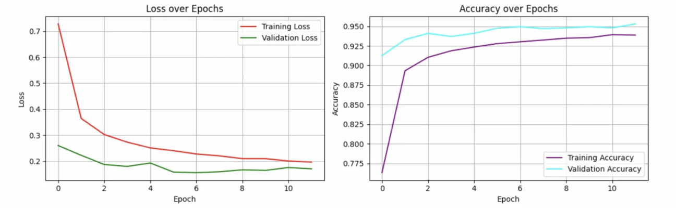

Figure 3.6: Experiment 3 training curves. Faster convergence but identical final accuracy.

Training Cost

All training ran on a GPU. Experiment 1 (100 epochs, 50,000 samples) took 10-30 minutes. Experiment 2 (11 epochs, 100,000 samples) took a similar time because more data offset fewer epochs. Experiment 3 (15 epochs, three conv blocks) finished fastest. The final model has approximately 225,000 learnable parameters. Early stopping reduced wasted computation by 60-75% compared to a fixed 100 epochs, with no accuracy loss.

4. Reflection

What was done well

The progressive approach worked. Starting with the small baseline let us understand and visualise each CNN layer before scaling up. We traced single images through normalisation, convolution, pooling, flattening, and classification, confirming the filters learned meaningful features. This made debugging easier and gave us confidence in each component before adding complexity.

Systematic experimentation produced clear evidence for each decision. We observed overfitting in Experiment 1, applied targeted fixes in Experiment 2, and confirmed the fixes by comparing training curves and accuracy. When Experiment 3 showed no improvement from a third convolutional block, we had concrete evidence the problem was data-bound rather than model-bound. Each experiment built on the findings of the previous one.

Early stopping was effective. Training stopped at the right point (epoch 11) without manual intervention, saving computation and preventing overfitting. The healthy training curves in Experiments 2 and 3, with validation loss tracking training loss closely, confirmed the regularisation strategy was correct.

What could be done better

The cat/dog confusion was never resolved. Higher resolution images would give the model more pixel detail to differentiate between cat and dog drawings. Data augmentation techniques such as rotation, flipping, and slight distortion could increase effective training variety without downloading more samples. We did not try either approach due to time constraints.

We changed multiple variables simultaneously between Experiments 1 and 2 (more data, early stopping, increased dropout, added dense layer). A more rigorous experimental approach would change one variable at a time to isolate the contribution of each change to the final result.

A learning rate scheduler or manual learning rate tuning could have improved convergence speed and final accuracy. We used Adam’s default learning rate throughout all experiments. Batch normalisation, which normalises activations within each layer, was another technique we did not explore but could have improved training stability.

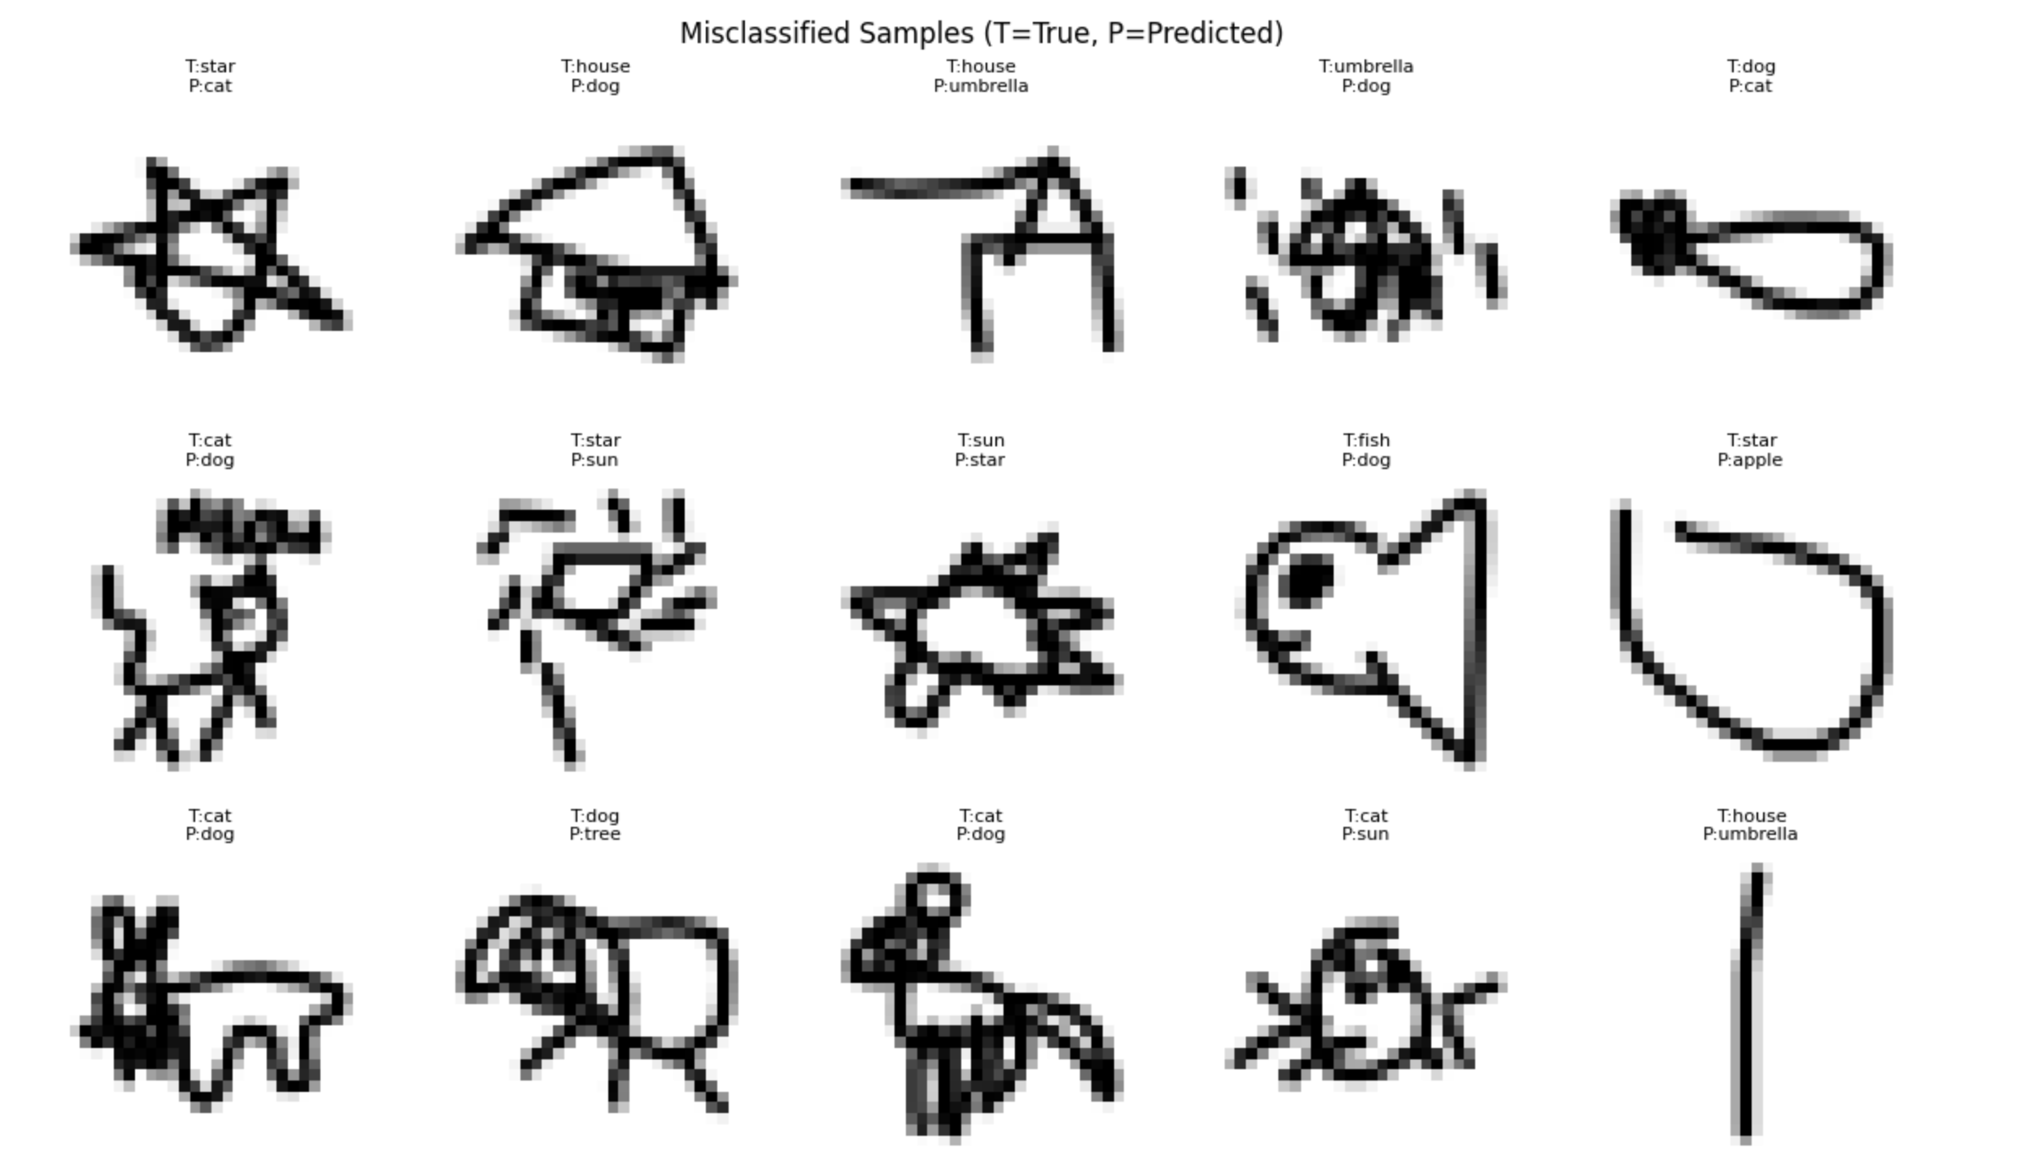

Figure 4.1: Misclassified samples from the final model, showing true and predicted labels.

5. Conclusion

We built a CNN that classifies 10 categories of QuickDraw doodles at 94% test accuracy with a weighted F1-score of 0.94. The model uses two convolutional blocks following the LeNet-5 pattern from Lectures 8 and 9, with dropout regularisation and early stopping.

Three experiments showed that doubling training data from 5,000 to 10,000 samples per class and adding early stopping eliminated overfitting, while a third convolutional block produced no accuracy gain. The persistent cat/dog confusion (85-86% for both classes) is a data constraint at 28×28 resolution, not a model limitation. Eight of ten categories exceeded 93% accuracy. The final model generalises well, with no gap between training and validation performance.

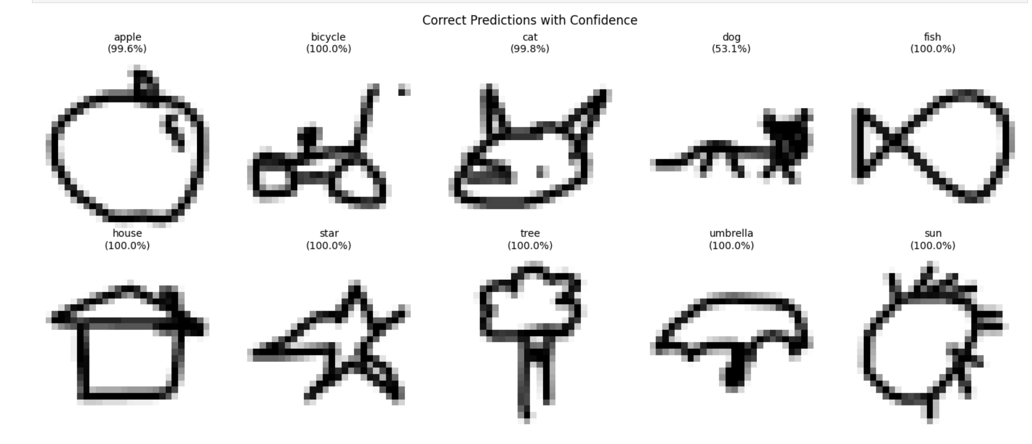

Figure 5.1: Correct predictions with model confidence for each category.

