Tom Ferko

8/3/2020

Intro to DB

Assignment 04

**SQL Transactions and Terminology**

**Introduction**

When using SQL there is a terminology for a block of code that executes a query. That is known as a transaction, more specifically it is a sequence of operations performed (using one or more SQL statements) on a database as a single logical unit of work (External Link, w3resource.com 1). In Microsoft SQL server, transactions are set up automatically when code is written, however, using advanced transactions the code is able to be controlled more finitely, with failsafes in order to rollback mistakes.

**Topic 1- Basic SQL Statements**

Within a transaction there are 4 main tools used to execute changes in a database. These are CREATE, SELECT, UPDATE, and DELETE, using these four terms allows for basic control over the data within a database. CREATE is the term used to create an object within a database. The SELECT function allows for reading and displaying of data. UPDATE is used to update information within a table, though specificity is key when using this as it could be very easily used to change entire columns of information. And DELETE is used to remove information from a table, though not the table itself, there is a different function used for that.

**Topic 2 - Transactions**

As stated before, transactions are a series of operations, however the key to transactions lies in controlling them for specific needs. Because MS SQL server creates transactions by default, they are automatically written into the database. It may be the case that there is a complex transaction that needs to be completed, and it may hurt data in a table if performed incorrectly. In those types of situations, manually stating the start and end of a transaction can be a powerful tool. This allows for cases where error handling can be implemented and a mistake can be automatically rolled back. For example, see figure 1:

Figure 1:

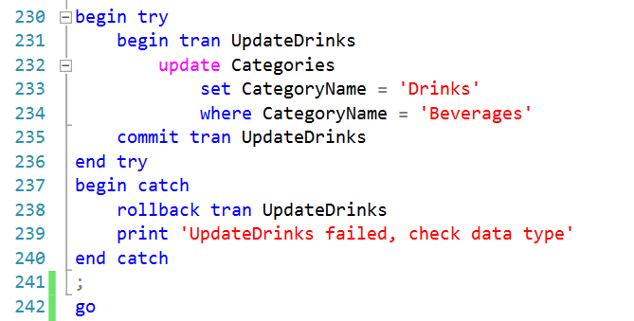

This code allows for a transaction to be run, but also allows for it to be rolled back in the case where it is incorrectly written, or if the table does not allow for certain data due to constraints. The error handling specified after the PRINT function also allows for specific tracking of where a piece of code may have gone wrong. There are many more uses to transactions, and they become much more useful as the queries get more complex.

**Topic 3 - Identity**

IDENTITY is a function used in SQL to auto number and auto increment rows in a table. Because of its automatic functionality it does not need to be stated when importing information into a table, it will be created automatically. This differs from the function @@IDENTITY, this is a built in function to find the maximum IDENTITY in a column (External link, sqlshack.com 1). This is used as a shorthand for longer code that does the same thing, as seen in figure 2.

Figure 2:

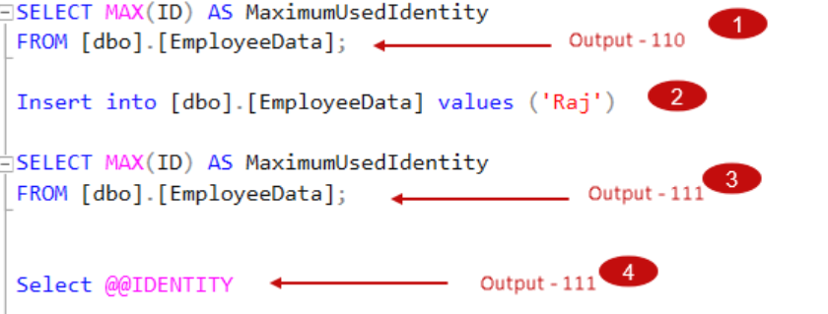

(External link, sqlshack.com 2)

Finally the last Identity function is IDENT_CURRENT(), this is used to return the last Identity generated in a table(External Link, sqlshack.com 3). Again this is used as a shorthand, and both shorthands can be used in subqueries to create more powerful data filtering.

**Closing**

In conclusion transactions are made up of a series of operations to perform logical actions in a block of code. Within that code there are basic statements like CREATE, SELECT, UPDATE, and DELETE that are used to change or create data within a table. Along with those basic functions are the IDENTITY statements that help to create, and track the identification of all rows of data in a given query.