Test report

We tried to solve this problem without using special external solutions. Our approach gave us about 15-20% percents of similarity between prepared images and rectified ones. The problem is that when our program maps coordinates to the new one and we create new image there are a lot of empty entries in the matrix representation of image. (black distortion).

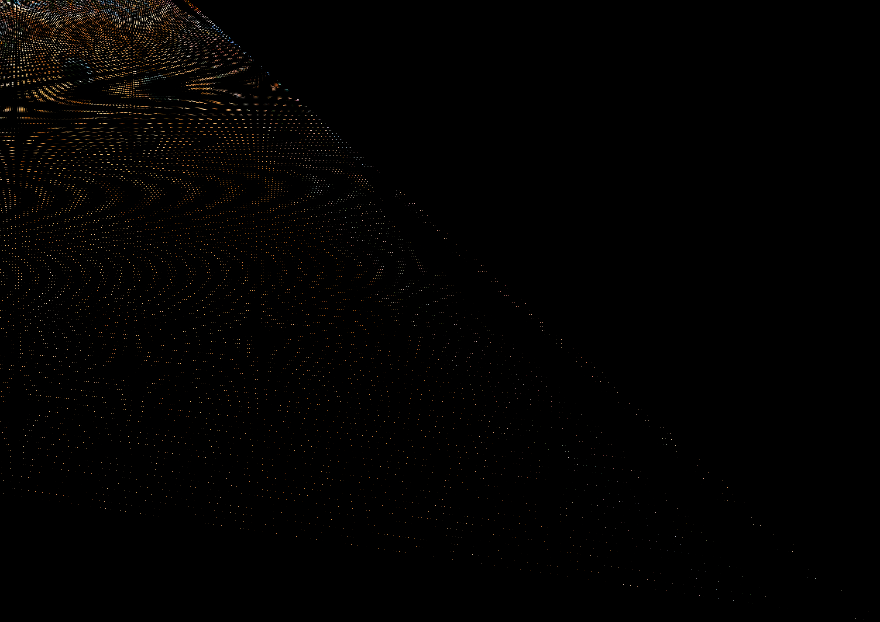 Tests showed that our code is running pretty long time to solve average example. Also I discovered problem with this black distortion. Sometimes there is more black (empty) points then mapped one.

To avoid this OpenCV or skimage use specific algorithms which are pretty hard to implement without using the whole OpenCV or skimage. We decided not to reinvent a bicycle and to use skimage library to make our project work.

Tests also cover exception handling. They test our program on wrong input information. Not all of the such inputs were handled right.

In conclusion we have pretty bad results for image processing with 15-20% of correctness in average and 25% of wrong input handling.