**Report on APPU 2nd Postal CEO & 11th Postal Business Forum 2024**

**Arrival at Bangkok**

As approved by the Board of Bhutan Post flew to Bangkok on the 16th November 2024 to represented Bhutan Post as its CEO and attend the APPU Postal CEO’s inaugural roundtable, the 2nd CEO Forum and the 11th Postal Business Forum held in Bangkok, Thailand from 17th – 21st November 2024.

**Opening Ceremony**

The 2024 |APPU Postal CEO’s Forum and Postal Business Forum was officially opened by Mr. Marjan Osvald, Deputy Director General of the Universal Postal Union. The ceremony was attended by CEO’s of APPU region, postal business firms andpostal start-ups along with delegates, guests and observers which also included Mr. Jean-Paul Forceville - the Chair of the Postal Operations Council of the UPU, Mr. Walter Trezek – Chair of the Consultative Committee of UPU and the Secretary General of APPU and his team.

**Day-0: Sunday 17 November 2024- Inaugural Edition of CEO RoundTable**

On the night of 17th November, attended the the inaugural edition of the CEOs Roundtable organized by APPU- an exclusive event for the CEOs to interact and discuss trends and business strategies. It was attended by the following APPU Postal CEO’s:

Bhutan Post: Mr. Karma Nidup, CEO  
Brunei Post: Dr. Awang Rosi bin Hj Abdul Aziz, PMG  
Cambodia Post: Mr. Then Samvisoth, CEO  
China Post Group: Mr. Chenglin Guo, CFO  
India Post: Mr. Subrat Das, Member, Postal Services Board  
Pos Indonesia: Dr. Faizal Rochmad Djoemadi, CEO  
Japan Post: Ms. Haruko Takachi, Executive Manager  
Lao Post: Mr. Samith Khanthikone, Asst CEO  
Pos Malaysia: Mr. Charles Brewer, Group CEO  
Maldives Post: Mr. Ahmed Shafeeq, CEO  
Mongolia Post: Mr. Telmen Gerelt, CEO  
PHL Post: Mr. Luis D Carlos, PMG & CEO  
Sing Post: Mr. Li Yu, CEO  
Sri Lanka Post: Mr. Ruwan Sathkumara, PMG  
Thailand Post: Mr. Dhanant Subhadrabandhu, CEO   
Oman Post: Mr. Ibrahim Sultan Al Hosni, Acting CEO

The occasion was graced by Mr. Marjan Osvald, Deputy Director General of UPU along with Mr. Jean-Paul Forceville - Chair of the Postal Operations Council of the UPU, Mr. Walter Trezek – Chair pof the Consultative Committee of UPU and by Dr. Vinaya Prakash Singh, Secretary-General of APPU.

**​**

**Day-1: Monday, 18th November - Postal CEO’s Forum 2024**

The Asian-Pacific Postal Union organized the 2nd Postal CEO’s Forum at Hotel Sofitel, Bangkok.

The second edition of the Postal CEOs Forum was organized on 18 November in conjunction with the Postal Business Forum. It provided a platform to bring together 15 APPU postal CEOs and other postal leaders from the region and beyond to share their vision and insights about the sector and to interact with the stakeholders.

During the Forum, discussions covered a range of topics, including e-commerce, last-mile delivery, digitalization, sustainability, and cross-border mail. Through interactive sessions (round tables and presentations), expert panel discussions, and keynote speeches, participants shared and gained insights into the evolving postal landscape and learnt about best practices, successful case studies, and innovative solutions and technology showcase from around the world.

Sessions included presentation on the following:

1. Strategic approach for future growth
2. Evovling postal services into regional logistic hubs
3. Navigating challenges and seizing opportunities in diverse postal markets

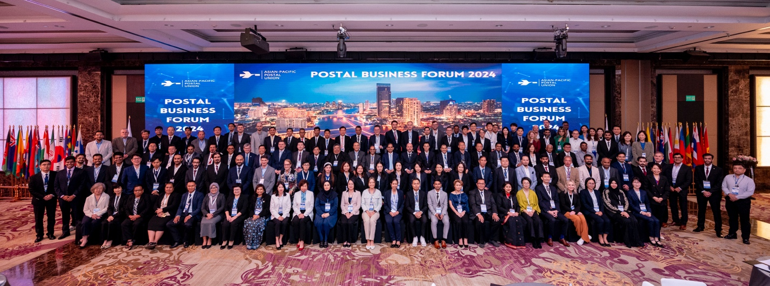

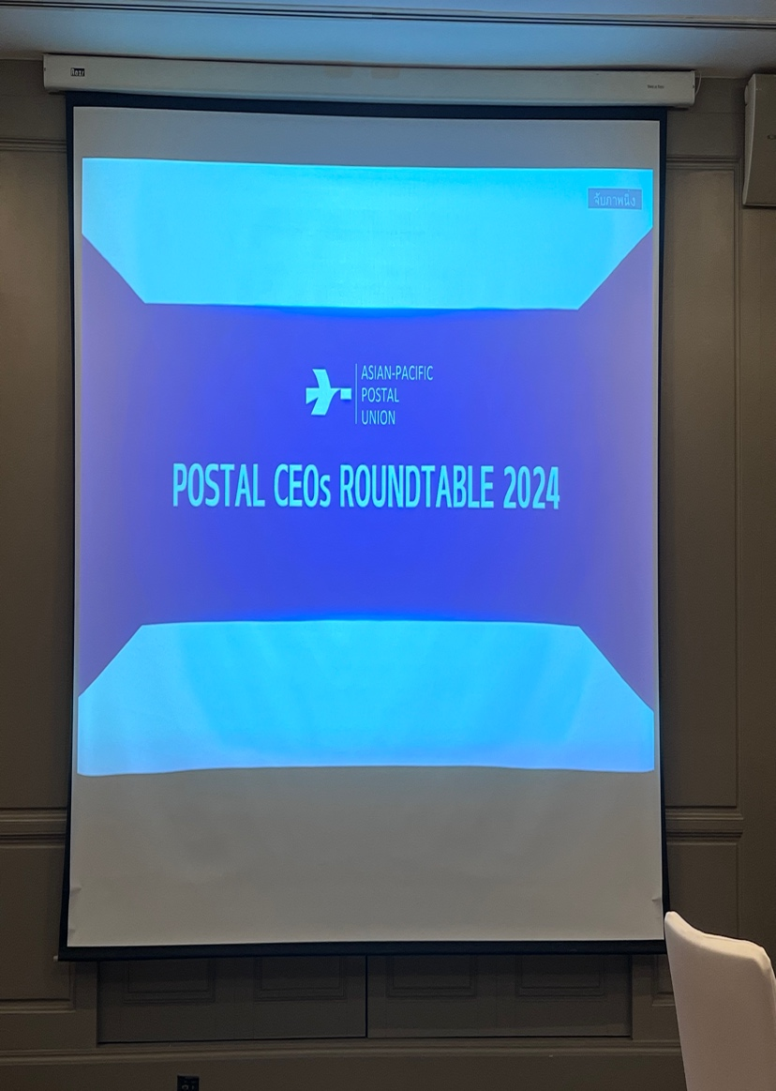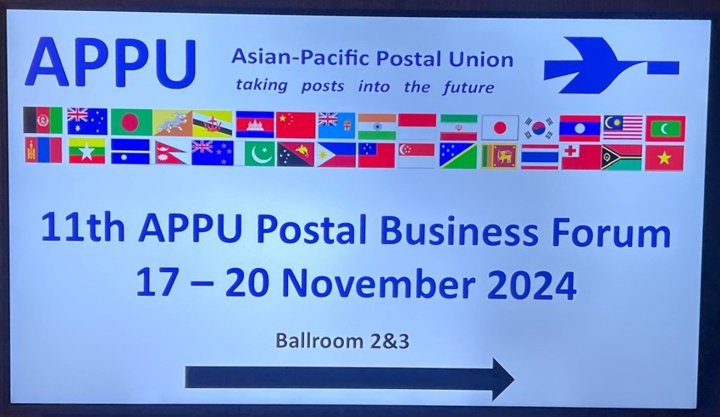

**Day-2: Tuesday, 19 November - Postal Business Forum 2024**

The Asian-Pacific Postal Union organized the 11th Postal Business Forum at Hotel Sofitel, Bangkok.

The second day panel discussions, round tables and presentations were moderated by Mr. Derek Osborn, consutant at APPU on exploring new market opportunities in the digital age and technology showcase.

The program for the day were as follows:

0930    Inauguration and Keynote Address

1030    Session 1 of CEOs Forum: Strategic approach for future growth

1200    Session 2 of CEOs Forum: Evolving Postal Services into Regional Logistics Hubs

1400   Session 3 of CEOs Forum: Navigating Challenges and Seizing Opportunities in Diverse Postal Markets

1530    Award Ceremony: Presentation by short-listed postal operators and distribution of awards on “Innovation in the Postal Sector” and “Sustainable Initiatives in the Postal Sector”

Bhutan Post was awarded the “Sustainable Initiatives in the Postal Sector” award by APPU from amongst the competitors.

The sessions for the day ended at 1600 hours by visiting booths and networking followed by dinner reception for CEOs, delegates, and participants at 1800 hours

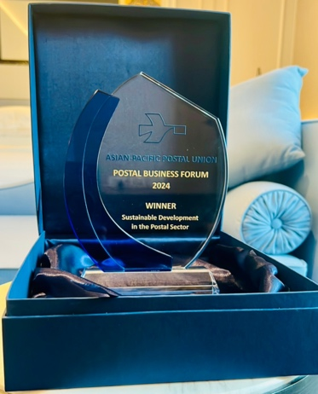

**Day-3: Wednesday, 20 November - Postal Business Forum 2024**

The third day of the Postal Business Forum’s panel discussions, round tables, and presentations on e-commerce, logistics, and regional collaborations was moderated by Mr. Derek Osborn in the forenoon. A special showcase of postal start-ups was also made in the afternoon which was moderated by Dr. Bernhard Bukovc.

The program for the day were as follows:

0900   Session 1: Repositioning posts as key players in cross-border commerce

1100   Session 2: Regional Collaboration and Co-operation

1330   Start-up Forum: Showcase of start-ups

1600   Building a culture of innovation and nurturing start-ups and good ideas

The day ended with a Gala Farewell Dinner at 1830 hours organised and sponsored by our platinum sponsor SHIPSY.

**Conclusion:**

The APPU’s Inaugural CEO Roundtable, 2nd Postal CEO’s Forum and the 11th Postal Business Forum provided me platform to network as well as engage in promising discussions and insights into the future of postal sector besides gaining invaluable insights and knowledge on postal business.

Submitted by:

Karma Nidup

Chief Executive Officer