**Name of PO :** Dagapela Post office

**Rental**  : Nu.3500/month

**No. of Employee** : Handled by 1 Postal Assistant ( 1 )

**Location Covered: 8 Gewogs** : 1. Dorona 5. Geserling

2. Goshi 6. Tashiding

3. Tshangkha 7. Tshendagang

4. Drujegang 8. Lhaja

**Average Daily revenue Collection (Walk in Customers)** : Nu**. 2060.16**

**Revenue collection for the year 2024** : **Nu. 612130.00**

**Observation:** The post office was located below the road and been operating from a small tiny untidy room located far from the market area. So I with postmaster immediately relocated the office in the market area in a much bigger space after negotiating the rental at Nu. 3500/month.

**Business Opportunity:**

1. With many constructions and development taking place, advised the postmaster to grasp the opportunity to get construction Insurance.
2. Lost many customers of RIA money transaction due to cease of RIA service for the past 3 months. However, if the service resumes, there’s opportunity to generate revenue from the WUMT/RIA transactions.

**Before After**

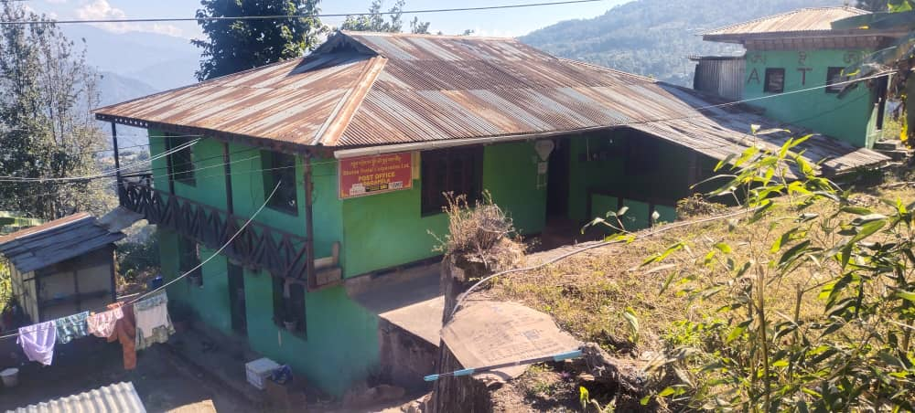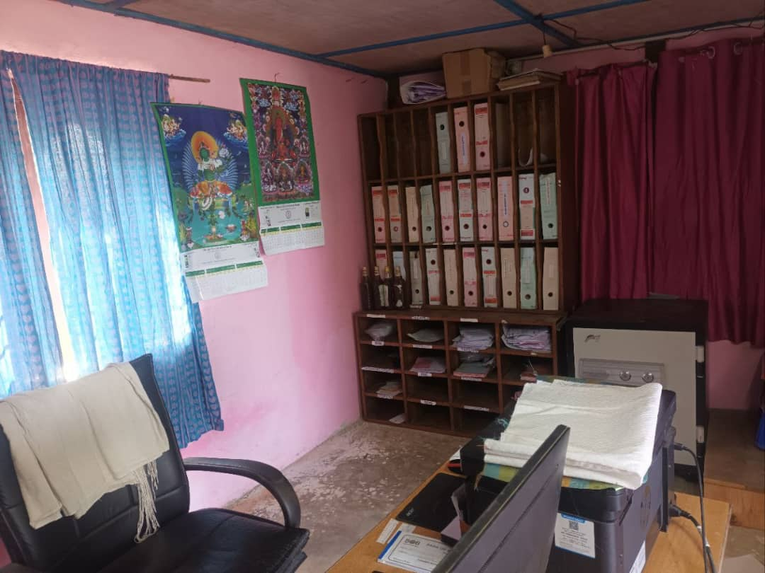

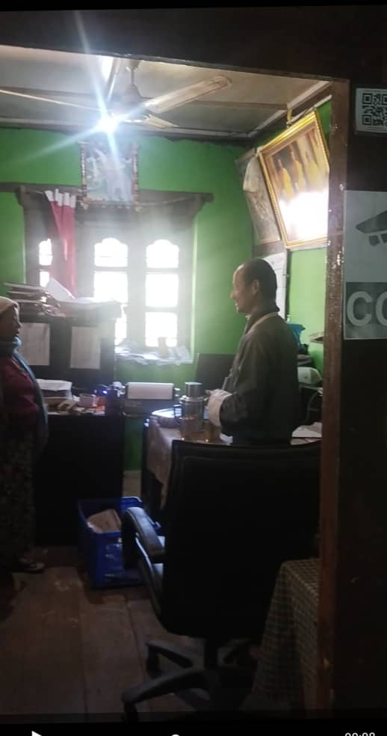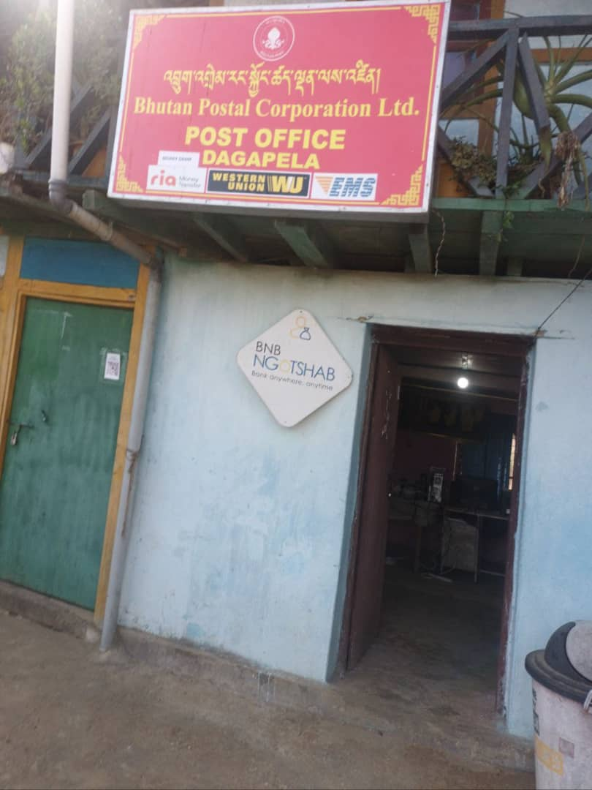

**Name of PO:** Dagana Post office

**Rental:** Own building (9845 sq.ft)

**No. of Employee:** Handled by Postmaster and a messenger ( 2 )

**Location Covered:** 3 Gewogs 1. Tseza

2. Kana

3. Khebisa

**Average Daily revenue Collection (Walk in Customers)** **: Nu. 1884.00**

Revenue collection for the year 2024 **: Nu. 5,59,650.00**

**Observation:**

1. The post office was located in the heart of the town built in the 70’s.The building is in a very bad condition. The roof’s all broken, wall’s all cracked and floor’s sinking.
2. Though the office is run by 2 employees at present, it is observed that with declining of mail volumes and average daily customer, the office can be easily handled by 1 employee.

**Business Opportunity:**

Since the asset is located in the heart of the town surrounded by the Dzong, court and the High school, there’s huge opportunity if we built 2 storied offices cum residential building.

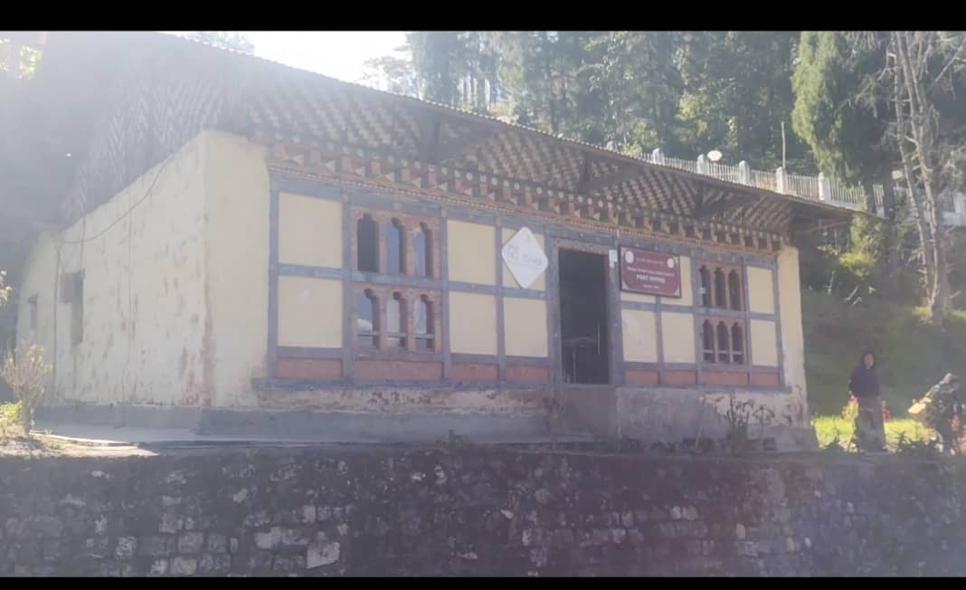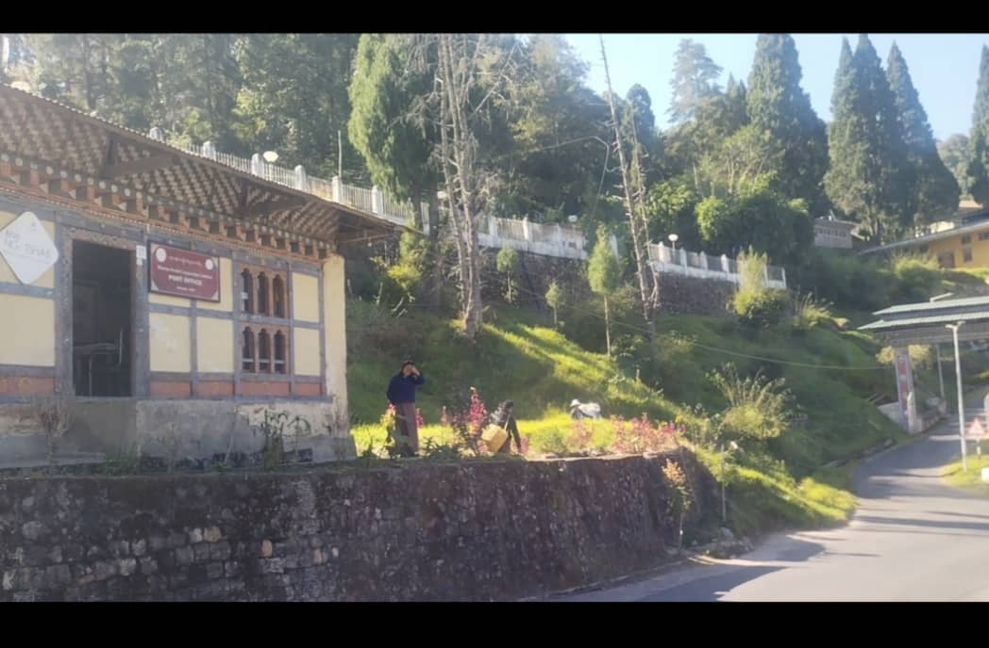

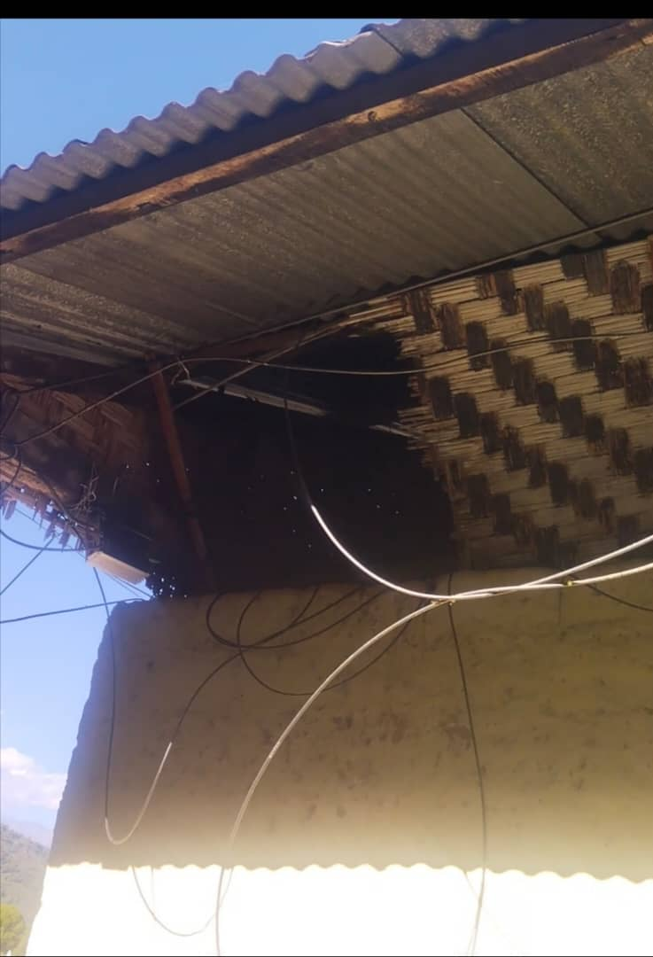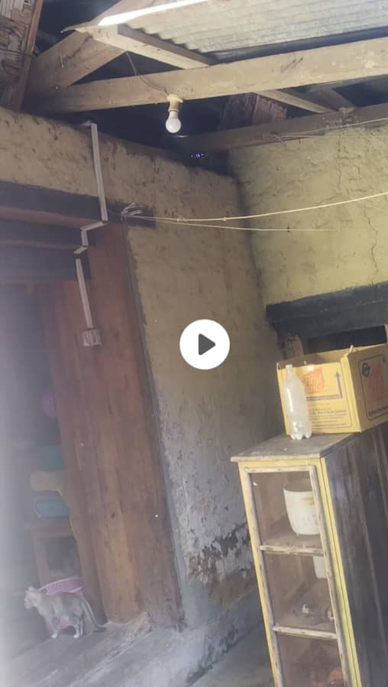

**Name of PO:** Tsirang Post office

**Rental:** Own building ( 22216 Sq.ft)

**No. of Employee:** Handled by Postmaster and 2 messengers ( 3 )

**Location Covered: 12 Gewogs covered:** 1. Goserling 7. Patashaling

2. Semjong 8. Mendrelgang

3. Tsirangtoe 9.Barshong

4. Phuentchu 10.Doonglagang

5. sergithang 11.Rangthaling

6. Tsholingkhar 12.Patashaling

**Average Daily revenue Collection (Walk in Customers)** : **Nu. 12,860.00**

**Revenue collection for the year 2024 : : Nu. 38,14,700.00**

**Observation:**

1. The post office is located in the heart of the town built in the 70’s. Done minor repairing in the year 2023. Need’s to do roof, wall painting and need to repair rake and eaves of the roof
2. Lost many customers of RIA money transaction due to cease of RIA service for the past 3 months. However, if the service resumes, there’s opportunity to generate revenue from the WUMT/RIA transactions.

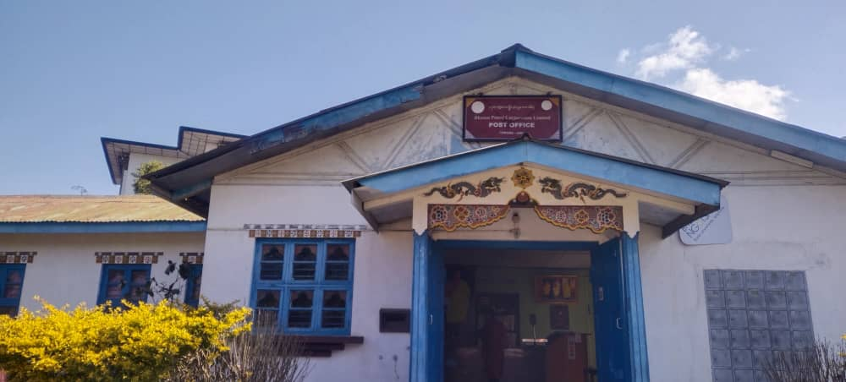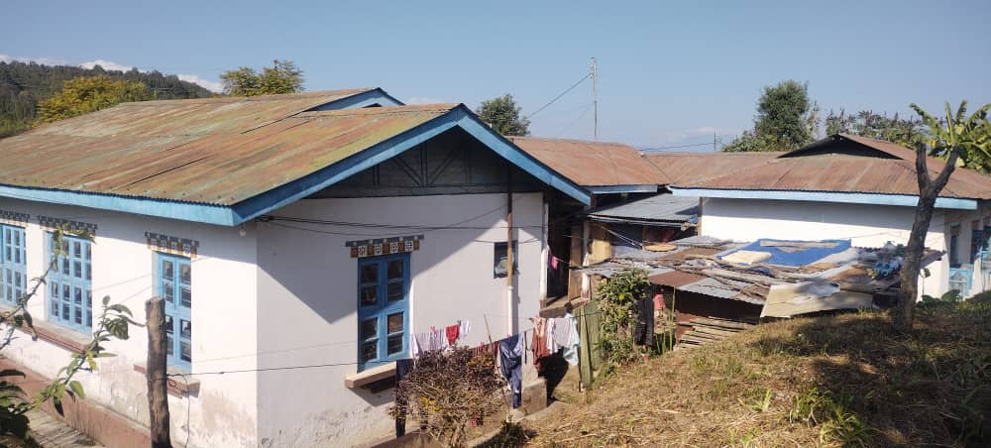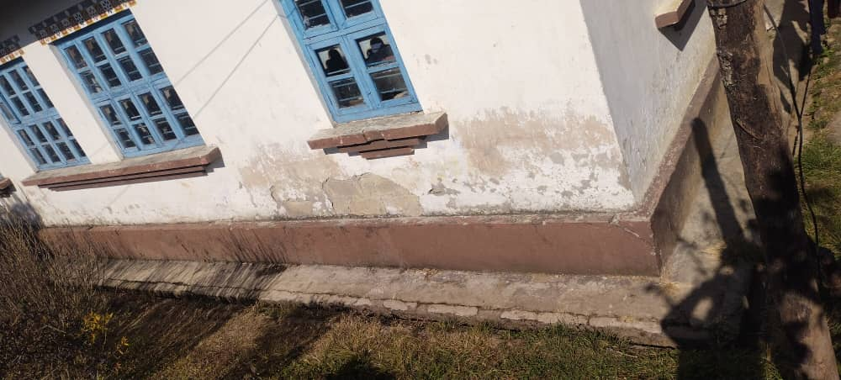

**Business Opportunity:**

Since the asset is located in the heart of the town and with the huge land area, there’s huge opportunity if we built 2 storied 16 units for commercial office space purpose for the offices listed below. Presently they are renting private property.

|  |  |
| --- | --- |
| **Sl No** | **Name of Offices** |
| 1 | BDBl |
| 2 | BNBl |
| 3 | Ricbl |
| 4 | Bafra |
| 5 | Bil |
| 6 | Tashi Cell |

**Name of PO:** Trongsa Post office

**Rental:** Own building (14771 sq.ft)

**No. of Employee:** Handled by Postmaster and a messenger ( 2 )

**Location Covered:** 4 Gewogs Covered : 1. Nubi

2. Tangsibji

3. Langthel

4. Dragten

**Average Daily revenue Collection (Walk in Customers)** : **Nu. 460.00**

**Revenue collection for the year 2024 : : Nu. 135035.00**

**Observation:**

1. The post office located in the slope core town was built in the 70’s. The building is in a very bad condition. The roof’s all broken, wall’s all cracked and with the floor sinking, the building might collapse at any time.

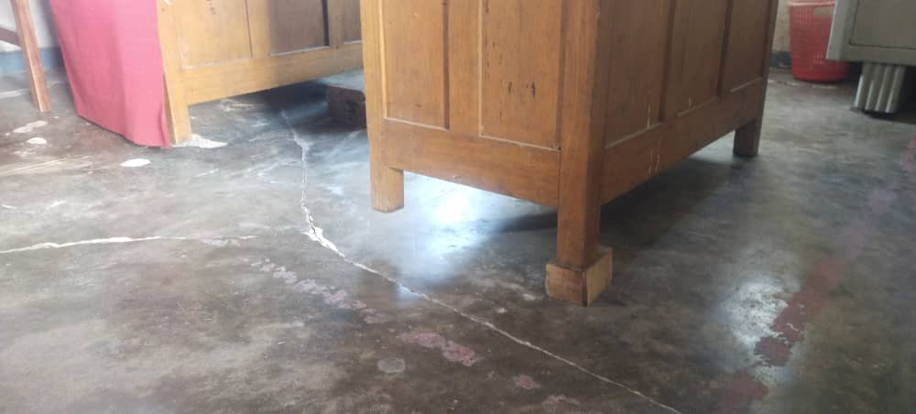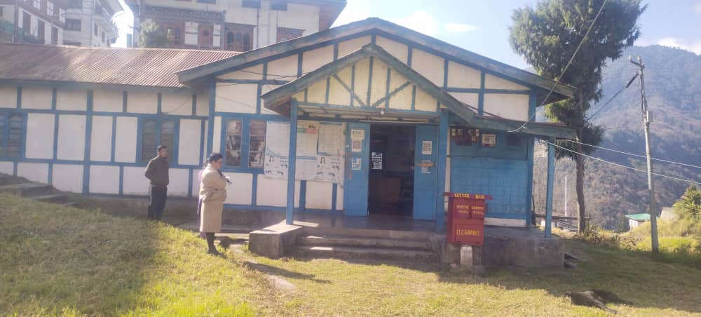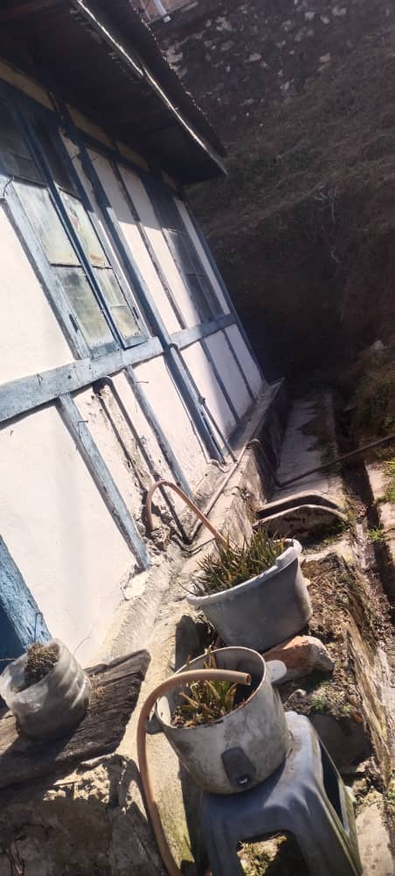

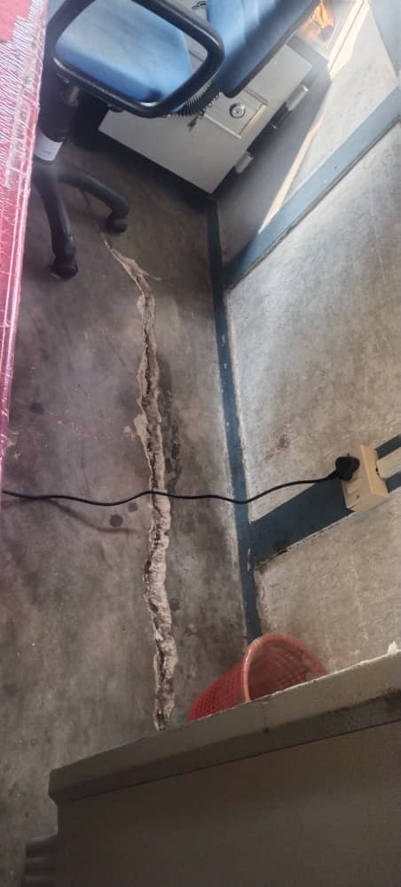

**Business Opportunity:**

1. Construct structure for consolidated service collaborating with other institution like BDBL,BIL and BNBL

**Name of PO:** Zhemgang Post office

**Rental:** Own building (13623 Sq.ft )

**No. of Employee**: Handled by Postmaster and a postal Assistant ( 2 )

**Location Covered:** 5 gewogs : 1. Trong

2. Nangkor

3. Bardo

4. Shingkhar

5. Korphu

**Average Daily revenue Collection (Walk in Customers) : Nu. 300.00**

**Revenue collection for the year 2024 : : Nu. 87240.00**

**Observation:**

1. With the sinking of the floor and need for re-electrification**,** it’s time to repair the building however there is a notification from the Dzongkhag administration that the whole area might be re allocated for the development of the dzong. Therefore, the maintenance of the building may be put on halt for the time being.

**Business Opportunity:**

1. Advised the Postmaster to talk to the manager of Eco –lodge, a tourist hub where the local and foreign tourist comes for rafting and other re-creational purposes to sell our philatelic stamps and products on commission basis.