**Sustainable Supply Chain Performance Dashboard in Power BI**

**Introduction**

This project involves creating a Sustainable Supply Chain Performance Dashboard using Power BI. The main goal is to understand supply chain processes and use data analysis to gain meaningful insights for better decision-making.

**Data Analysis and Supply Chain**

Data analysis is the process of examining, cleaning, and transforming data to uncover useful insights.

In supply chains, data analysis helps:

* Manage inventory efficiently.
* Identify operational bottlenecks.
* Improve supplier performance.
* Increase overall productivity and sustainability.

**Datasets**

Datasets are critical for analysis and can be sourced from:

* Online platforms like Kaggle or GitHub.
* Company systems such as ERP tools.
* Public datasets related to supply chains.

For this project, we used a CSV file.

Common formats include CSV, Excel, JSON, or SQL exports.

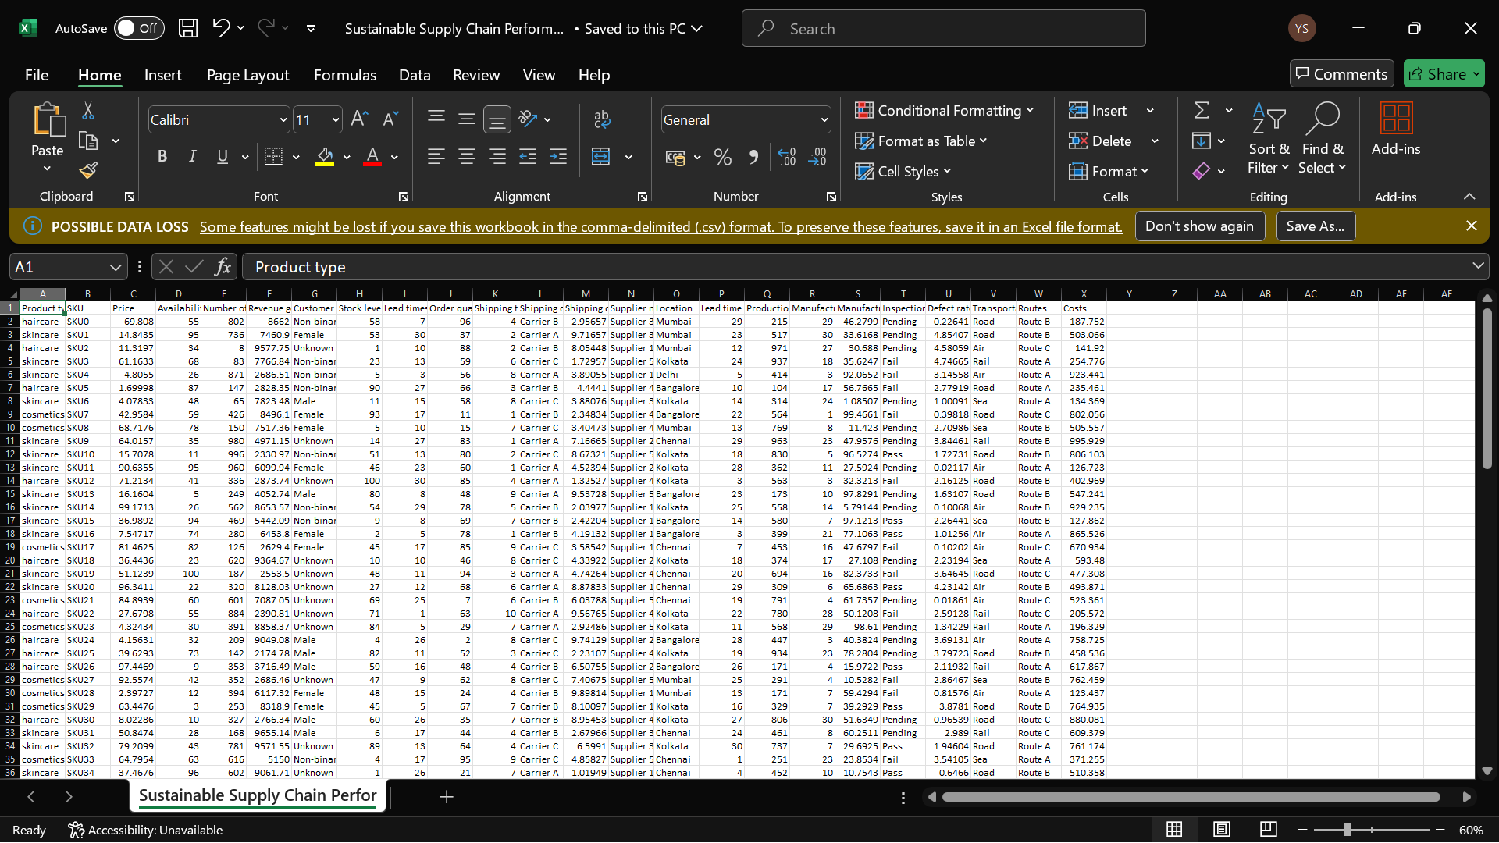

**Process**

**Analysis Tool:** Power BI is used in this project because it is:

* Easy to use for both beginners and professionals.
* Capable of handling various data types.
* 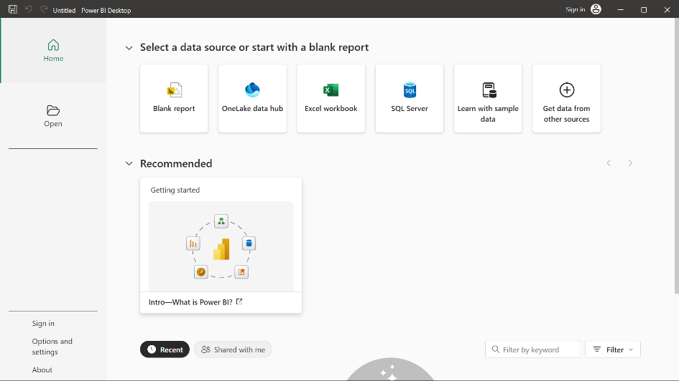Great for creating interactive dashboards.

**Steps in Power BI**

Getting Started:

1. Download Power BI Desktop from the official website.
2. Launch Power BI and use the Get Started menu.

Importing Data:

1. Go to the Home tab and click Get Data.
2. Select the CSV file and load the dataset into Power BI.
3. Ensure the dataset is ready and saved locally.

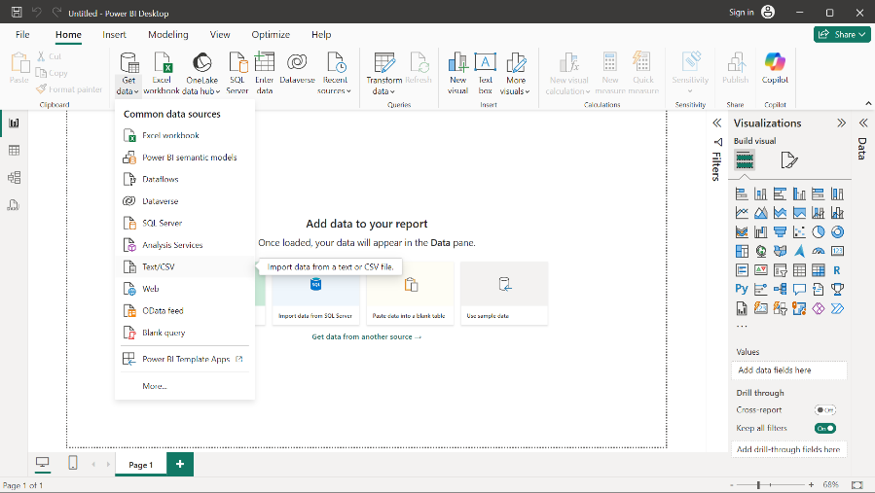

In the Power BI Desktop it consists of 3 view:

**> Report View:** Design and visualize your data through interactive charts, graphs, and visuals.

**> Data (Table) View:** Inspect and manage the underlying data tables used in your reports.

**> Model View:** Define and explore the relationships between your data tables.

**ETL Process (Extract, Transform, Load)**

Steps

1. **Extract:** Import the dataset (e.g., CSV file).
2. **Transform:** Clean and prepare the data for analysis. i.e Removes duplicates, handles null values, renaming columns, etc.
3. **Load:** Load the cleaned data into Power BI for visualization.

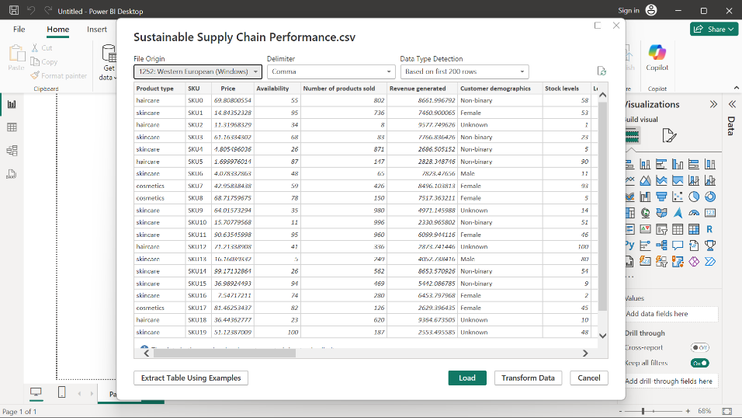

**Table Formation**

Working with Tables:

1. View the imported dataset as a table.
2. Check column quality (valid, empty, or errors).
3. Create or duplicate tables to organize data logically.

Tables Created for This Project:

1. Inventory Table
2. Supply Chain Table
3. Manufacturing Table
4. Supplier Table

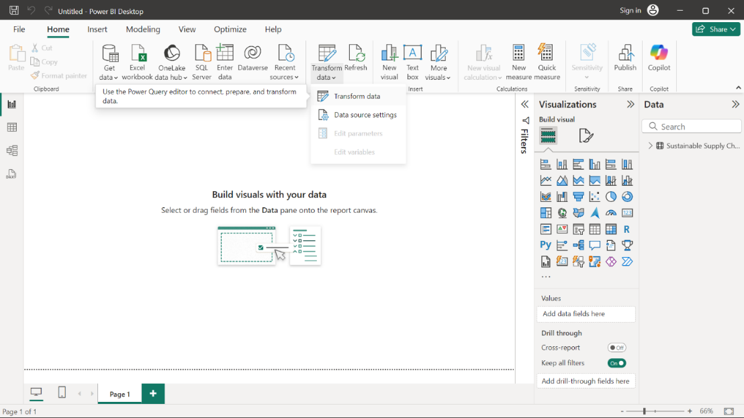

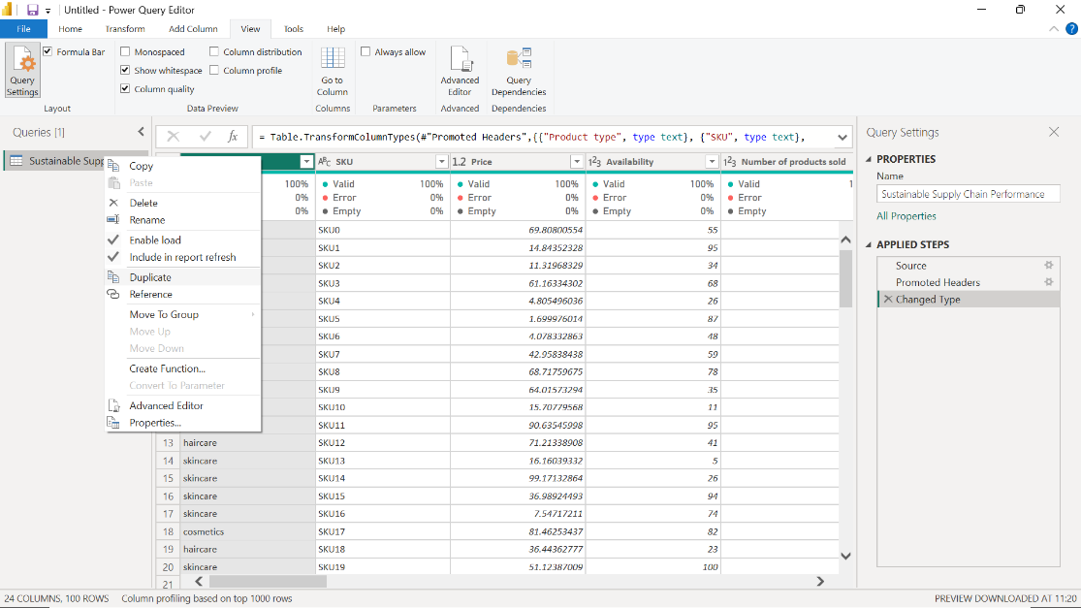

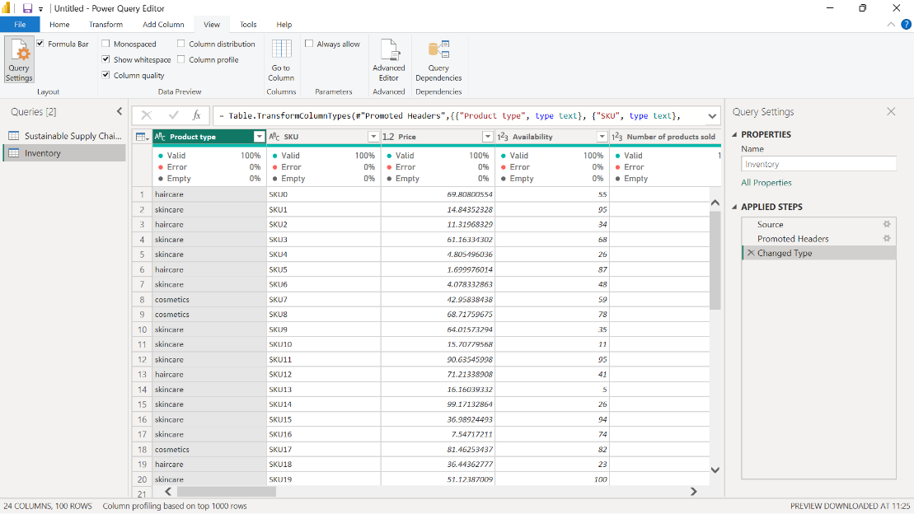

**Conclusion**

By following these steps, we analyze the sustainable supply chain's performance.

This ensures:

* Clean and accurate data for analysis.
* Meaningful insights for decision-making.
* Clear and interactive reporting.