D:\projects\wu\apn\ws_apn\wudigital\eai_integration\truck\APN-Test

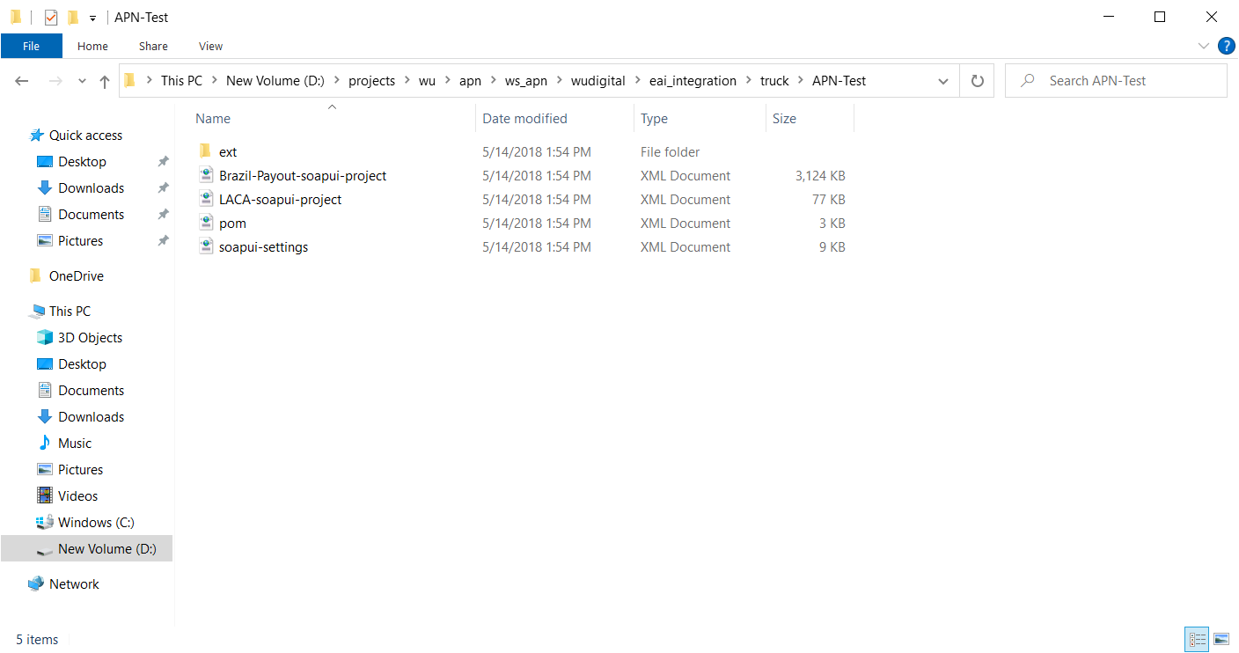

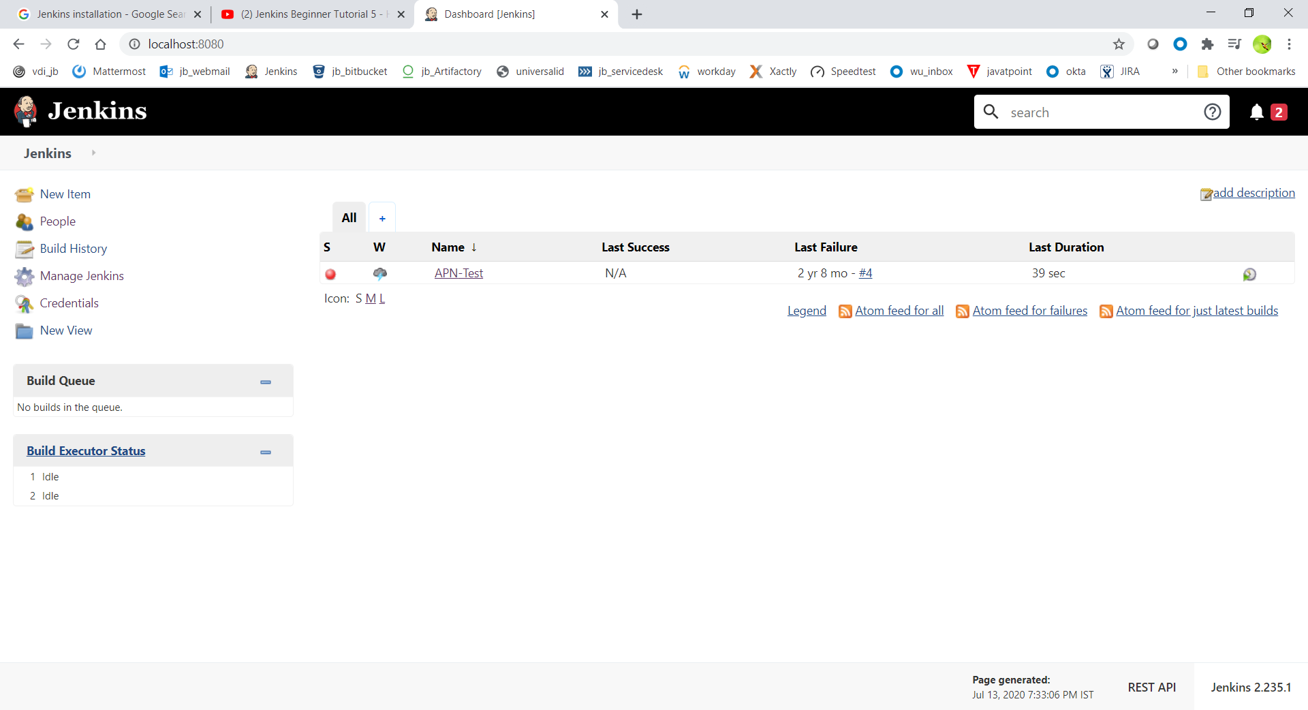

[apn](http://localhost:8080/job/APN-Test/ws/apn)/[ws_p4v](http://localhost:8080/job/APN-Test/ws/apn/ws_p4v)/[wudigital](http://localhost:8080/job/APN-Test/ws/apn/ws_p4v/wudigital)/[eai_integration](http://localhost:8080/job/APN-Test/ws/apn/ws_p4v/wudigital/eai_integration)/[truck](http://localhost:8080/job/APN-Test/ws/apn/ws_p4v/wudigital/eai_integration/truck)/[APN-Test](http://localhost:8080/job/APN-Test/ws/apn/ws_p4v/wudigital/eai_integration/truck/APN-Test)

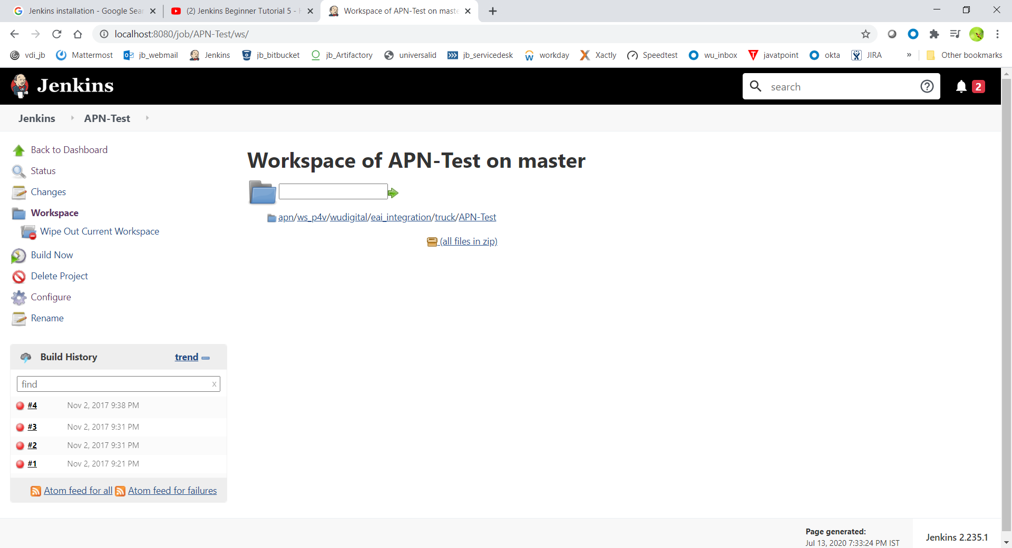

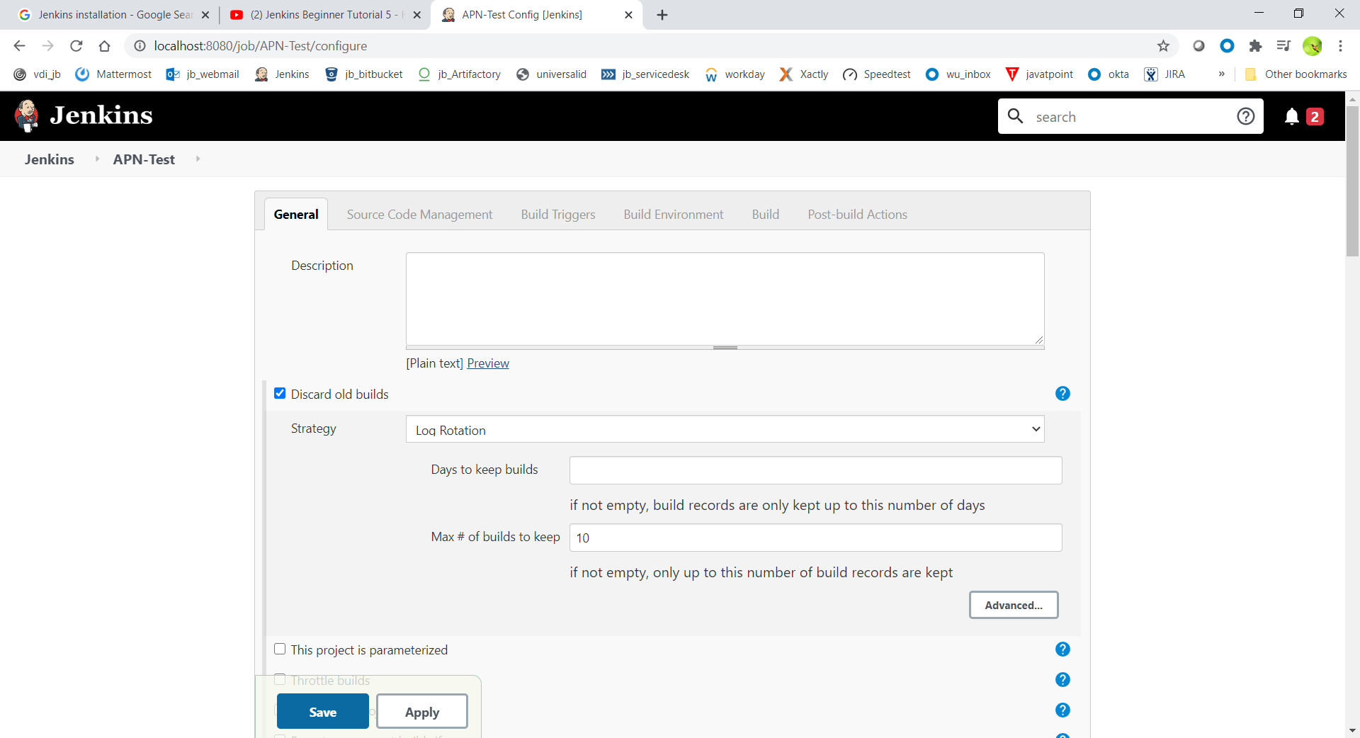

ssl:perforce1.wuintranet.net:1667

View Map:

//depot/wudigital/eai_integration/truck/APN-Test/... //projects/apn/ws_p4v/wudigital/eai_integration/truck/APN-Test/...

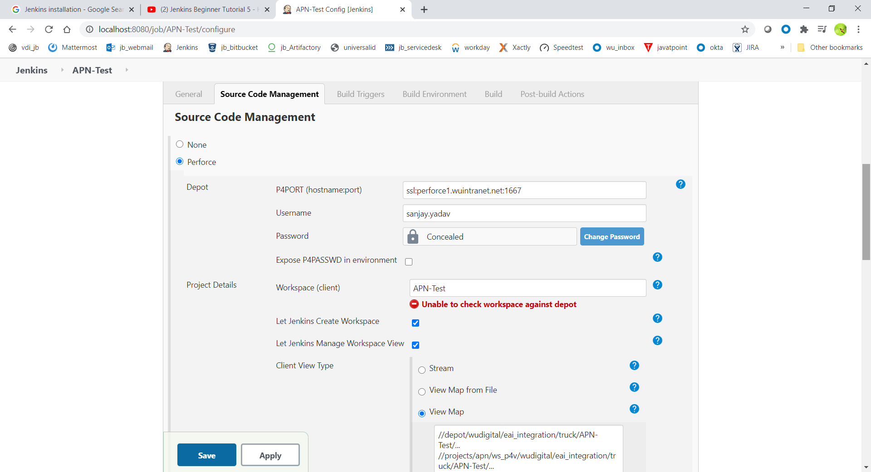

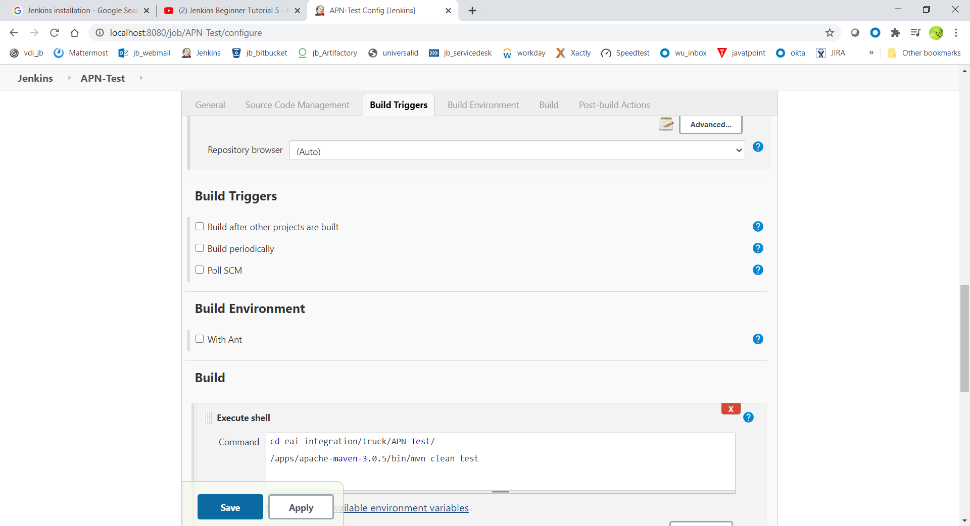

cd eai_integration/truck/APN-Test/

/apps/apache-maven-3.0.5/bin/mvn clean test

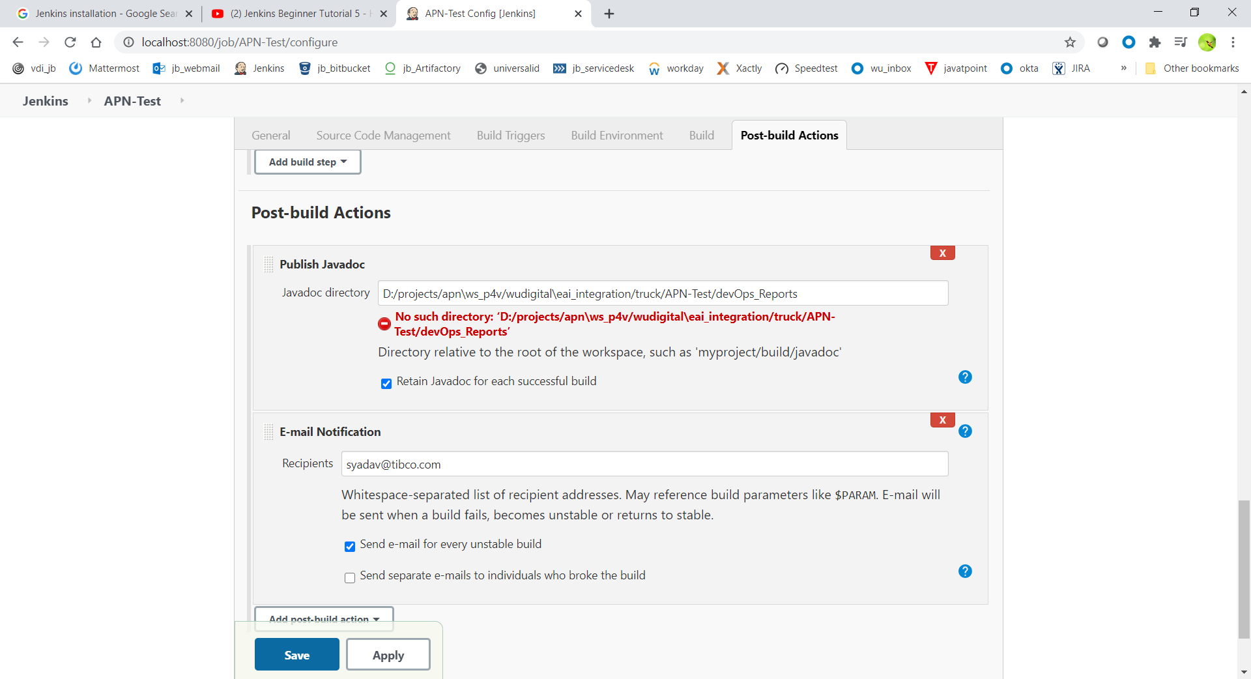

D:/projects/apn\ws_p4v/wudigital\eai_integration/truck/APN-Test/devOps_Reports

