Objective: A software that helps students to solve maths problems, especially geometry.

* Prove that the triangle is existed or not.
* Is it a special triangle? (equilateral triangle, isosceles triangle or right-angled triangle)
* Calculate the hypotenuse of the right-angled triangle.
* Calculate the perimeter and the area of the triangle.

User stories:

* As a student, I want to solve the problems so that I know whether I am doing right or wrong.

UML Class Diagram:

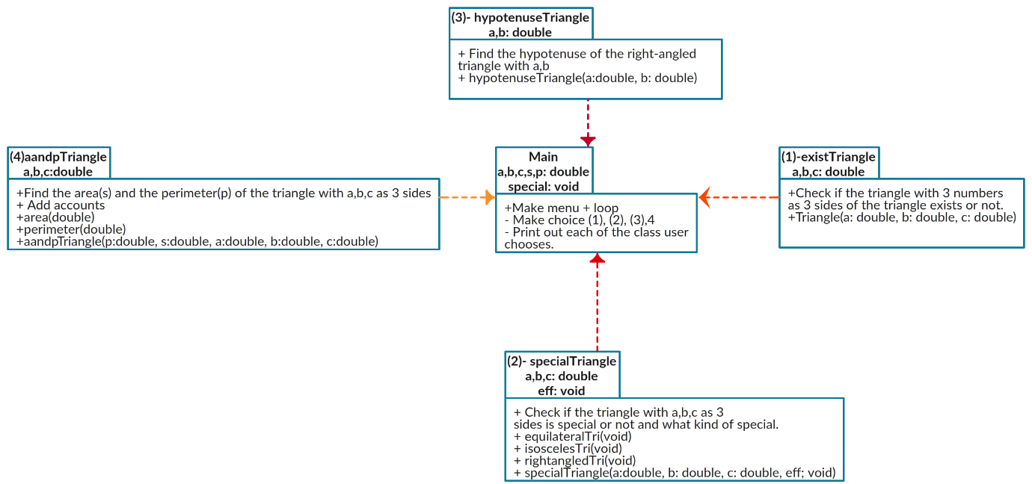

Coded Prototype (Pseudocode):

ExistTriangle()- void: (1)

Input: a,b,c

IF a+b>c AND b+c>a AND c+a>b THEN  
 RETURN TRUE

ELSE

RETURN FALSE

ENDIF

Specil Triangle()-void: (2)

Input: a,b,c

IF a=b and b=c THEN

PRINT equilateral triangle

ELIF a=b OR b=c OR c=a THEN

PRINT isosceles triangle

ELSE  
 PRINT scalene triangle

ENDIF

IF pow(a,2) +pow(b,2) =pow(c,2) OR pow(a,2) +pow(b,2) =pow(c,2) OR

pow(a,2) +pow(b,2) =pow(c,2) THEN

PRINT righted-angled triangle

ENDIF

hypotenuseTringle()-float: (3)

INPUT: a,b

c=(float) sqrt(pow(a, 2) +pow(b, 2));

aandpTriangle()-double: (4)

INPUT: a,b,c

P=(a+b+c)/2 \*\*Perimeter\*\*

S=(float).sqrt(S\*(S-a)\*(S-b)\*(S-c));

PRINT P,S

GitHub Repository: