|  |
| --- |
| **MEC E 451** |

Lab 1: Damped Free SDOF Vibrations

**Instructions:**

* **Submissions must be typed.**
* Prepare and submit your answers to the assessment questions as a single PDF file through eClass.
* Include your data with your submission.
* Required plots can be made with any software of your choice (MATLAB, Excel, Mathematica, etc.).
* While you can discuss the problems with classmates, all submitted work must be your own to conform to academic integrity guidelines.
* **Late submissions will not be accepted.**

# Preface

The objective of this lab is to measure the natural frequency of a simple apparatus consisting of a platform supported by four springs. The natural frequency is a fundamental characteristic of any mechanical system and describes the frequency at which any system tends to oscillate freely when given an initial excitation (displacement or velocity).

**For this lab, you will be recording data using the built-in accelerometer on your phone. Before coming to the lab, please download the PhyPhox application on your phone. It is available for free and compatible with Android and iOS phones.**



# Instructions

1. Place your phone at the centre of the platform and open the PhyPhox app. Select the “Acceleration (without g)” option. When ready, initiate data collection by pressing Start.

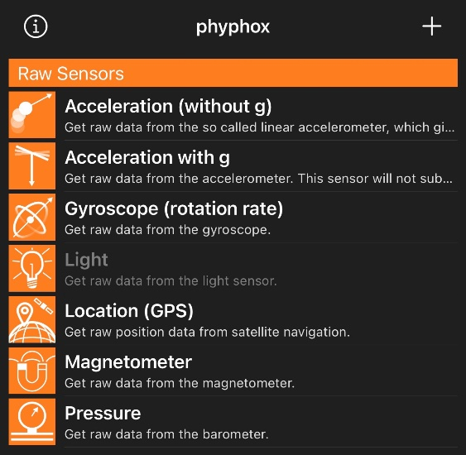 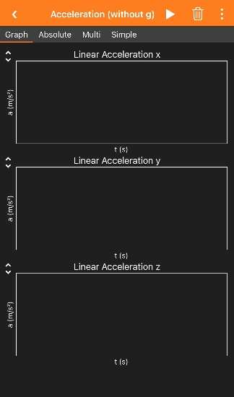

1. While data is being recorded, apply an initial displacement (on the order of a few centimetres) to the platform by pressing down on the centre of the platform. The measured acceleration in the – direction should approximately follow the free vibration of an underdamped system.

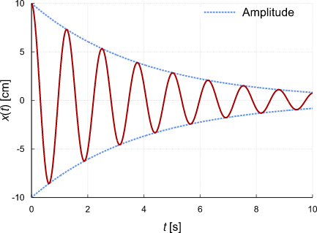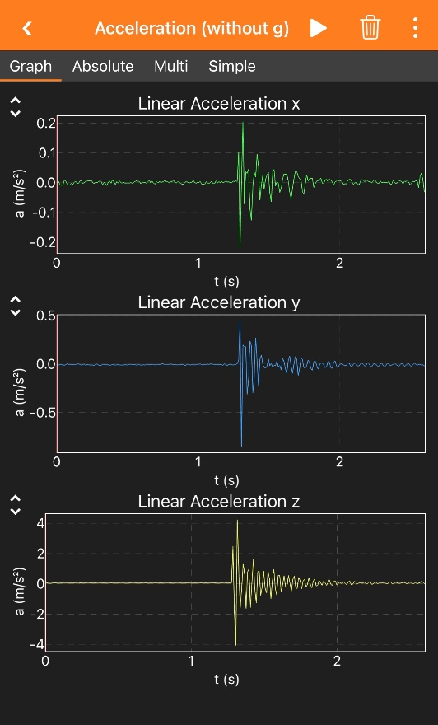

**SIDE NOTE:** Rocking of the platform can occur if the platform is not pressed down at its centre or if the springs are uneven. This will affect the recorded vertical acceleration data.

To re-do data collection, clear the data by pressing the delete button (trash bin at top right corner of screen). Before re-initiating data collection, make sure that the springs are properly seated and at the same height, and that the platform is being pressed at its centre.

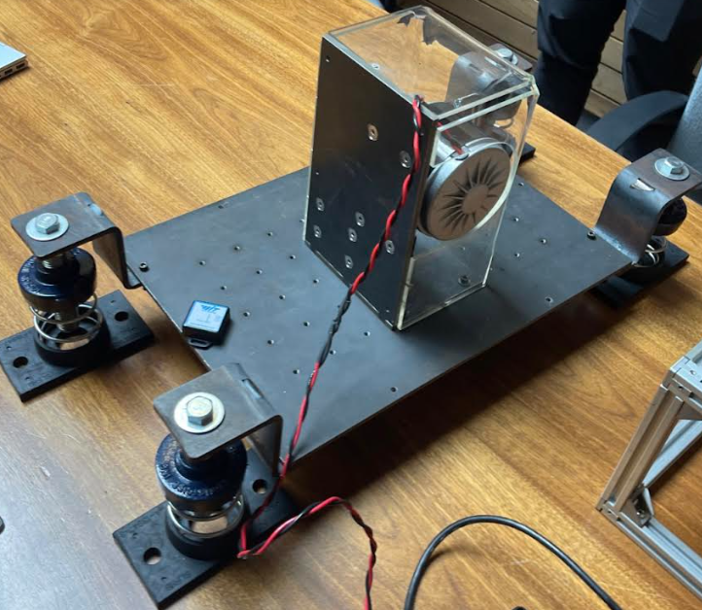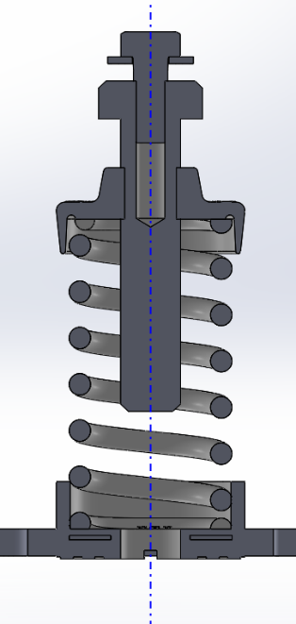

Spring height can be adjusted by turning the bolt shown on the left.

Springs should be aligned such that they remain approximately vertical and perpendicular to the rubber base plate.

1. You can export the data as an Excel file by selecting the three dots at the top right corner of the screen and selecting “Export Data” on the menu, which will allow you to email the data to yourself.

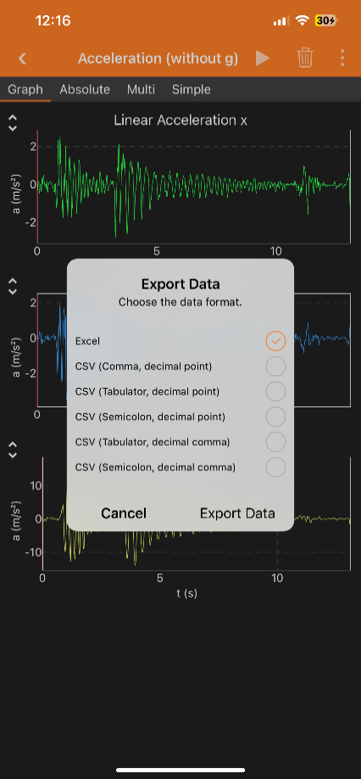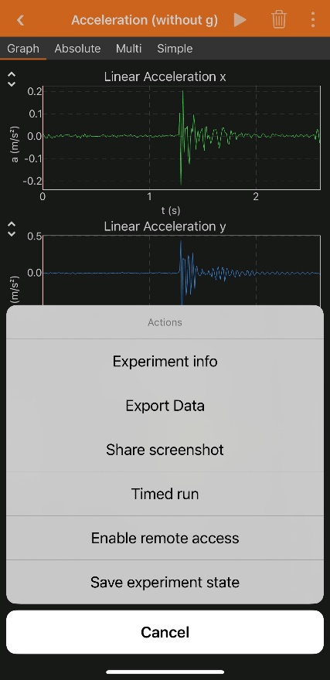

1. Use the recorded time and linear acceleration in the – direction to answer the assessment questions (located in the Assignment section on eClass).