TECHNICAL DESIGN DOCUMENT (TDD) - LUMEN
Team Name: Apex
Members: Yasar Pathan (College ID: D24IT181)
College: Charusat University

Deployments –
1) Live Website – Cick here for live app
2) Demo Video – Click here for demo video

1. Cover Page
- System Title: Lumen AI Observability & Governance Command Center
- Version: 1.0.0
- Date: July 2, 2026
- Abstract: Real-time semantic tracing, deterministic groundedness analysis, and comparative prompt playground loops for high-reliability conversational agents.
- Tech Stack: Laravel API Service Layer, Vite + React SPA, PostgreSQL/Supabase DB.

2. Problem Statement
Generative AI pipelines, specifically Retrieval-Augmented Generation (RAG) models, suffer from a critical lack of operational trust when deployed in enterprise spaces:
- Semantic Silent Failures: Traditional Application Performance Monitoring (APM) tools track systems hardware utilization (CPU, memory, response time) but cannot identify semantic hallucinations, factual contradictions, or safety policy violations.
- Evaluating Latency & Cost: Relying on large models (LLM-as-a-Judge) to audit production outputs introduces unacceptable latency overhead (often >5 seconds) and high recurring API costs.
- Ungoverned Prompt Engineering: Prompt engineers lack a developer environment to test system instruction changes against historical traces, leading to regression risks.
- Vector Omissions (Knowledge Gaps): RAG databases silently fail when missing context is requested. Developers have no centralized interface to aggregate search failures and insert missing ground-truth data into vector stores.
Without runtime observability, enterprises cannot audit Conversational AI pipelines at scale.

3. Proposed Solution
Lumen AI is an AI Observability and Governance Platform built for Retrieval-Augmented Generation (RAG) systems. Instead of simply displaying conversations or logging errors, it continuously analyzes every AI interaction to determine why a response was generated, whether it is trustworthy, and how it can be improved.
Think of Lumen AI as a mission control center for enterprise AI assistants. Every user query is traced from retrieval to response generation, evaluated using a deterministic diagnostics engine, and transformed into actionable insights that help engineers improve AI quality with confidence.
+----------------------+
| User Query |
+----------+-----------+
|
v
+---------------------------+
| Retrieval Service |
| (Relevant Knowledge) |
+------------+--------------+
|
v
+---------------------------+
| LLM Generation |
+------------+--------------+
|
v
+---------------------------+
| Diagnostics Engine |
| • Groundedness |
| • Root Cause Analysis |
| • Knowledge Gap Detection |
| • Safety Evaluation |
+------------+--------------+
|
+-----------------+-----------------+
| |
v v
+----------------------+ +----------------------+
| Conversation Doctor | | AI Health Dashboard |
| Flag & Diagnose | | Metrics & Analytics |
+----------+-----------+ +----------+-----------+
| |
+-----------------+-----------------+
|
v
+---------------------------+
| Knowledge Improvement |
| Replay & Validation |
+---------------------------+

Core Capabilities

1. Real-Time AI Guardrails
Every AI response is evaluated immediately using lightweight, deterministic algorithms. Lumen measures groundedness, retrieval quality, and safety without relying on a second LLM, enabling fast and cost-effective quality assurance.

2. Intelligent Root Cause Analysis
When an AI response is incorrect, Lumen identifies the most likely cause instead of simply flagging an error. Responses are automatically classified into categories such as Knowledge Gap, Hallucination, Safety Violation, Prompt Issue, or Healthy, allowing engineers to focus on solving the underlying problem.

3. Closed-Loop Knowledge Improvement
Detecting an issue is only the first step. Lumen enables developers to add or update missing knowledge directly from the platform, eliminating knowledge gaps and continuously improving future responses through an integrated feedback loop.

4. Comparative Replay & Prompt Validation
Before deploying prompt changes, engineers can replay historical conversations using different prompt versions and compare results side by side. This allows teams to validate improvements, prevent regressions, and confidently release updates without affecting production users.

4. System Workflow
The workflow enforces diagnostic evaluations and correction loops:
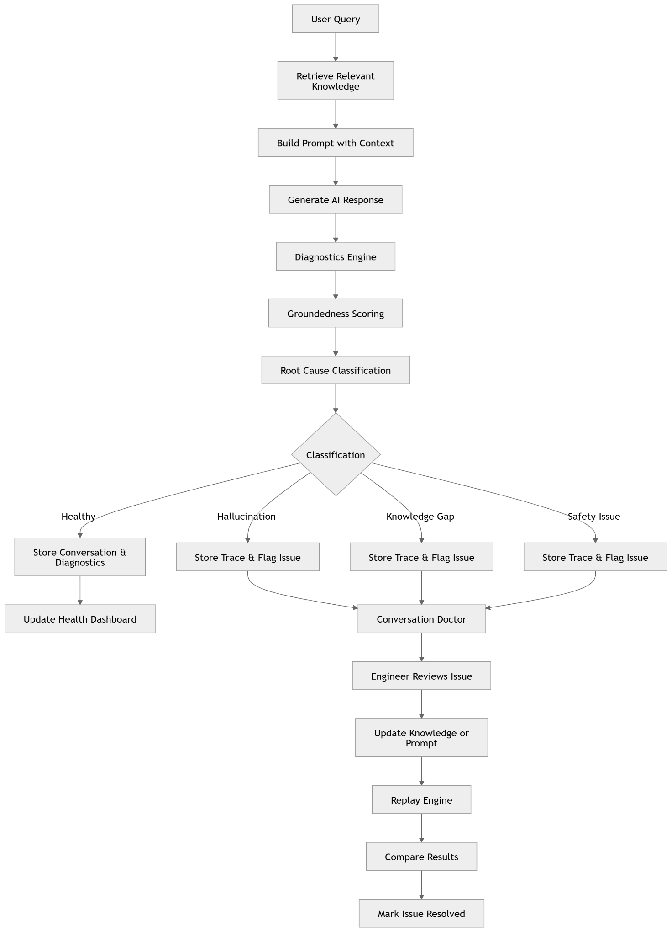

5. High-Level Architecture
The architecture uses a decoupled model: React handles user interactions and layout rendering, while Laravel acts as the stateless engine managing data flow, model completions, and diagnostics.
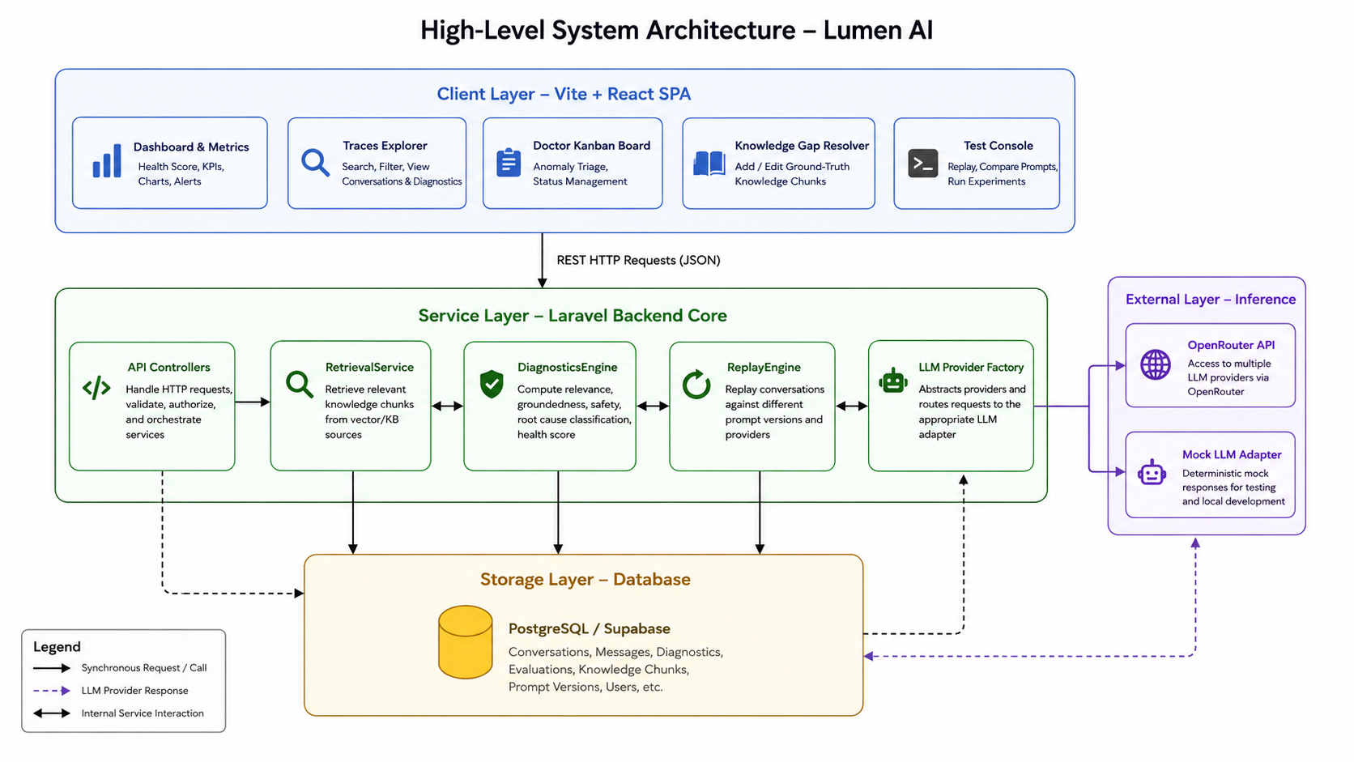

6. Component Architecture
Lumen AI isolates data persistence, orchestrators, and third-party wrappers through dependency-injected interfaces:
- RetrievalService: Decouples context fetch logic, query keyword parsing, and similarity scoring.
- DiagnosticsEngine: Parses response-to-context semantic overlap. It remains independent of any database drivers.
- LLMProviderInterface: Abstracts model APIs. Allows switching providers (e.g., local mock to OpenRouter cloud APIs) without altering core workflows.

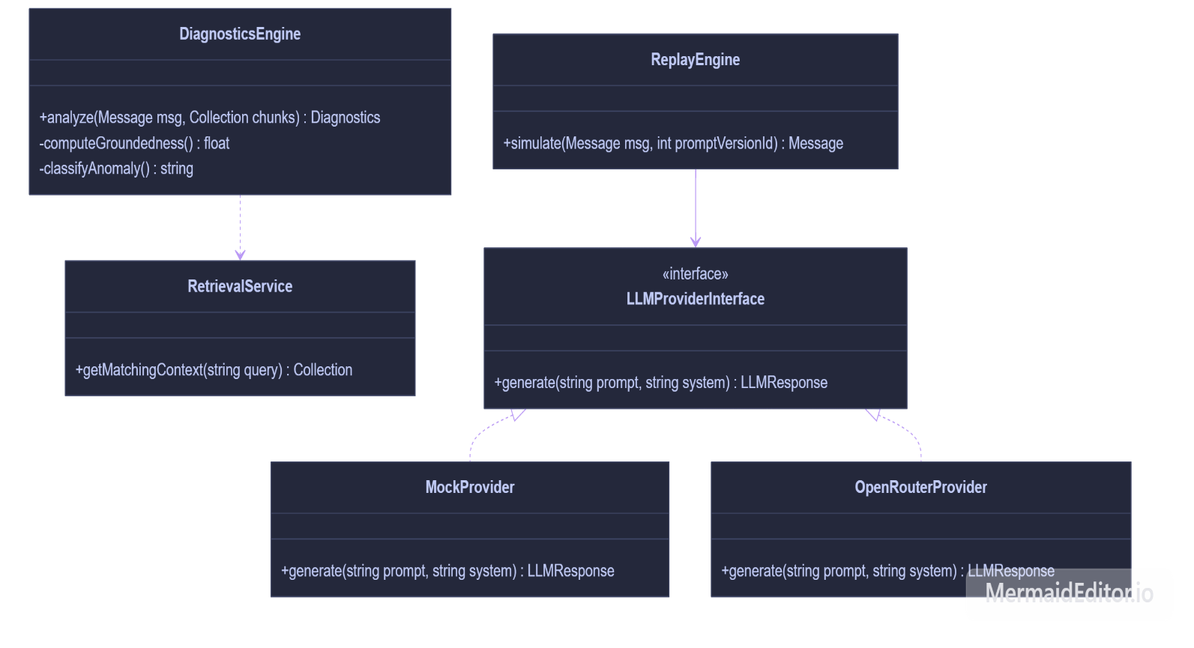

7. Request Flow
When running queries in the Test Console, requests travel through the following pipeline:
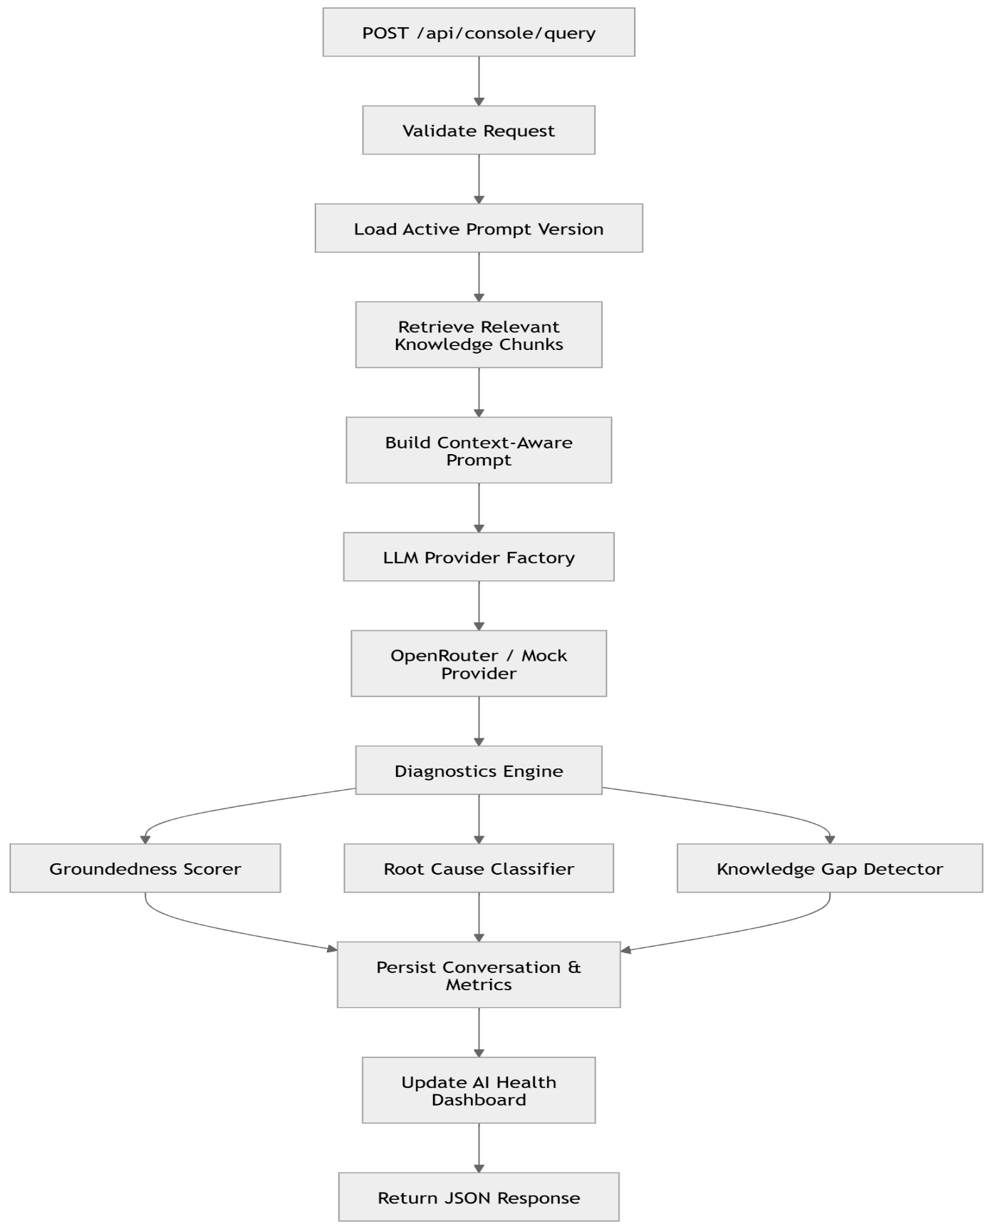ve
- Ingest: React sends query parameters to /api/console/query.
- Extraction: The server reads the designated prompt_version and fetches matching knowledge_chunks.
- Inference: The payload compiles and routes to the selected LLM provider.
- Audit: The returned output runs through word-overlap groundedness checks.
- Persistence: Diagnostic scores, prompt associations, and trace content write to the DB.
- Response: Staged measurements return to the front-end dynamically.

8. Sequence Diagram
This sequence diagram illustrates the live execution trace cycle:
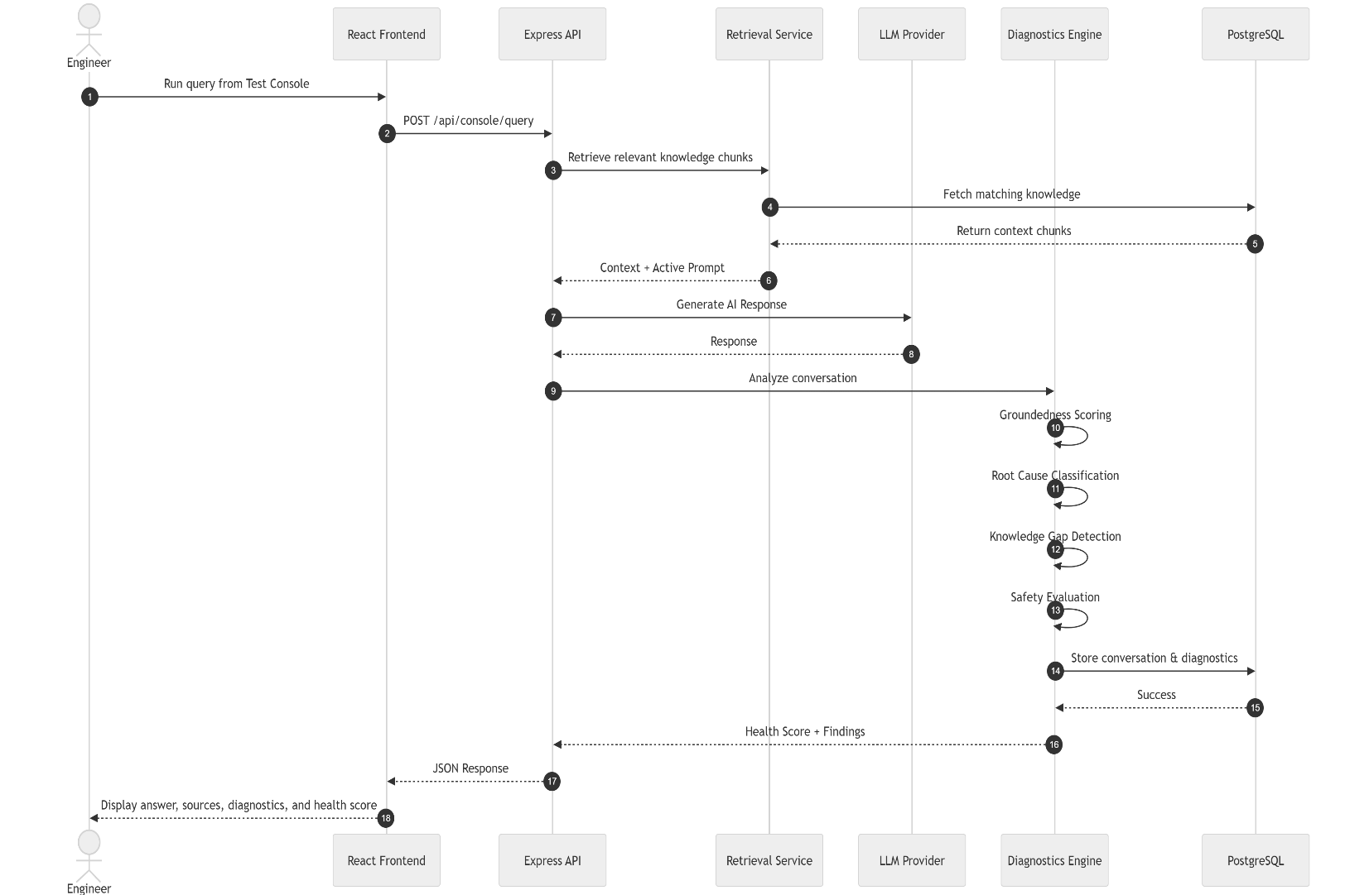

9. Key Design Decisions

1. PHP/Laravel Service Container Pattern
- Decision: Decouple controllers from core RAG processes using a Service Layer.
- Why: By encapsulating logic in RetrievalService and DiagnosticsEngine, code can be tested in isolation and reused across console endpoints, Livewire views, and Artisan CLI commands.

2. Overlap Similarity vs. LLM-as-a-Judge
- Decision: Run deterministic, token-overlap similarity scoring.
- Why: Real-time production RAG guardrails cannot support the latency (often >5s) or API costs of calling an external LLM to evaluate another LLM. Token-overlap is sub-millisecond, deterministic, and cost-free.

3. Trace Replay Modals
- Decision: Implement side-by-side comparative simulation outputs.
- Why: System prompt updates carry high regression risks. Visualizing a trace side-by-side using two system prompts lets developers catch regression errors before committing prompt revisions to production.

4. Kanban Anomaly Grouping
- Decision: Map diagnostic results (root_cause) to Kanban lanes.
- Why: Conversational data is messy. Placing anomalies on a board lets developers track issues through clear stages (To Review ➔ Investigating ➔ Fixed) rather than scrolling through endless plain logs.

10. Assumptions & Trade-offs
- Keyword Vector Search Simulation:
  - Trade-off: We query matching documents using DB index matches rather than a full pgvector cosine similarity setup.
  - Assumption: In a hackathon context, this is sufficient to simulate a vector database's behavior and allows the platform to be fully portable without external database extensions.
- Token-Overlap Groundedness Limit:
  - Trade-off: Token overlap handles direct factual contradictions well, but may struggle with abstract semantic formatting.
  - Assumption: The sub-millisecond execution time and zero cost outweigh the accuracy variance of LLM-as-a-judge evaluators.

10. AI Used
- Anti-Gravity IDE – for faster development.
- Claude – mostly for documentation.
- Chatgpt – mostly for documentation.

