Plant Check DX

# Digital platform for operator rounds, log sheets and maintenance forms

Plant Check DX system is a software developed by XPSOES LLC to replace paper forms used commonly in industrial facilities for equipment checklists, operator rounds, and maintenance forms. Systematic and complete implementation of checklists by Plant Check DX system increases operational and technical reliability. In addition to quick access to checklist records within organization, Plant Check DX system also offers optional integration tools to ERP systems (SAP PM, Maximo etc.)

Description

Plant Check DX consists of two main components: Web Application and Android Mobile App. The web application is used to create and customize plant specific checklists. Powerful view, graphic and reporting tools are also available.

Preparation of checklists for many different purposes is possible in the Plant Check DX. Matrix view is especially useful to get actual status information of all the planned and completed checklists in an industrial facility.

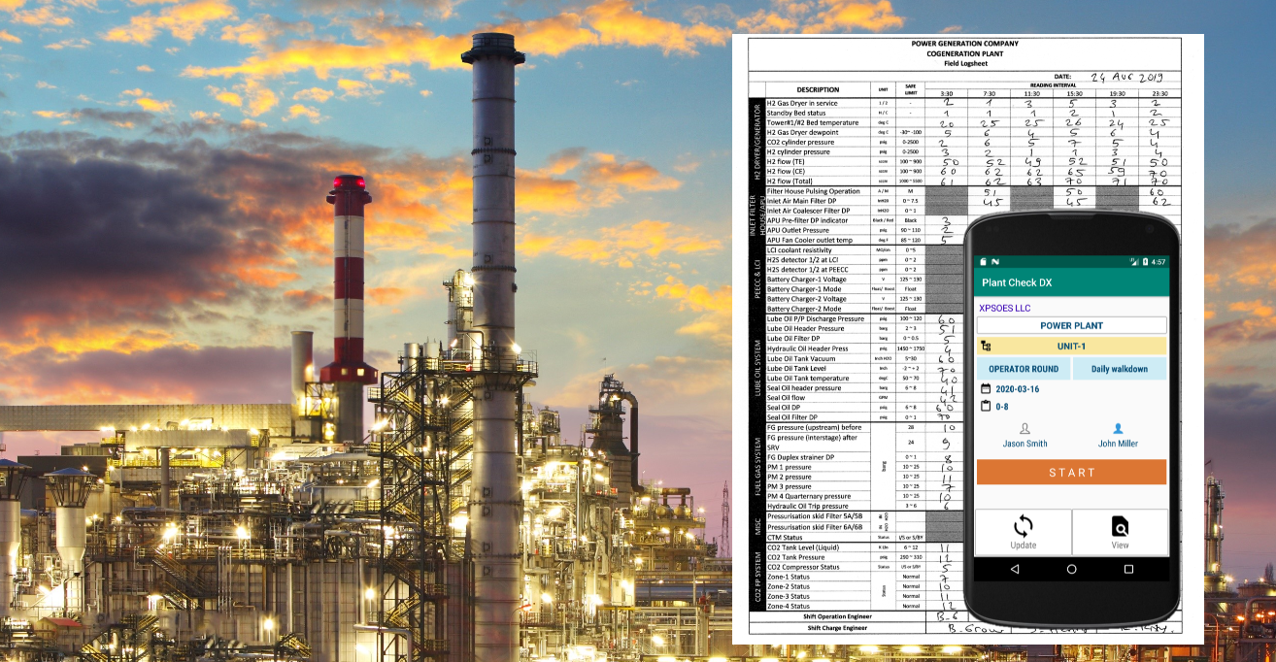

Android mobile app for Plant Check DX is used to complete checklists defined in the web application. Moreover, image capturing, sound and video recording options are available. Plant wide wireless network connection is not required. Data transfer between the server and mobile devices occurs only if data sync is required.

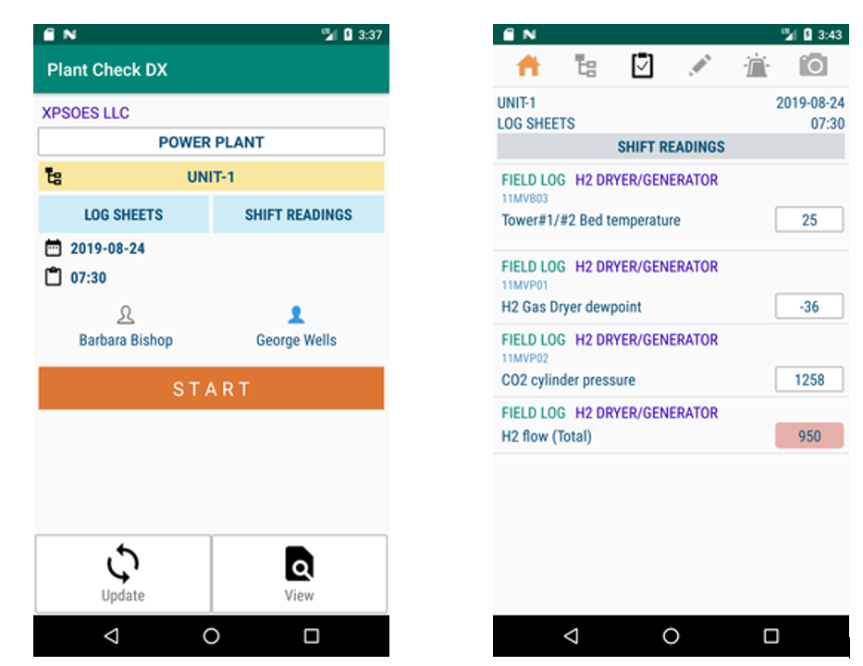

Checklist route optimization and condition based dynamic listing are two unique features of Plant Check DX. Round optimization creates the most efficient walking route for the personnel. Questions are updated automatically depending on the running condition of the equipment or plant unit.

NFC (Near Field Communication) tags can be used to ensure that personnel take the readings or perform the checks in the plant area or equipment (proof of presence) and quick navigation to the equipment in the mobile application.

By specifying the acceptable limits for the numerical readings (temperature, pressure etc), an automatic alarm record is created upon entering an abnormal value for the reading point by the personnel.

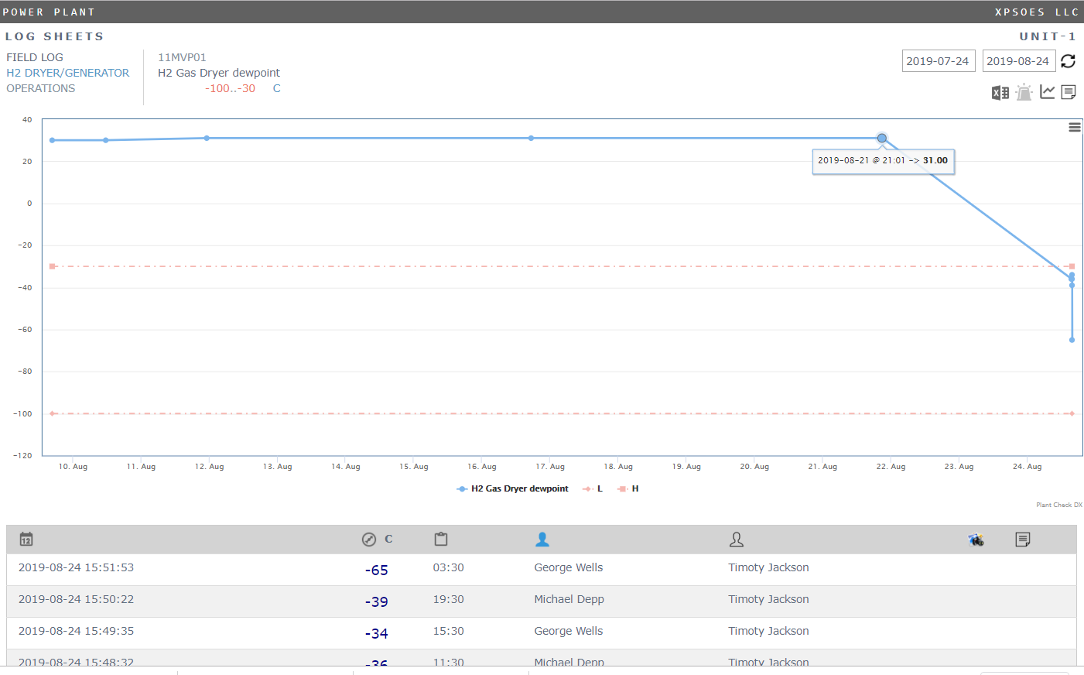

Checklist records can be viewed both in a tabular form and chart display.

Quick overview feature gives summary of planned and completed checklists in the plant. Number of checkpoints, abnormal conditions and new findings are shown in checklist summary metrics.

