Digital transformation

Plant DX

Operator Rounds

Log sheets

Checklists

Inspections



Regular inspection of plant areas and equipment plays an important role in achieving high standards for technical availability and safety. Many operators however still use paper checklists on clipboards to perform these crucial tasks. Once back in the control room, the recordings on the paper forms are usually entered again in an excel file creating double work.

 

Using paper forms for field operator rounds and routine inspection tasks are inefficient and creates problems such as:

* Ineligible and inconsistent records
* Lack of visibility of plant inspection activities
* Data anomaly detection is difficult
* Trends and observations from previous rounds are not available to field operators
* Providing additional information about observations (e.g. picture or video) is not possible
* The perception of poor information sharing process among operators decreases motivation
* No dynamic guidance about safe limits of operation
* Accessing historical records even from excel files for data analysis purposes is not practical

Plant DX digital platform is fully optimized for operator rounds, maintenance inspections and checklists in power plants, cement factories, petrochemical facilities, and similar industrial plants. Plant DX includes many useful and unique features to manage plant-wide inspection activities and solve the problems with paper forms.

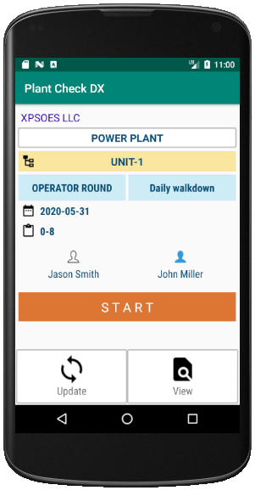

Android Mobile Application

* Complete structure of operator rounds and checklists in one App
* Image, video, sound recording and freehand drawing
* Checklist based authorization of field operators and staff
* Data transfer over wireless network or USB cable
* Near Field Communication (NFC) support for checkpoint identification
* Plant / equipment status based dynamic listing
* Route optimization independent from hierarchical structure
* E-mail notifications
* SAP & Maximo integration

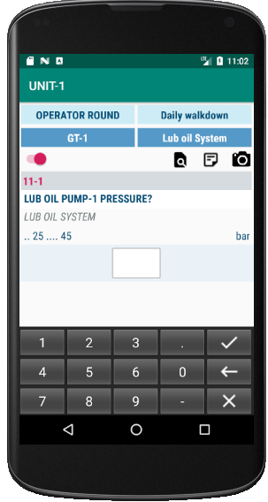

Android Mobile Application

* A wide range of input options (numerical values, Yes/No, No/Yes, Check, Single or multiple selections from a list)
* Automatic alarm display for numerical entries if an alarm value is entered
* Range configuration for numeric entries
* Unconditional note creation
* Picture taking requirement for individual or random checkpoints
* View and plot past values for a checkpoint
* Automatic notification of a previous alarm record (optional)
* Image, video, sound recording and freehand drawing

Plant DX - Planned / Actual master view with summary data about completed checklists

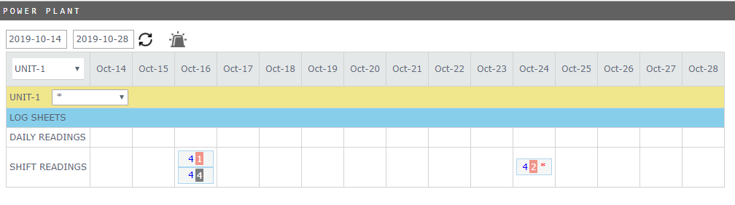

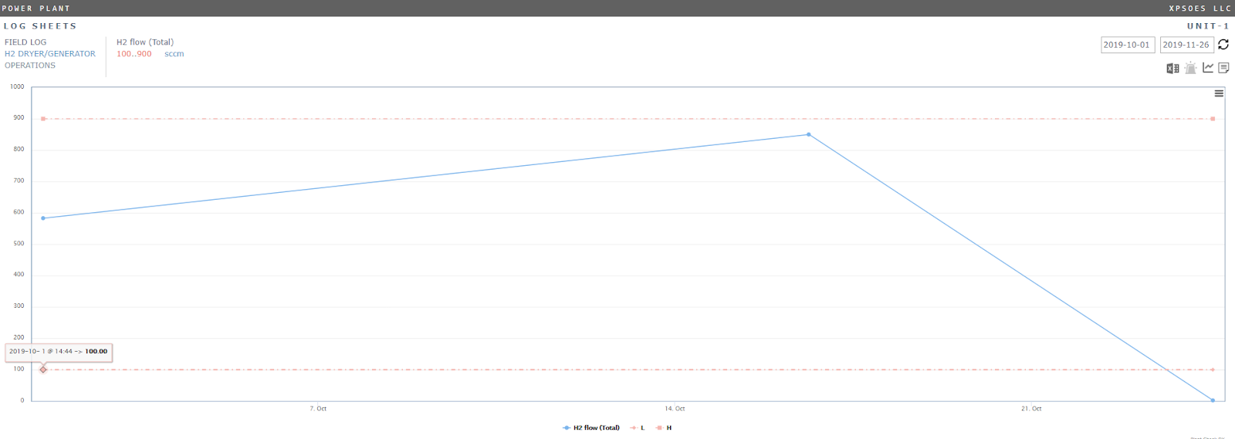 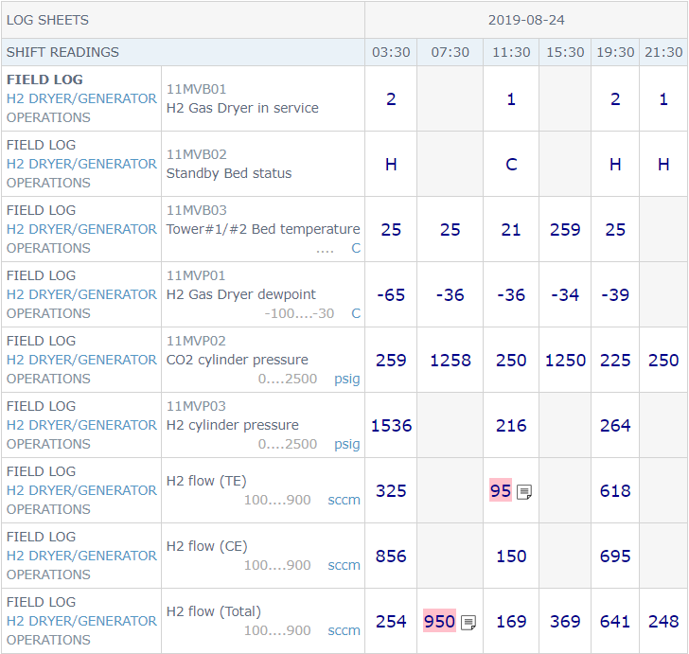

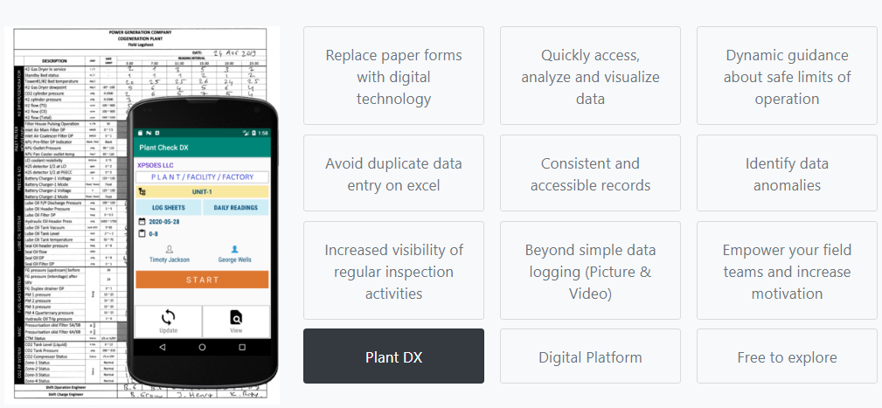

[www.plantdx.com](http://www.plantdx.com)