**Lab Reservation System**

**Individual Report**

Yasas Ranawaka

15001113

2015CS111

SCS3112 Advanced Web Development

**Introduction**

Scenario **– Lab Reservation System for UCSC**

Technologies – **Angular, NodeJs and MongoDb**

**Main Requirements**

1. All the current lab reservations should be displayed.
2. User should be able to search on lab availability for a given time.
3. The user should be able to do a new reservation
4. If the reservations are overlapping, that should be informed to the user.
5. Admin of the system should have the functionality to generate reports on lab reservations.

**Problems that Occurred and Solutions**

In implementation of the “do new reservation” function there should be two overlap checking. One is with same lab overlap checking and second one is with same user’s reservations in other labs. When I was implementing this, I had to think that how to implement this and what are the different implementation method for this and what is the best efficient way. Firstly I thought check overlapping in same lab. I had two different ideas to do this implementation.

1. Once get appropriate data from the database and then check the overlapping on three different situations in a loop.
2. Read the database with appropriate conditions with three different situations and in one situation it has to read the all data in database.

I chose first option because it is easy to change and update the code in future. In one date and one lab, maximum number of reservation is 10 or 8 that can be happen in practically. So practically I thought that we don’t have to worry about efficiency much more.

Secondly for checking same user’s reservations in other labs I update the code that was chosen in first one.

**Use Case Diagram**

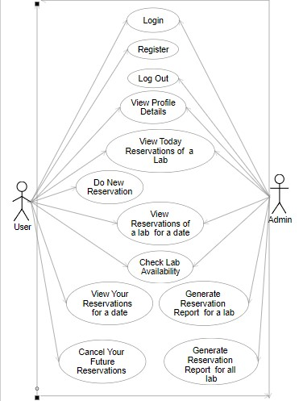

**Public Home Page**

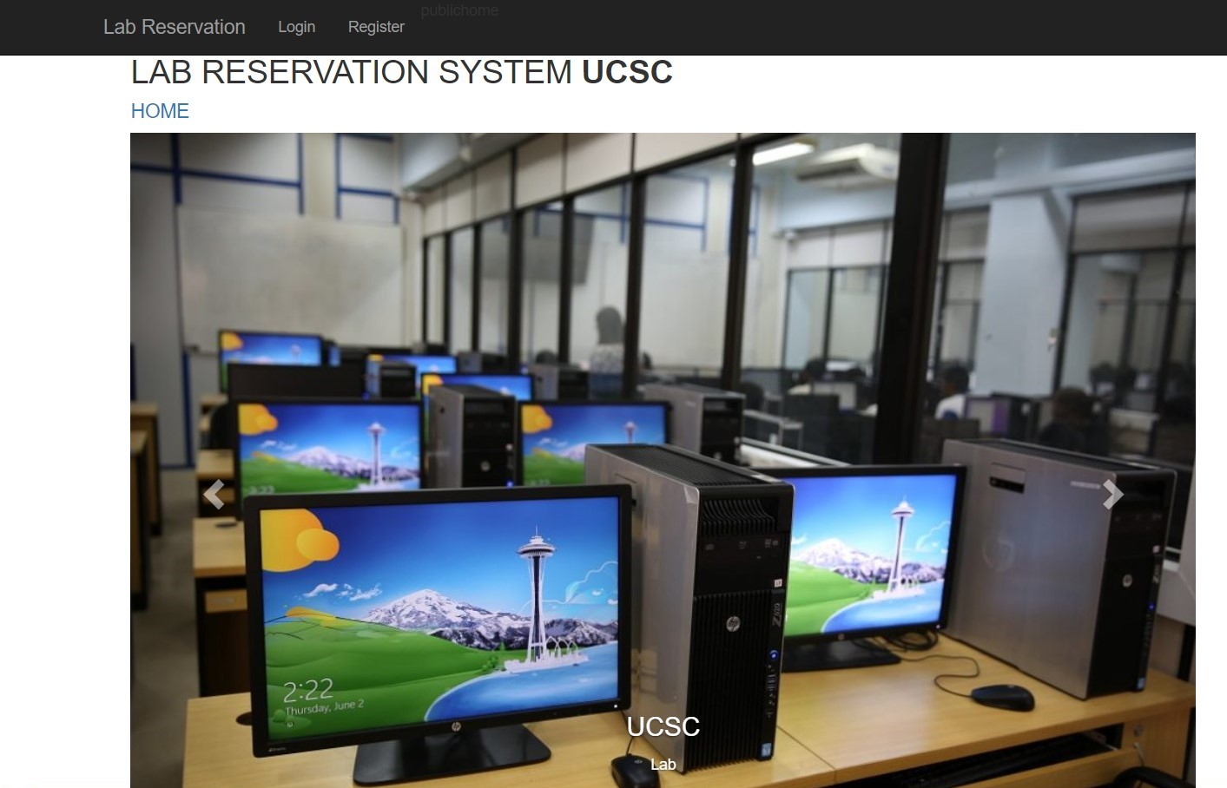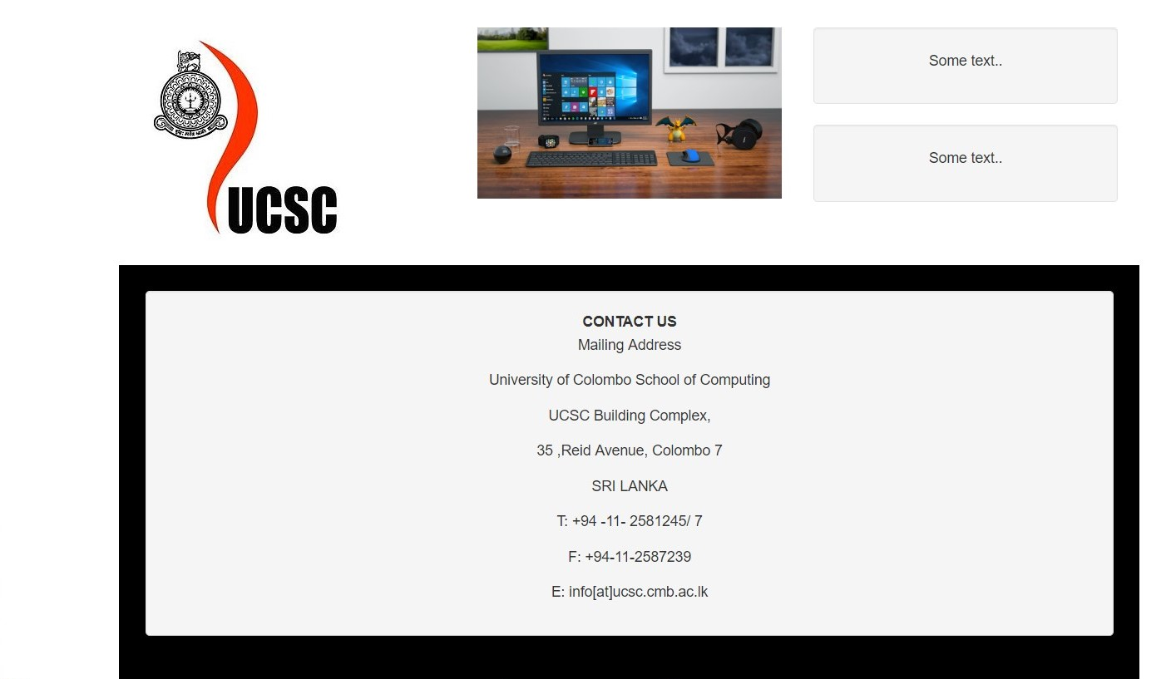

**Functionalities**

**User**

1. **User Login**

Given username will be checked in the database. If it is not in the database, it will be informed and if username is in there, given password will be checked according to username. If it is correct, user can login to system or if password is incorrect user will be informed by a message.

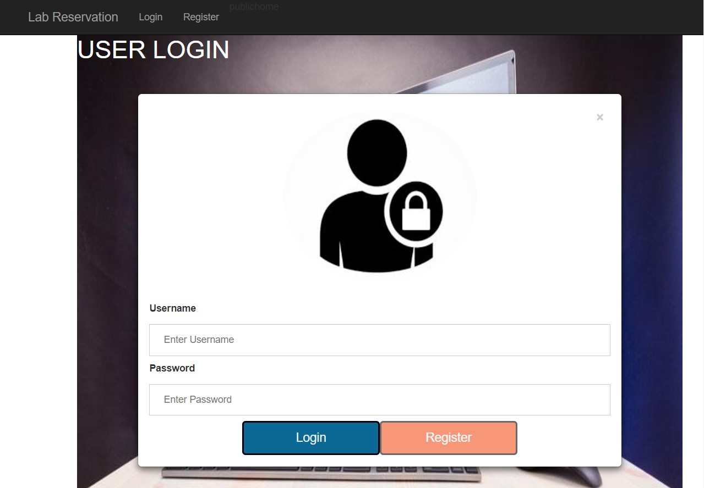

1. **Log out**
   * 1. When user log out, page will be redirect to the User Login Page
2. **Registration**

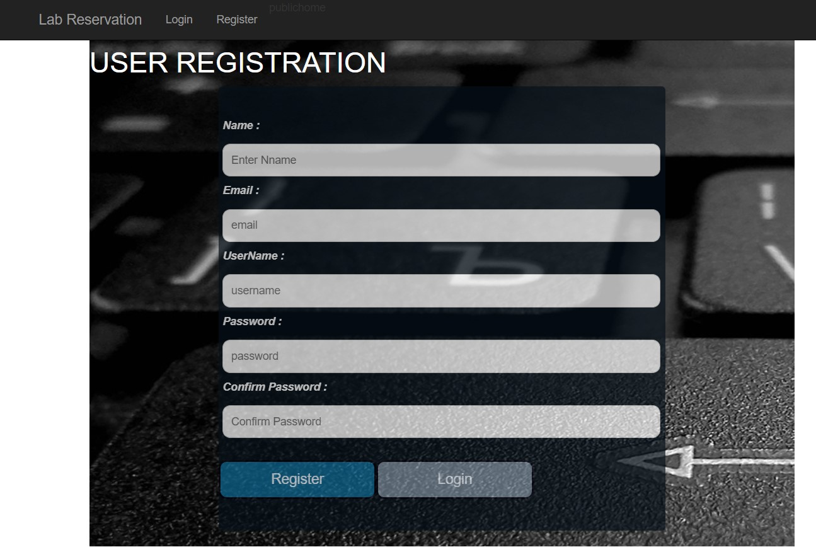

1. **Profile**
   1. User can see profile details.

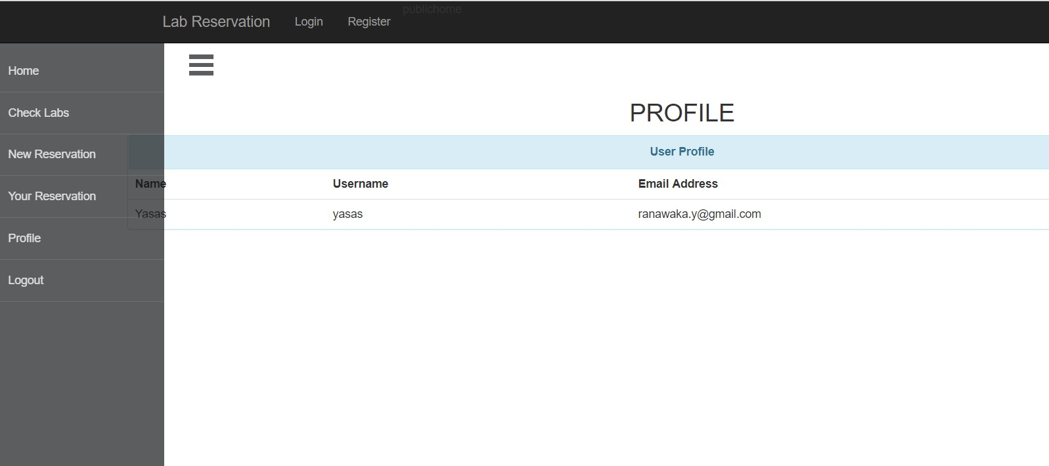

1. **User Home** 
   * 1. User can view today lab reservations in a table by selecting lab name. When logged in, user can see Lab A today reservations.
     2. If there is no reservation on today for a lab, then message is displayed.
     3. Also there is a particular bar chart which display today reservations as a total reservations grouped by lab.

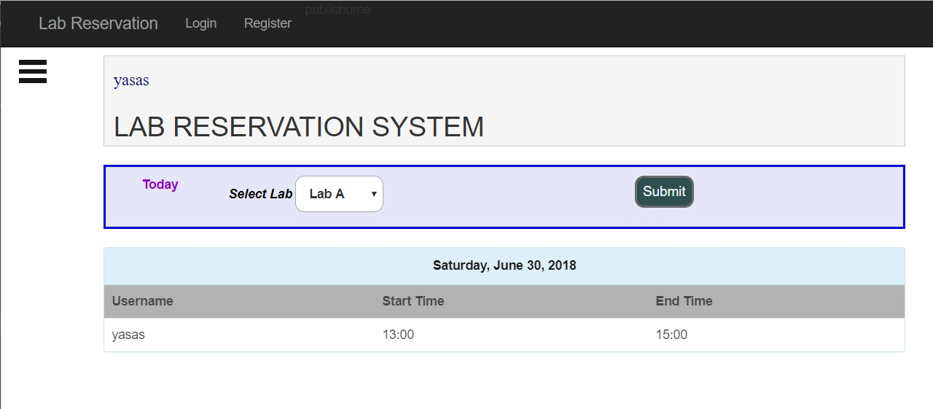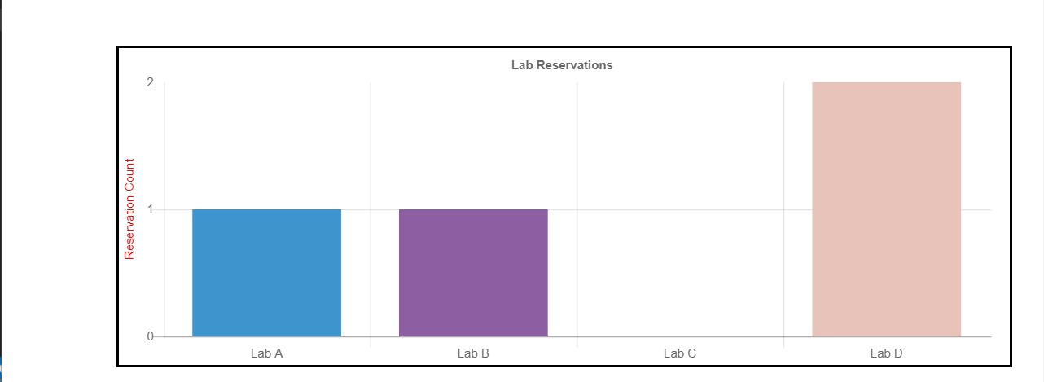

1. **Checking**
   1. Lab Reservations
2. User can view lab reservations in a table by selecting date and lab name.
3. If there is no reservation on the date and lab, then the table will be empty.

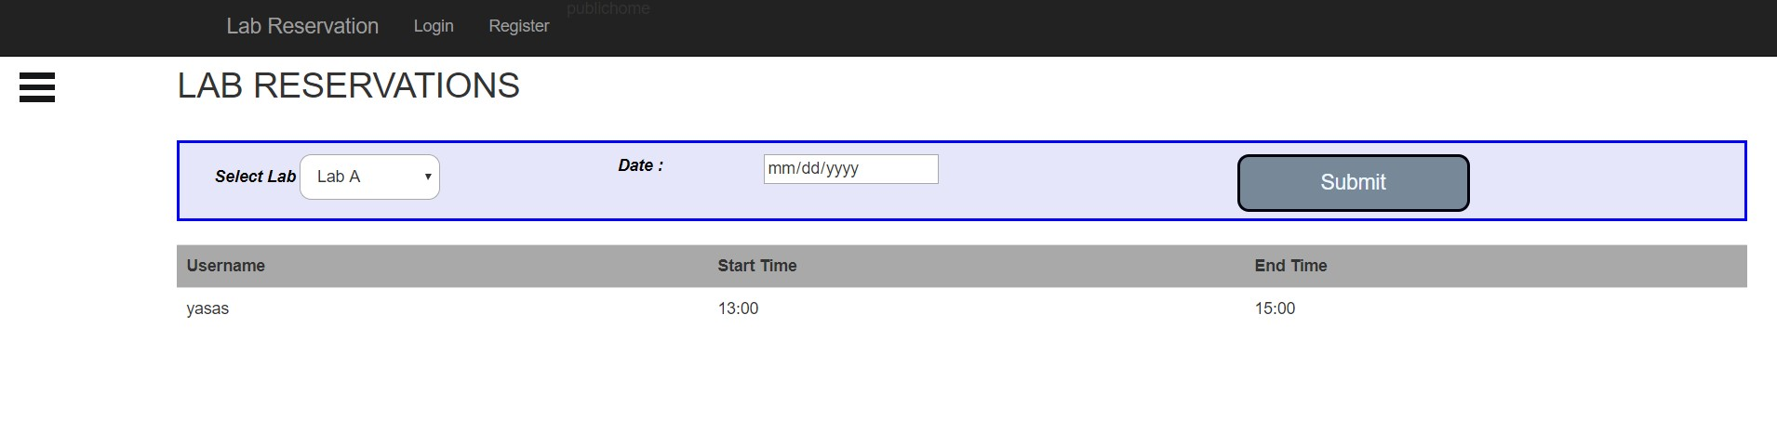

* 1. Lab Availability

1. User can check lab availability by selecting lab name, date and time period.
2. After enter that fields and submit, message will be displayed that lab is available or not on entered time slot.

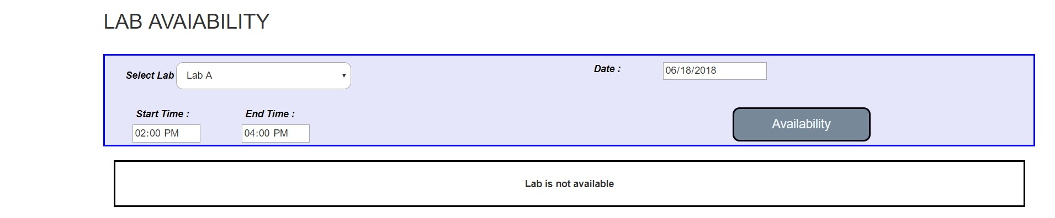

1. **Do New Reservation**
   1. User can reserve a lab on a time period.
   2. If there is already a reservation for the requesting lab and time period, then user will be informed by a message alert. Otherwise a reservation success message will be displayed.**(overlapping with same Lab).**
   3. Also there is checking for when there is overlapping request with already reserved user’s reservation on another lab and user will be informed for that. **(overlapping with user’s other Lab reservations).**

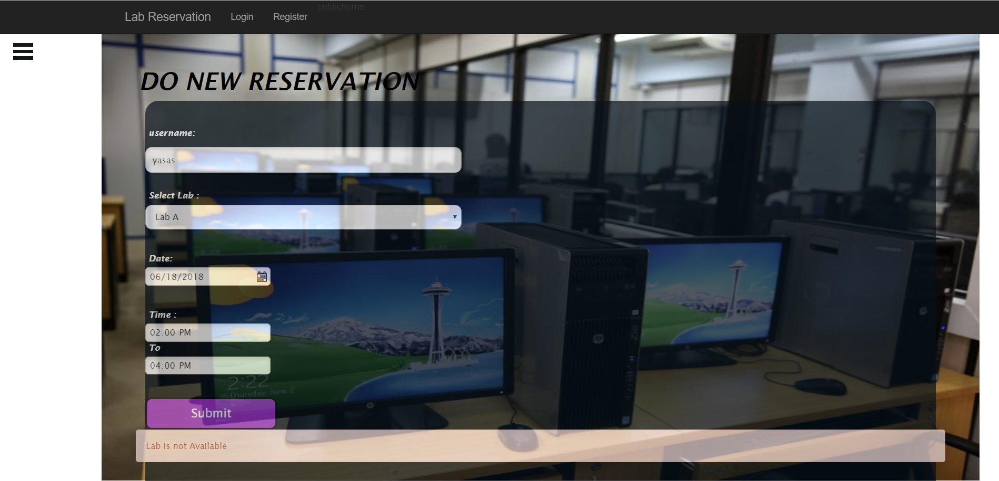

08) **Your Reservations**

a) Users’ reservations will be displayed after selecting the date.

b) Also there is overlap checking. If there are reservation overlapping with reservations on different labs, user will be informed by messages that included overlapping lab with time slot. **(Overlapping with user’s other Lab reservations).**

c) Here user can **cancel** user’s reservations if selected date will be future date. It means user can cancel his/her **future reservations** and can’t delete past reservations.

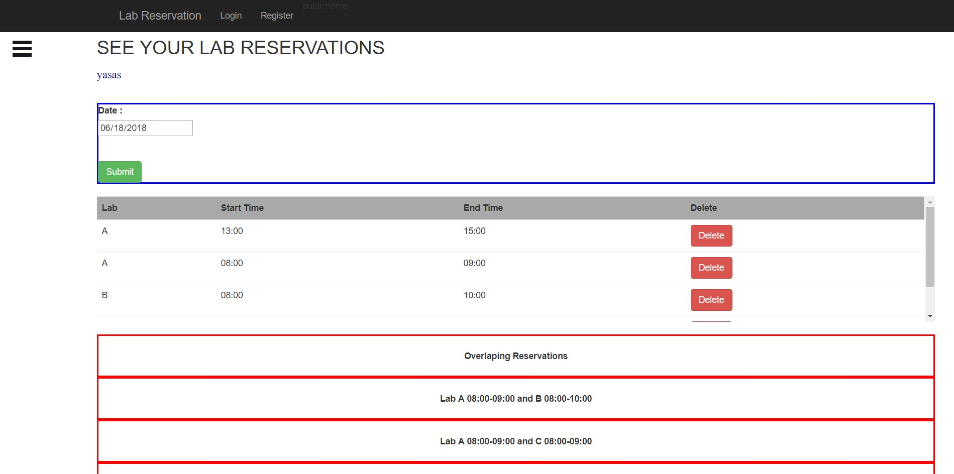

**Admin of the System**

Admin can do functions that are also user can do except do new reservation and view own reservations.

9) **Generate Reports**

* 1. **Reservations Report**
     1. Admin can generate a report for a selected lab and a selected date about reservations including reserved username and reserved time period.

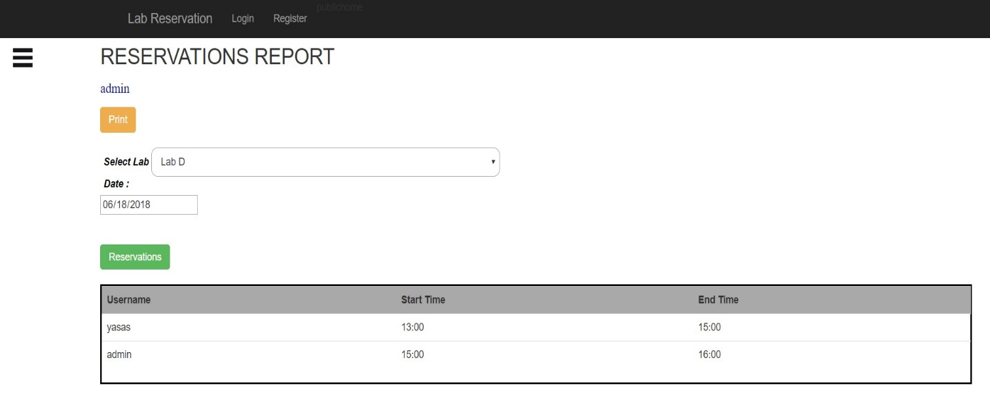

**Report PDF**

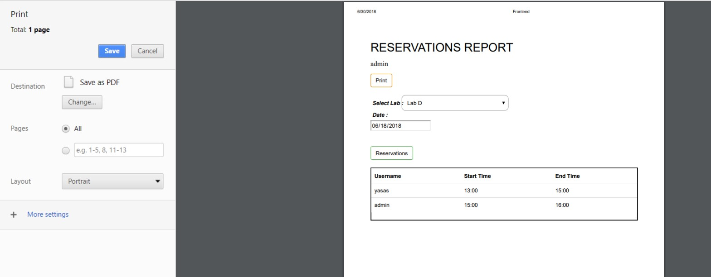

* 1. **Summary By Date Report** 
     1. Admin can generate a report for all labs with selected date a about reservations including reserved username and reserved time period.
     2. Admin can see these reservations in bar chart grouped by lab name and counted reservations.

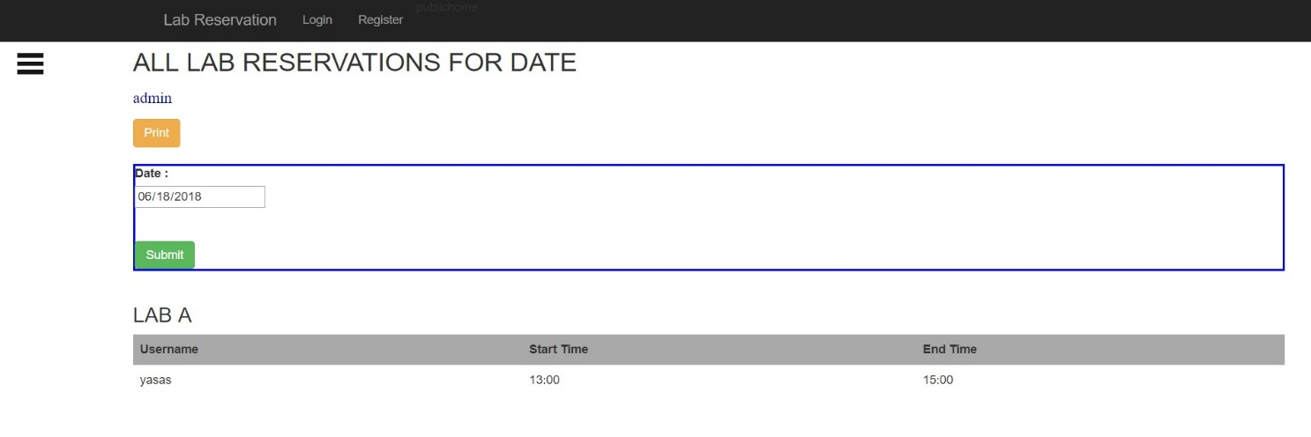

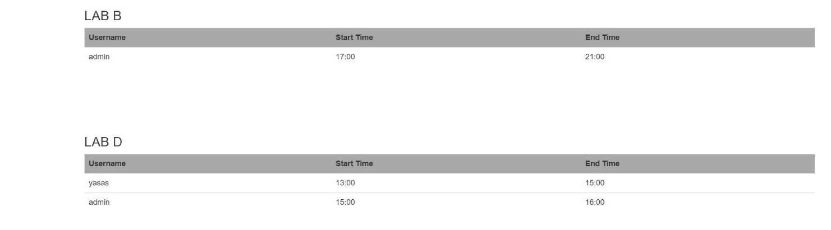

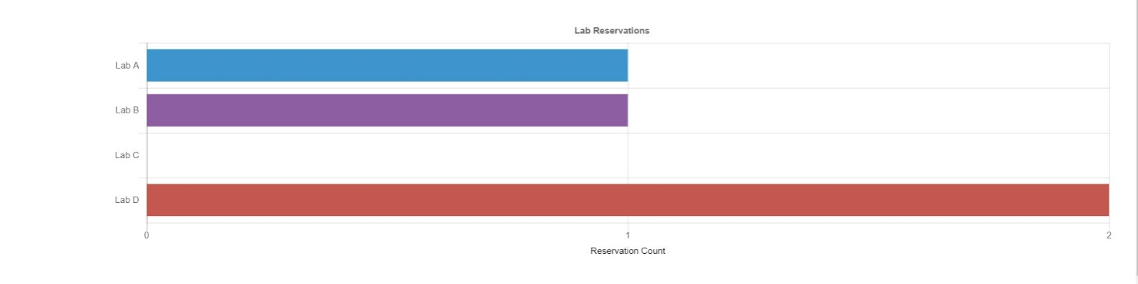

**Report PDF**

