|  |  |
| --- | --- |
| Web Application Development  Project Proposal  28/03/2021 | Prepared for  Mr. Chaminda Wijesinghe  PREPARED BY  MY Harshana  LN Hasalanaka  Gsmaleesha  Xxx  yyy |

TABLE OF CONTENTS

INTRODUCTION

We have been instructed to choose one of the seventeen Sustainable Development goals and develop a website to achieve or help to achieve the goal. The Sustainable Development Goals or Global Goals (<https://sdgs.un.org/goals>) are a collection of 17 interlinked global goals designed to be a "blueprint to achieve a better and more sustainable future for all". The SDGs were set in 2015 by the United Nations General Assembly and are intended to be achieved by the year 2030.



We have decided to develop our website to help achieving the Goal 9 which is Industry, Innovation, And Infrastructure.

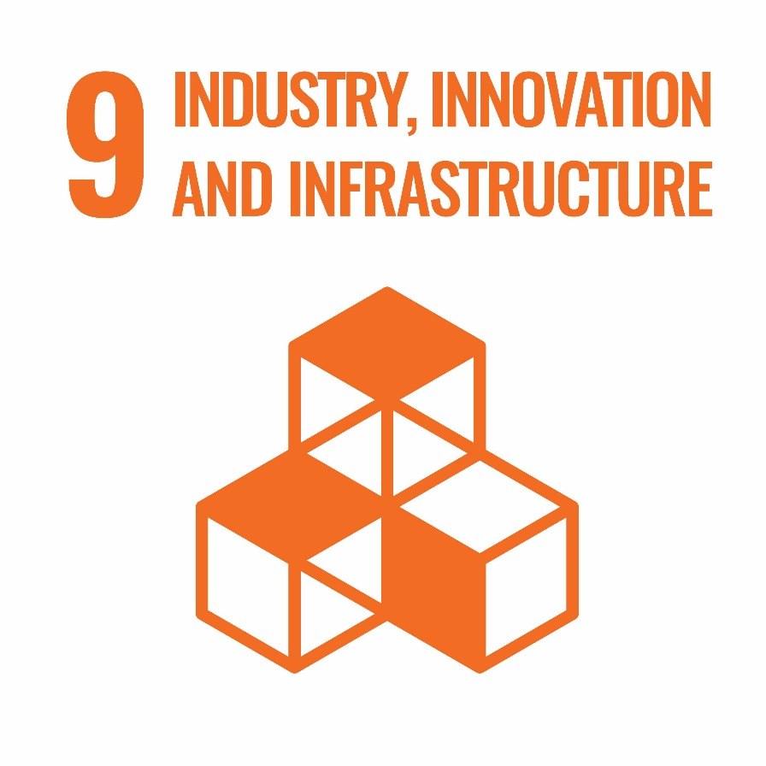

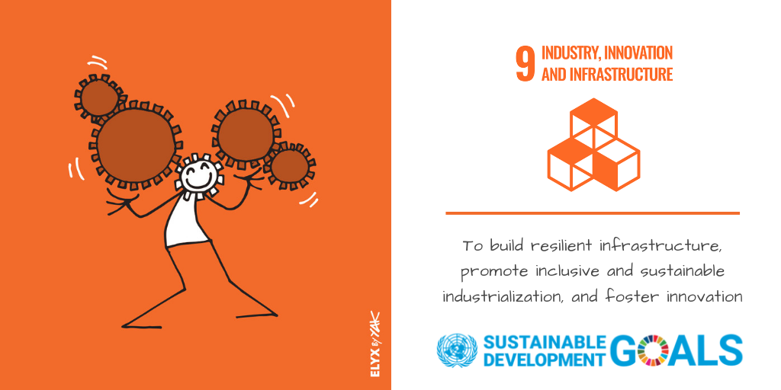The goal here is to build resilient infrastructure, promote inclusive and sustainable industrialization and foster innovation.

Sustainable industrialization, together with innovation and infrastructure, can unleash dynamic and competitive economic forces that generate employment and income. They play a key role in introducing and promoting new technologies, facilitating international trade, and enabling the efficient use of resources. The growth of new industries means improvement in the standard of living for many of us. If industries pursue sustainability, this approach will have a positive effect on the environment.

To accomplish this, we must establish standards and promote regulations that ensure company projects and initiatives are sustainably managed. Collaborate with the public sector to help promote sustainable growth within developing countries.

PROBLEM

There are many roles related to industry, innovation, and infrastructure. The challenge they all face is not having a common platform for them to expose their ideas and experience.

/vision/Benefits

PROJECT OVERVIEW

Our goal is to sustainably manage all of them using a single web platform. We would like to develop a website to focus on providing a platform to all innovators, engineers, and designers workers. Most of the visitors are viewing the websites on their mobile devices. So, we must make the website more responsive to mobile devices.

EXECUTION TIMELINE

We have been instructed to complete the website before 24th May 2021. The following table details our projected execution timeline and deadlines for our website development project.

Project First Meeting 30/03/2021

Wireframe Design 01/04/2021

Page Mockups 15/04/2021

Site Copy & Images 03/05/2021

Functional Prototype 10/05/2021

Website Development Complete 17/05/2021

Testing 21/05/2021

Website Launch 24/05/2021

Disclaimer: The dates in the table above are estimates. We may move delivery dates in response to unforeseen delays or changes to project requirements.

APPROACH

We have planned to use HTML and CSS frameworks to facilitate the procedure. We will use GitHub as our version control as we are instructed, and all our members will contribute regularly to the project.

MEMBERS

MY Harshana 20864

LN Hasalanka

Gsmaleesha

WAD Kavinda 20732

EMOD De Seram