# Story Title

# Story Title

• • •

**Swami Vivekananda**[[a]](https://en.wikipedia.org/wiki/Swami_Vivekananda#cite_note-4) (12 January 1863 – 4 July 1902), born **Narendranath Datta**[[b]](https://en.wikipedia.org/wiki/Swami_Vivekananda" \l "cite_note-5) was an Indian [Hindu](https://en.wikipedia.org/wiki/Hindus) monk, philosopher, author, religious teacher, and the chief disciple of the Indian mystic [Ramakrishna](https://en.wikipedia.org/wiki/Ramakrishna).[[4]](https://en.wikipedia.org/wiki/Swami_Vivekananda#cite_note-6)[[5]](https://en.wikipedia.org/wiki/Swami_Vivekananda#cite_note-7) He was a key figure in the introduction of [Vedanta](https://en.wikipedia.org/wiki/Vedanta) and [Yoga](https://en.wikipedia.org/wiki/Yoga) to the Western world.[[6]](https://en.wikipedia.org/wiki/Swami_Vivekananda#cite_note-8)[[7]](https://en.wikipedia.org/wiki/Swami_Vivekananda#cite_note-FOOTNOTEFeuerstein2002600-9)[[8]](https://en.wikipedia.org/wiki/Swami_Vivekananda#cite_note-10) He is credited with raising [interfaith](https://en.wikipedia.org/wiki/Interfaith_dialogue) awareness and bringBorn into an aristocratic [Bengali Kayastha](https://en.wikipedia.org/wiki/Bengali_Kayastha) family in [Calcutta](https://en.wikipedia.org/wiki/Kolkata), Vivekananda was inclined from a young age towards religion and spirituality. He later found his guru Ramakrishna and became a [monk](https://en.wikipedia.org/wiki/Sannyasa). After the [death of Ramakrishna](https://en.wikipedia.org/wiki/Ramakrishna#Last_days), Vivekananda extensively toured the [Indian subcontinent](https://en.wikipedia.org/wiki/Indian_subcontinent) as a wandering monk and acquired first-hand knowledge of the living conditions of Indian people in then [British India](https://en.wikipedia.org/wiki/British_India). Moved by their plight, he resolved to help them and found a way to travel to the United States, where he became a popular figure after the 1893 [Parliament of Religions](https://en.wikipedia.org/wiki/Parliament_of_Religions) in [Chicago](https://en.wikipedia.org/wiki/Chicago) at which he delivered his famous speech beginning with the words: "Sisters and brothers of America ..." while introducing Hinduism to Americans.[[10]](https://en.wikipedia.org/wiki/Swami_Vivekananda#cite_note-12)[[11]](https://en.wikipedia.org/wiki/Swami_Vivekananda#cite_note-FOOTNOTEDutt2005121-13) He made such an impression there that an American newspaper described him as "an orator by divine right and undoubtedly the greatest figure at the Parliament".[[12]](https://en.wikipedia.org/wiki/Swami_Vivekananda#cite_note-14)

ing [Hinduism](https://en.wikipedia.org/wiki/Hinduism) to the status of a major world religion in the late [nineteenth century](https://en.wikipedia.org/wiki/Timeline_of_the_19th_century).[[9]](https://en.wikipedia.org/wiki/Swami_Vivekananda#cite_note-FOOTNOTEClarke2006209-11)

NEWS LETTER

|  |  |  |
| --- | --- | --- |
| [Type the company name] | [Pick the date] | [Edition 1, Volume 1] |

Born into an aristocratic [Bengali Kayastha](https://en.wikipedia.org/wiki/Bengali_Kayastha) family in [Calcutta](https://en.wikipedia.org/wiki/Kolkata), Vivekananda was inclined from a young age towards religion and spirituality. He later found his guru Ramakrishna and became a [monk](https://en.wikipedia.org/wiki/Sannyasa). After the [death of Ramakrishna](https://en.wikipedia.org/wiki/Ramakrishna#Last_days), Vivekananda extensively toured the [Indian subcontinent](https://en.wikipedia.org/wiki/Indian_subcontinent) as a wandering monk and acquired first-hand knowledge of the living conditions of Indian people in then [British India](https://en.wikipedia.org/wiki/British_India). Moved by their plight, he resolved to help them and found a way to travel to the United States, where he became a popular figure after the 1893 [Parliament of Religions](https://en.wikipedia.org/wiki/Parliament_of_Religions) in [Chicago](https://en.wikipedia.org/wiki/Chicago) at which he delivered his famous speech beginning with the words: "Sisters and brothers of America ..." while introducing Hinduism to Americans.[[10]](https://en.wikipedia.org/wiki/Swami_Vivekananda#cite_note-12)[[11]](https://en.wikipedia.org/wiki/Swami_Vivekananda#cite_note-FOOTNOTEDutt2005121-13) He made such an impression there that an American newspaper described him as "an orator by divine right and undoubtedly the greatest figure at the Parliament".[[12]](https://en.wikipedia.org/wiki/Swami_Vivekananda#cite_note-14)

Born into an aristocratic [Bengali Kayastha](https://en.wikipedia.org/wiki/Bengali_Kayastha) family in [Calcutta](https://en.wikipedia.org/wiki/Kolkata), Vivekananda was inclined from a young age towards religion and spirituality. He later found his guru Ramakrishna and became a [monk](https://en.wikipedia.org/wiki/Sannyasa). After the [death of Ramakrishna](https://en.wikipedia.org/wiki/Ramakrishna#Last_days), Vivekananda extensively toured the [Indian subcontinent](https://en.wikipedia.org/wiki/Indian_subcontinent) as a wandering monk and acquired first-hand knowledge of the living conditions of Indian people in then [British India](https://en.wikipedia.org/wiki/British_India). Moved by their plight, he resolved to help them and found a way to travel to the United States, where he became a popular figure after the Born into an aristocratic [Bengali Kayastha](https://en.wikipedia.org/wiki/Bengali_Kayastha) family in [Calcutta](https://en.wikipedia.org/wiki/Kolkata), Vivekananda was inclined from a young age towards religion and spirituality. He later found his guru Ramakrishna and became a [monk](https://en.wikipedia.org/wiki/Sannyasa). After the [death of Ramakrishna](https://en.wikipedia.org/wiki/Ramakrishna#Last_days), Vivekananda extensively toured the [Indian subcontinent](https://en.wikipedia.org/wiki/Indian_subcontinent) as a wandering monk and acquired first-hand knowledge of the living conditions of Indian people in then [British India](https://en.wikipedia.org/wiki/British_India). Moved by their plight, he resolved to help them and found a way to travel to the United States, where he became a popular figure after the 1893 [Parliament of Religions](https://en.wikipedia.org/wiki/Parliament_of_Religions) in [Chicago](https://en.wikipedia.org/wiki/Chicago) at which he delivered his famous speech beginning with the words: "Sisters and brothers of America ..." while introducing Hinduism to Americans.[[10]](https://en.wikipedia.org/wiki/Swami_Vivekananda#cite_note-12)[[11]](https://en.wikipedia.org/wiki/Swami_Vivekananda#cite_note-FOOTNOTEDutt2005121-13) He made such an impression there that an American newspaper described him as "an orator by divine right and undoubtedly the greatest figure at the Parliament".[[12]](https://en.wikipedia.org/wiki/Swami_Vivekananda#cite_note-14)

1893 [Parliament of Religions](https://en.wikipedia.org/wiki/Parliament_of_Religions) in [Chicago](https://en.wikipedia.org/wiki/Chicago) at which he delivered his famous speech beginning with the words: "Sisters and brothers of America ..." while introducing Hinduism to Americans.[[10]](https://en.wikipedia.org/wiki/Swami_Vivekananda#cite_note-12)[[11]](https://en.wikipedia.org/wiki/Swami_Vivekananda#cite_note-FOOTNOTEDutt2005121-13) He made such an impression there that an American newspaper described him as "an orator by divine right and undoubtedly the greatest figure at the Parliament".[[12]](https://en.wikipedia.org/wiki/Swami_Vivekananda#cite_note-14)

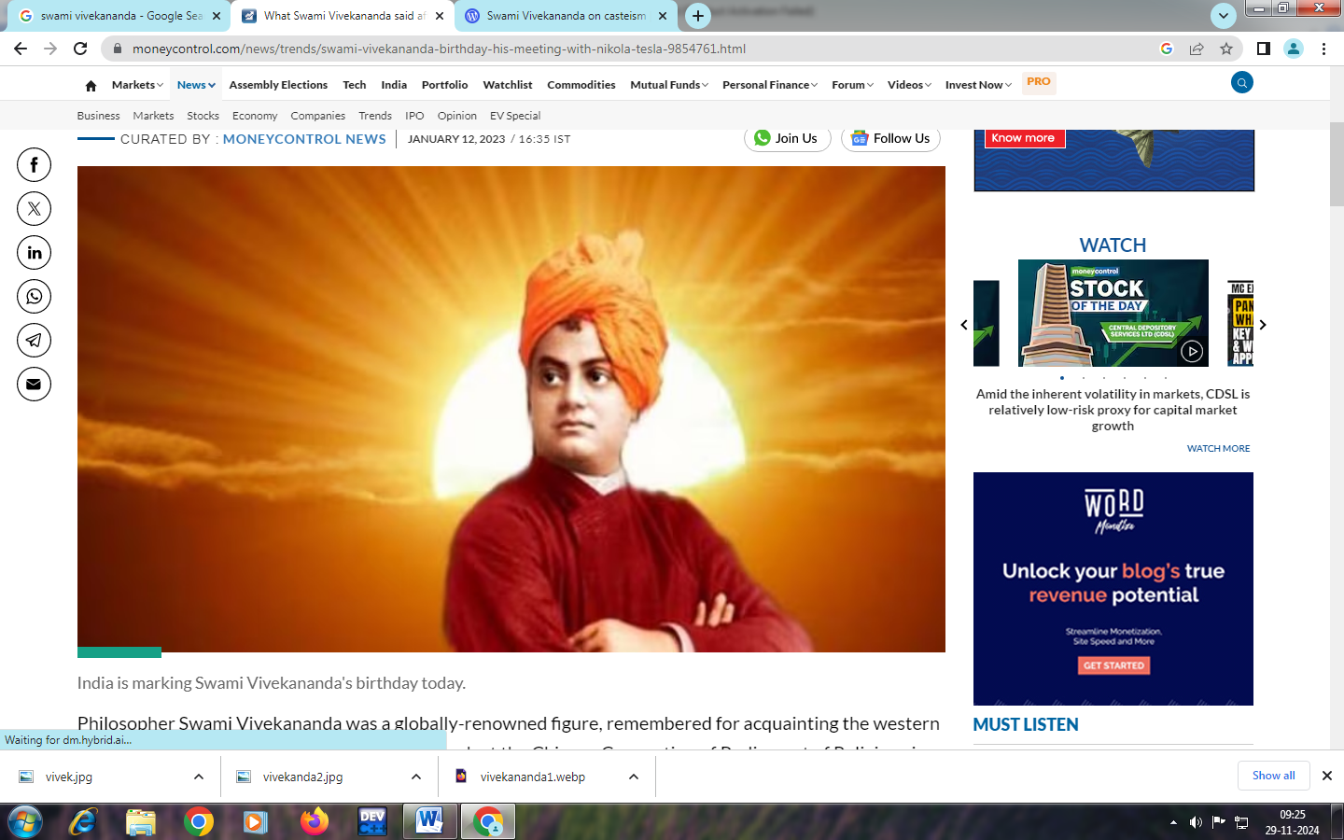

# Story Title

Story Subtitle or summary

After great success at the Parliament, in the subsequent years, Vivekananda delivered hundreds of lectures across the [United States](https://en.wikipedia.org/wiki/United_States), [England](https://en.wikipedia.org/wiki/England), and [Europe](https://en.wikipedia.org/wiki/Europe), disseminating the core tenets of [Hindu philosophy](https://en.wikipedia.org/wiki/Hindu_philosophy), and founded the [Vedanta Society of New York](https://en.wikipedia.org/wiki/Vedanta_Society_of_New_York) and the Vedanta Society of San Francisco (now [Vedanta Society of Northern California](https://en.wikipedia.org/wiki/Vedanta_Society_of_Northern_California)),[[13]](https://en.wikipedia.org/wiki/Swami_Vivekananda#cite_note-FOOTNOTEJackson1994115-15) both of which became the foundations for [Vedanta Societies](https://en.wikipedia.org/wiki/Vedanta_Societies) in the West. In India, he founded the [Ramakrishna Math](https://en.wikipedia.org/wiki/Ramakrishna_Math), which provides spiritual training for monastics and householders, and the [Ramakrishna Mission](https://en.wikipedia.org/wiki/Ramakrishna_Mission), which provides charity, social work and education.[[7]](https://en.wikipedia.org/wiki/Swami_Vivekananda#cite_note-FOOTNOTEFeuerstein2002600-9)

Vivekananda was one of the most influential [philosophers](https://en.wikipedia.org/wiki/Philosophers) and [social reformers](https://en.wikipedia.org/wiki/Social_reformer) in his contemporary India, and the most successful missionary of [Vedanta](https://en.wikipedia.org/wiki/Vedanta) to the [Western world](https://en.wikipedia.org/wiki/Western_world). He was also a major force in contemporary [Hindu reform movements](https://en.wikipedia.org/wiki/Hindu_reform_movements) and contributed to the concept of [nationalism](https://en.wikipedia.org/wiki/Indian_nationalism) in [colonial India](https://en.wikipedia.org/wiki/Colonial_India).

|  |  |  |
| --- | --- | --- |
|  | *Swami vivekananda* |  |

|  |
| --- |
| ADMIN  [Type the sender company name]  [Type the sender company address] |
|  |
| [Type the recipient name]  [Type the recipient company name]  [Type the recipient address] |