Exhaustive Analysis of Indian Agriculture Sector Using Power BI

**WEEK-1**

________________________________________________________

STEP 1: ACESSING THE POWER BI

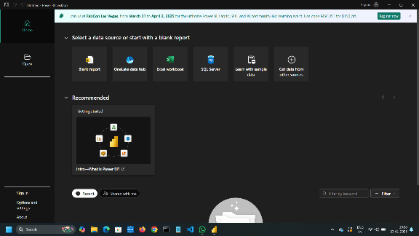 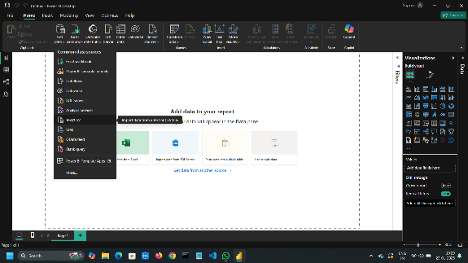

Step 1: Open power BI on your Desktop a new window is appears.

Step 2: Slick on the BLANKREPORT on the left top conner.

Step 3: Now click on the GET DATA and click TEXT/CSV to import the data set into the power BI.

STEP 2: View and updating the Data set

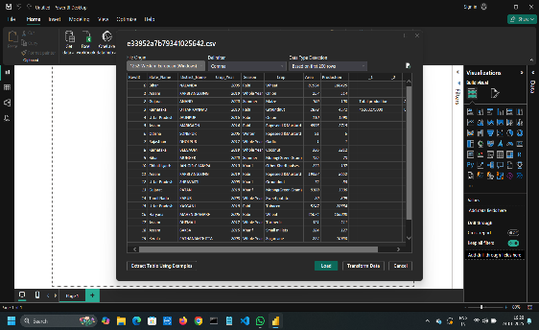 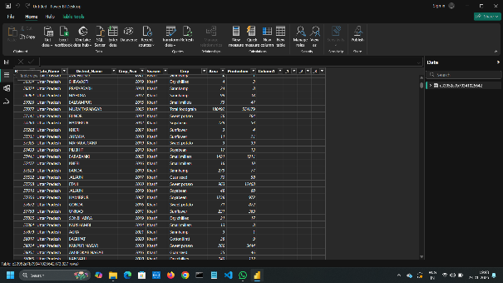

Step 1: After importing the file, click on the LOAD option

Step 2: Now you can see the file on the right side of the window

Step 3: Now on the left side, click on the TABLE VIEW.

STEP 3:TRANSFORM AND DELETING ROWS AND COLUMNS

Go back to home and click on the transform Data then a new window POWER QUERY EDITOR is opend

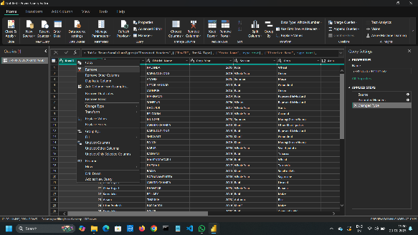 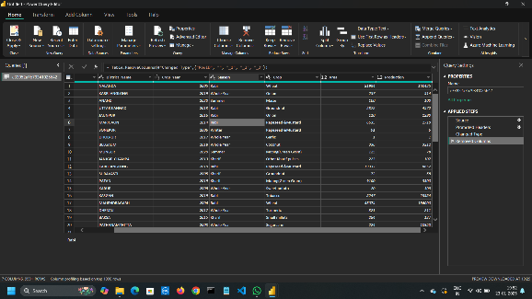

BEFORE AFTER

Step 1: We can delete unwanted columns and rows .

Step 2: Select particular row or columns and click delete .

Step 3: We can undo the process by clicking cross mark ,on the right side of the window

STEP 4: CHECKING THE ERROR AND NULL VALUES

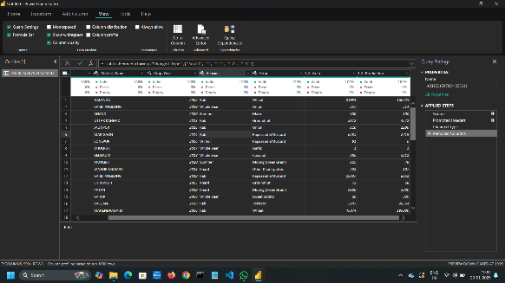 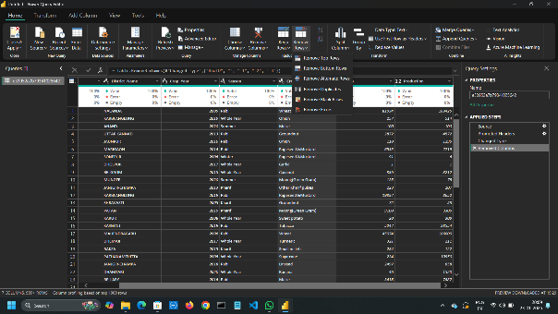

STEP 1 : Go to view ,click on the colum quality ,a box will appear with the data

STEP 5 : SAVING THE FILE

Go to the home,click on CLOSE AND APPLY ,AGAIN ON CLOSE AND APPLY to save all the changes on POWER BI .

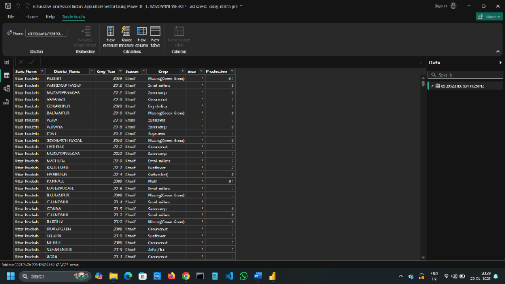

FINAL OUTPUT