**Spring 2024: CS5720  
 Neural Networks and Deep Learning - ICP-8**

**Yasaswini Majety (700747747)**

**Github Link: https://github.com/yasaswini8777/Neural-ICP8**

from keras.layers import Input, Dense

from keras.models import Model

from keras.datasets import fashion_mnist

import numpy as np

encoding_dim = 32 # 32 floats -> compression factor 24.5, assuming the input is 784 floats

input_img = Input(shape=(784,))

encoded = Dense(encoding_dim, activation='relu')(input_img)

decoded = Dense(784, activation='sigmoid')(encoded)

autoencoder = Model(input_img, decoded)

autoencoder.compile(optimizer='adadelta', loss='binary_crossentropy', metrics=['accuracy'])

(x_train, y_train), (x_test, y_test) = fashion_mnist.load_data()

x_train = x_train.astype('float32') / 255.

x_test = x_test.astype('float32') / 255.

x_train = x_train.reshape((len(x_train), np.prod(x_train.shape[1:])))

x_test = x_test.reshape((len(x_test), np.prod(x_test.shape[1:])))

autoencoder.fit(x_train, x_train,

epochs=5,

batch_size=256,

shuffle=True,

validation_data=(x_test, x_test))

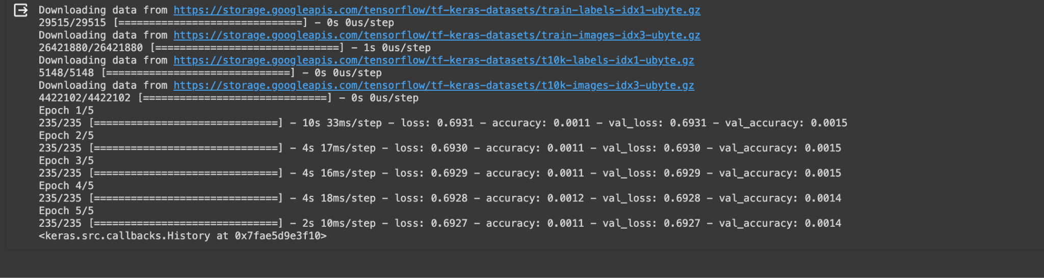

from keras.layers import Input, Dense

from keras.models import Model

encoding_dim = 32 # 32 floats -> compression of factor 24.5, assuming the input is 784 floats

input_img = Input(shape=(784,))

encoded1 = Dense(128, activation='relu')(input_img)

encoded2 = Dense(encoding_dim, activation='relu')(encoded1)

decoded1 = Dense(128, activation='relu')(encoded2)

decoded2 = Dense(784, activation='sigmoid')(decoded1)

autoencoder = Model(input_img, decoded2)

encoder = Model(input_img, encoded2)

encoded_input = Input(shape=(encoding_dim,))

decoder_layer1 = autoencoder.layers[-2]

decoder_layer2 = autoencoder.layers[-1]

decoder = Model(encoded_input, decoder_layer2(decoder_layer1(encoded_input)))

autoencoder.compile(optimizer='adadelta', loss='binary_crossentropy',metrics ='accuracy')

from keras.datasets import mnist, fashion_mnist

import numpy as np

(x_train, y_train), (x_test, y_test) = fashion_mnist.load_data()

x_train = x_train.astype('float32') / 255.

x_test = x_test.astype('float32') / 255.

x_train = x_train.reshape((len(x_train), np.prod(x_train.shape[1:])))

x_test = x_test.reshape((len(x_test), np.prod(x_test.shape[1:])))

autoencoder.fit(x_train, x_train,

epochs=5,

batch_size=256,

shuffle=True,

validation_data=(x_test, x_test))

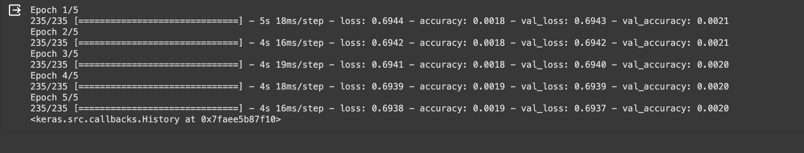

import matplotlib.pyplot as plt

plt.showhe reconstructed images for the test set

reconstructed_imgs = autoencoder.predict(x_test)

# Choose a random image from the test set

n = 10 # index of the image to be plotted

plt.figure(figsize=(10, 5))

# Plot the original image

ax = plt.subplot(1, 2, 1)

plt.imshow(x_test[n].reshape(28, 28))

plt.gray()

ax.get_xaxis().set_visible(False)

ax.get_yaxis().set_visible(False)

ax.set_title("Original Image")

# Plot the reconstructed image

ax = plt.subplot(1, 2, 2)

plt.imshow(reconstructed_imgs[n].reshape(28, 28))

plt.gray()

ax.get_xaxis().set_visible(False)

ax.get_yaxis().set_visible(False)

ax.set_title("Reconstructed Image")

plt.show()

Output:

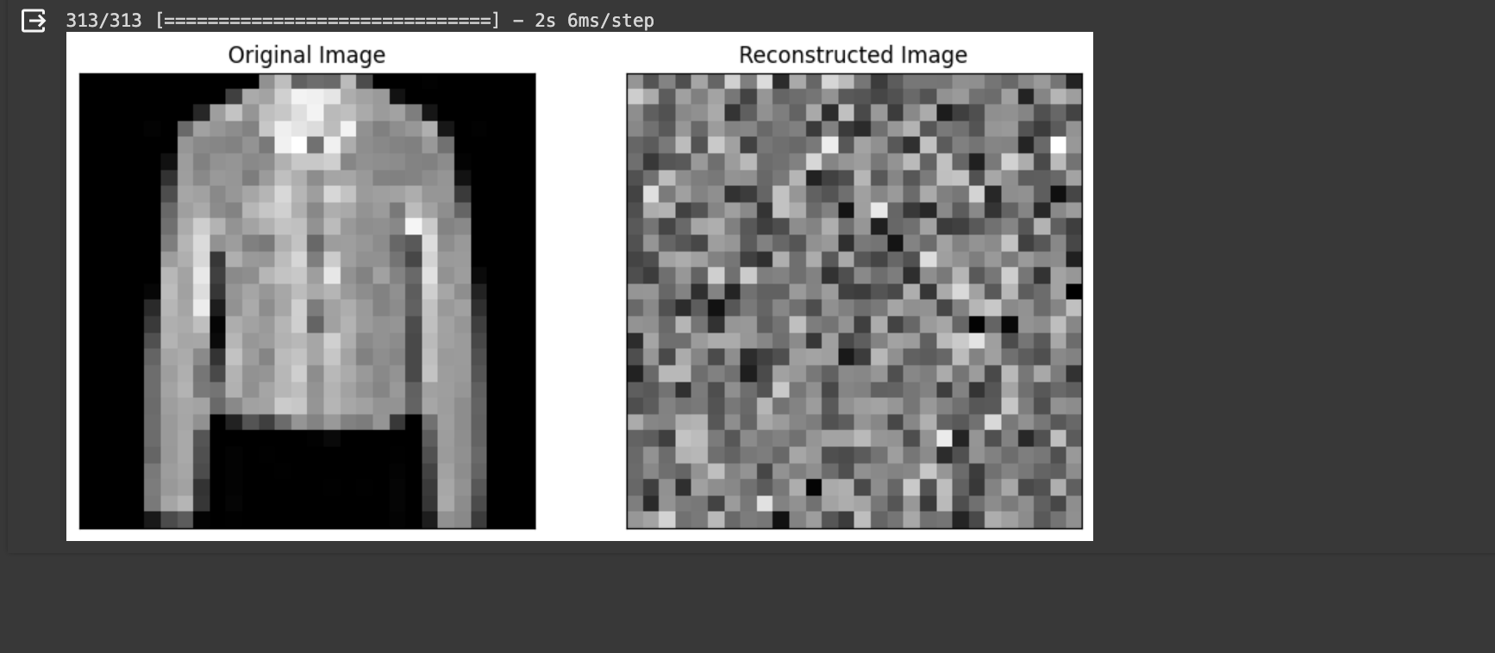

from keras.layers import Input, Dense

from keras.models import Model

encoding_dim = 32 # 32 floats -> compression of factor 24.5, assuming the input is 784 floats

input_img = Input(shape=(784,))

encoded = Dense(encoding_dim, activation='relu')(input_img)

decoded = Dense(784, activation='sigmoid')(encoded)

autoencoder = Model(input_img, decoded)

autoencoder.compile(optimizer='adadelta', loss='binary_crossentropy',metrics ='accuracy')

from keras.datasets import fashion_mnist

import numpy as np

(x_train, _), (x_test, _) = fashion_mnist.load_data()

x_train = x_train.astype('float32') / 255.

x_test = x_test.astype('float32') / 255.

x_train = x_train.reshape((len(x_train), np.prod(x_train.shape[1:])))

x_test = x_test.reshape((len(x_test), np.prod(x_test.shape[1:])))

noise_factor = 0.5

x_train_noisy = x_train + noise_factor * np.random.normal(loc=0.0, scale=1.0, size=x_train.shape)

x_test_noisy = x_test + noise_factor * np.random.normal(loc=0.0, scale=1.0, size=x_test.shape)

autoencoder.fit(x_train_noisy, x_train,

epochs=10,

batch_size=256,

shuffle=True,

validation_data=(x_test_noisy, x_test_noisy))

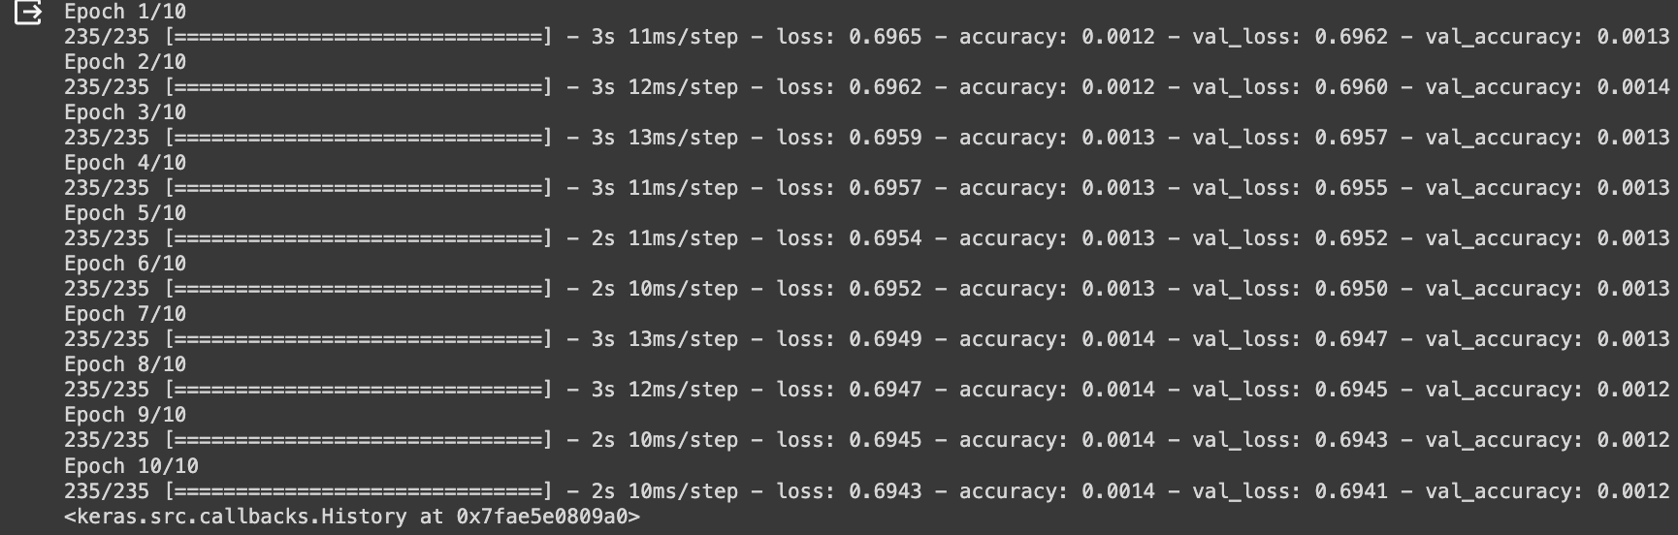

import matplotlib.pyplot as plt

# Get the reconstructed images for the test set

reconstructed_imgs = autoencoder.predict(x_test_noisy)

# Choose a random image from the test set

n = 10 # index of the image to be plotted

plt.figure(figsize=(10, 5))

# Plot the original noisy image

ax = plt.subplot(1, 2, 1)

plt.imshow(x_test_noisy[n].reshape(28, 28))

plt.gray()

ax.get_xaxis().set_visible(False)

ax.get_yaxis().set_visible(False)

ax.set_title("Noisy Image")

# Plot the reconstructed image

ax = plt.subplot(1, 2, 2)

plt.imshow(reconstructed_imgs[n].reshape(28, 28))

plt.gray()

ax.get_xaxis().set_visible(False)

ax.get_yaxis().set_visible(False)

ax.set_title("Reconstructed Image")

plt.show()

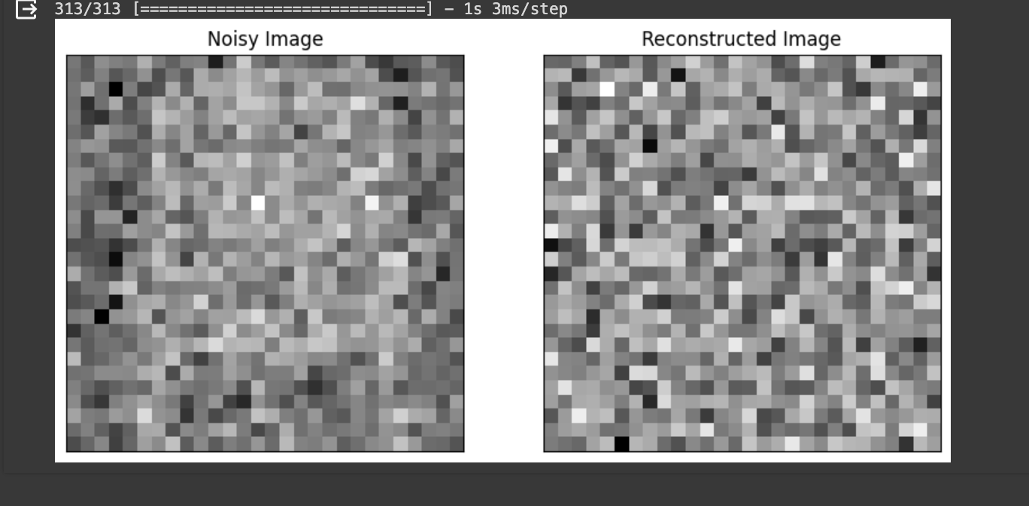

import matplotlib.pyplot as plt

plt.show the autoencoder

history = autoencoder.fit(x_train_noisy, x_train,

epochs=10,

batch_size=256,

shuffle=True,

validation_data=(x_test_noisy, x_test_noisy))

plt.plot(history.history['loss'], label='train')

plt.plot(history.history['val_loss'], label='test')

plt.title('Model Loss')

plt.ylabel('Loss')

plt.xlabel('Epoch')

plt.legend()

plt.show()

plt.plot(history.history['accuracy'], label='train')

plt.plot(history.history['val_accuracy'], label='test')

plt.title('Model Accuracy')

plt.ylabel('Accuracy')

plt.xlabel('Epoch')

plt.legend()

plt.show()

Output:

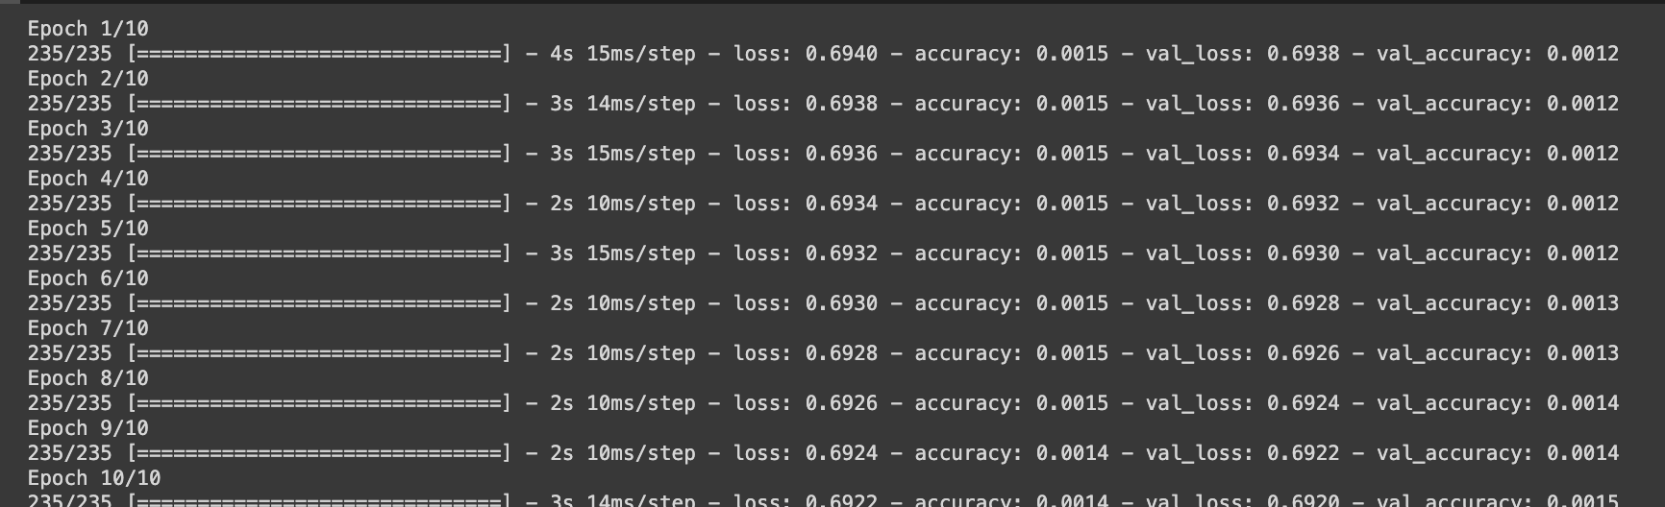

Test data using Matplotlib:

