Food Delivery App (MERN Stack) - Project Documentary

# 1. Project Title

Food Delivery Application using MERN Stack

# 2. Project Overview

The Food Delivery App is a web-based application developed using the MERN (MongoDB, Express.js, React.js, Node.js) stack. The app allows users to browse a variety of food items, add them to a cart, place orders, and track their order status. Admins have special access to manage the food inventory and monitor order progress.

# 3. Objective

To develop a responsive, efficient, and interactive food delivery platform that offers seamless user experience for food ordering and admin-side management using the MERN stack.

# 4. Tech Stack

Frontend:  
- React.js  
- Vanilla CSS  
  
Backend:  
- Node.js  
- Express.js  
- MongoDB

# 5. Application Links

Frontend (User Interface): https://food-order-app-3pw0.onrender.com/  
Admin Panel: https://food-order-admin-7chz.onrender.com/  
Backend (API Server): https://food-order-backend-ultg.onrender.com

# 6. Key Features

Admin:  
- Authentication  
- Food Management (Add, Update, Delete)  
- Order Management  
- Dashboard View  
  
User:  
- Authentication  
- Food Browsing by Category  
- Cart Management  
- Order Placement  
- Order History  
- Modern UI

# 7. System Architecture

Client (React) <--> Express Server (Node.js) <--> MongoDB Database

# 8. Environment Variables

BACKEND_URL = http://localhost:PORT or your deployed backend URL

# 9. Folder Structure (Simplified)

/client  
 /src  
 /components  
 /pages  
 App.js  
  
/server  
 /routes  
 /models  
 /controllers  
 server.js

# 10. Challenges Faced

- Asynchronous operations handling  
- State management  
- Route protection  
- Deployment configuration

# 11. Outcomes & Learnings

- Full-stack development experience  
- REST API implementation  
- Scalable codebase architecture  
- UI-state interaction  
- Debugging & deployment

# 12. Future Enhancements

- Payment gateway integration  
- Map-based delivery tracking  
- Admin analytics dashboard  
- Email/OTP verification

# 13. Screenshots

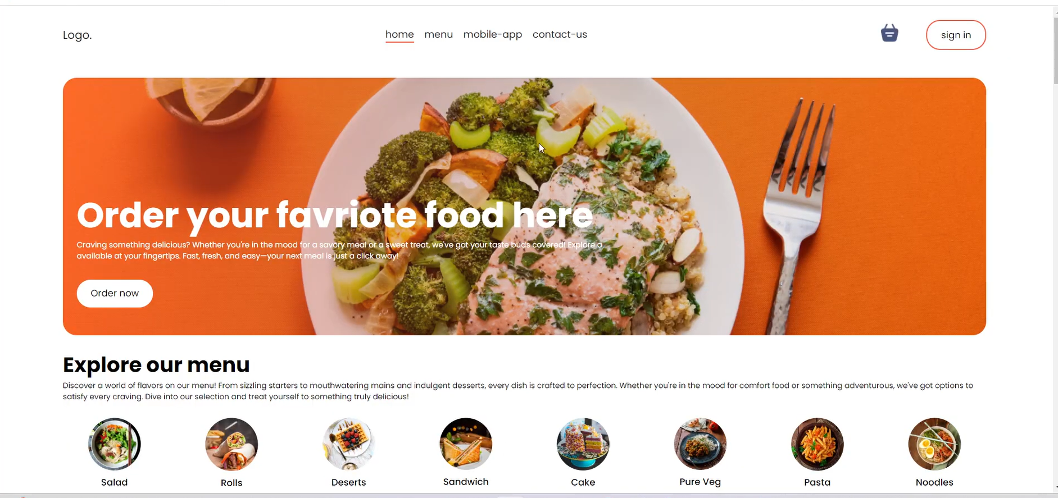

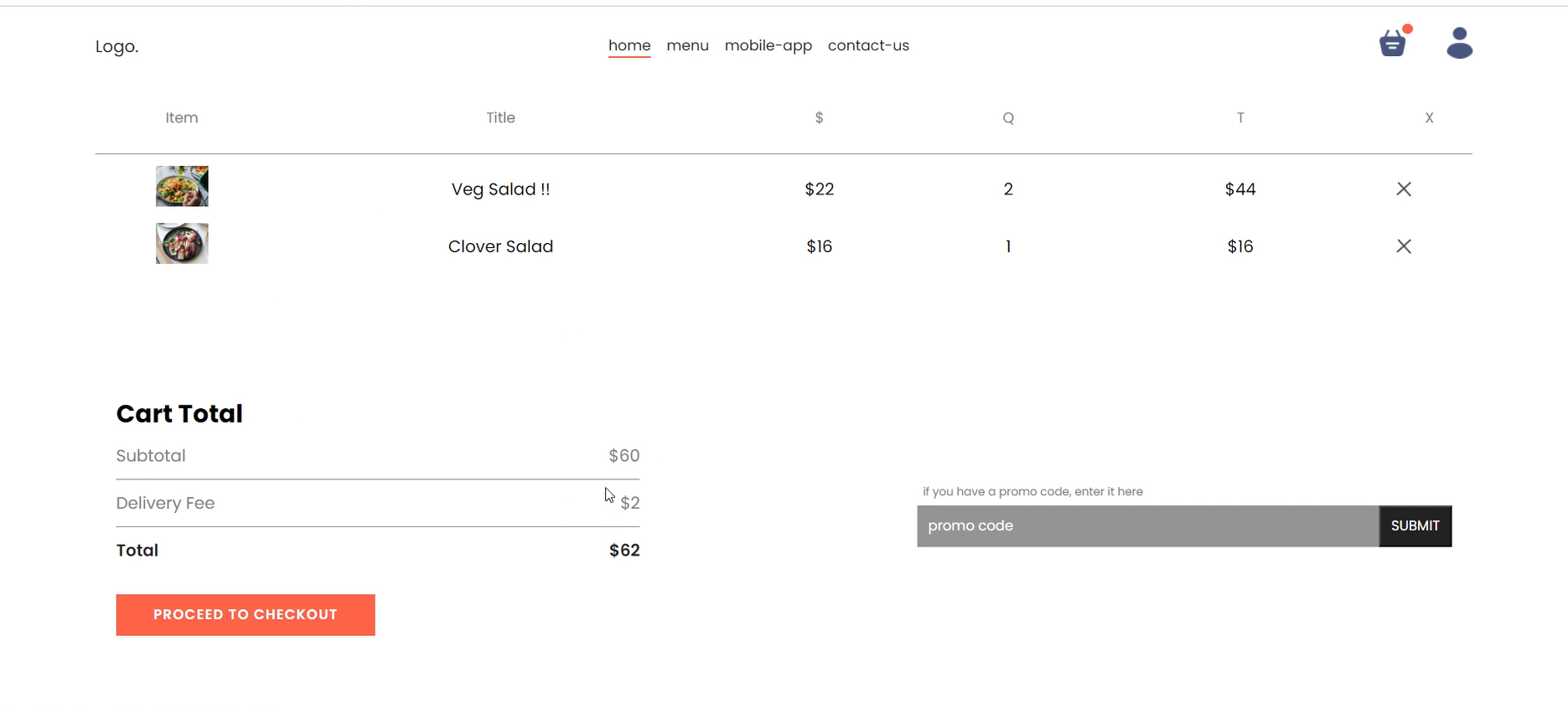

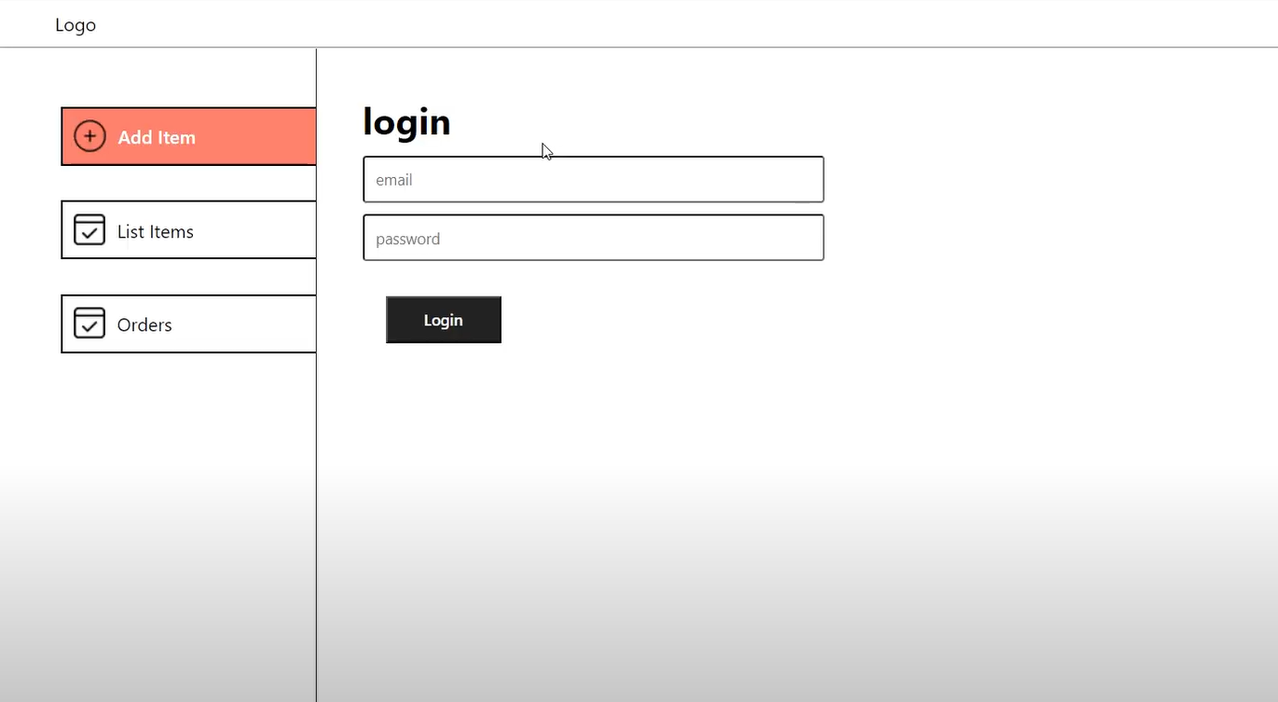

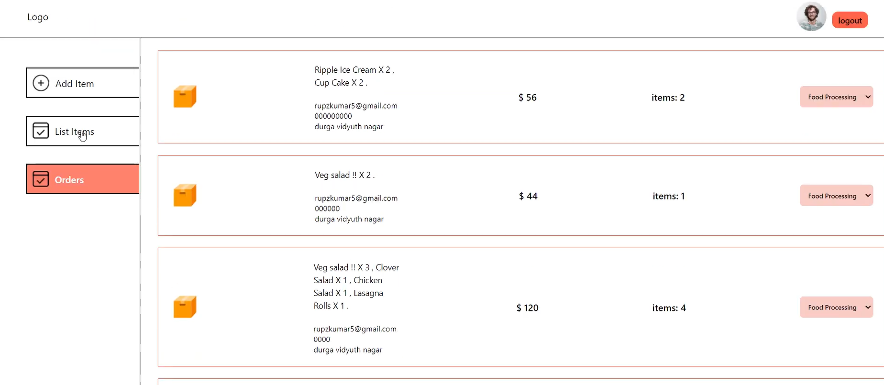

# 14. Conclusion

This project demonstrates the development of a real-world food delivery application using modern web technologies. The system provides full functionality from both the user and admin perspective. Completing this project has strengthened core development skills and provided essential experience for real-time full-stack development.