SENTINELNET–AI POWERED NETWORK INTRUSION DETECTION SYSTEM (NIDS)
Author: AARIFA R
Mentor: Dr. N Jagan Mohan

ABSTRACT-The rapid expansion of networked systems and the growing sophistication of cyberattacks have rendered many traditional defenses inadequate against threats such as zero-day exploits, advanced persistent threats, and rapidly mutating malware. This study introduces AegisNID, an intelligent network intrusion detection framework that combines machine learning and automated mitigation to detect and respond to threats in real time. We evaluate the approach on two benchmark corpora—NSL-KDD (representing classical attack patterns) and CICIDS2017 (reflecting contemporary, complex traffic)—and perform experiments for both binary (benign vs. malicious) and fine-grained multi-class classification (specific attack categories). Our data pipeline applies targeted feature engineering, normalization, and class-imbalance remedies to maximize learning effectiveness. We compare a variety of algorithms, including Logistic Regression, Decision Trees, Random Forests, and Gradient Boosting. Results show that ensemble techniques, notably Random Forest and Gradient Boosting, deliver the best detection performance, attaining accuracies above 99% on CICIDS2017 while remaining practical for deployment. The system reliably discriminates DoS, probing, U2R, R2L, DDoS variants, web attacks, and infiltration attempts. This work provides empirical support for hybrid ML-based IDS architectures and sets performance baselines for enterprise adoption.
KEYWORDS: Network Intrusion Detection System (NIDS), Cybersecurity, Machine Learning, NSL-KDD Dataset, CI CIDS2017 Dataset, Ensemble Methods, Network Security, Anomaly Detection, Real-Time Threat Detection.
STATEMENT OF ORIGINALITY: This paper presents SentinelNet, a hybrid IDS combining signature-based and anomaly-based methods with advanced preprocessing, feature selection, and class-imbalance handling, applied to NSL KDDandCICIDS2017 datasets.

1. INTRODUCTION
The exponential rise of internet-connected systems and the ongoing digital transformation of enterprises have drastically reshaped the cybersecurity landscape. Modern networks are continuously exposed to a spectrum of sophisticated attacks, including large-scale Distributed Denial-of-Service (DDoS) assaults and stealth-oriented Advanced Persistent Threats (APTs) capable of evading detection for extended periods. Conventional perimeter-based defenses such as firewalls, intrusion prevention systems, and antivirus tools, though fundamental, are increasingly inadequate against today’s dynamic and adaptive adversaries. This scenario underscores the urgent need for intelligent and adaptive defense mechanisms capable of autonomously learning network behavior and identifying deviations that signify potential intrusions.
Network Intrusion Detection Systems (NIDS) form a pivotal layer within the defense-in-depth paradigm, continuously inspecting and analyzing network traffic to detect signs of compromise. Unlike static preventive measures that rely on predefined signatures or access rules, NIDS enhances situational awareness by uncovering both known and unknown threats in real time. The integration of Artificial Intelligence (AI) and Machine Learning (ML) into NIDS frameworks represents a transformative step forward—empowering systems to discern complex behavioral patterns, predict emerging attack trends, and respond proactively.
The AegisNID framework arises from this growing demand for intelligent, self-learning cybersecurity solutions. The proposed system integrates both signature-based and anomaly-based detection paradigms to achieve high detection accuracy across diverse attack surfaces. By leveraging machine learning algorithms trained on benchmark datasets that encompass both traditional (NSL-KDD) and contemporary (CICIDS2017) network threats, the system aspires to enhance reliability, adaptability, and scalability within enterprise environments.
The primary objectives of this research include:
- Automated Threat Detection: Develop ML-based classifiers capable of autonomously distinguishing benign and malicious network activities with minimal human supervision.
- Real-Time Intrusion Classification: Implement efficient models that can analyze and categorize network flows instantaneously, facilitating immediate threat containment.
- Feature Extraction and Optimization: Identify and engineer relevant statistical and behavioral features from raw traffic data to maximize predictive accuracy while maintaining computational efficiency.
- Class Imbalance Mitigation: Address skewed data distributions by employing balancing strategies that ensure robust learning across both minority (attack) and majority (normal) classes.
- Comprehensive Attack Categorization: Enable fine-grained detection by classifying attacks into specific categories such as DoS, Probe, U2R, R2L, DDoS, web exploits, and infiltration events.
- Performance Evaluation and Benchmarking: Establish rigorous evaluation metrics—accuracy, precision, recall, F1-score, specificity, and ROC-AUC—to objectively compare model performance.
- Comparative Dataset Analysis: Assess model generalization by comparing outcomes on legacy (NSL-KDD) and modern (CICIDS2017) datasets, highlighting adaptability to evolving attack patterns.
This study contributes to the broader field of cybersecurity by empirically validating the efficacy of ensemble-based ML approaches for intrusion detection, exploring trade-offs between performance accuracy and resource efficiency, and presenting a structured evaluation framework for practical NIDS deployment. The insights derived from this research are intended to guide practitioners and organizations in selecting optimal detection models tailored to their network environments.
The remainder of this paper is organized as follows: Section 2 reviews existing literature on machine learning-based intrusion detection. Section 3 describes the methodological framework, including dataset properties, preprocessing techniques, and algorithmic design. Section 4 presents and discusses the experimental findings for both binary and multi-class classification. Section 5 concludes with the key insights, limitations, and avenues for future work.

2. LITERATURE REVIEW
Network Intrusion Detection Systems (NIDS) have evolved from early signature-based models, which detected known attacks, to anomaly-based and machine learning approaches capable of identifying novel threats. While signature systems struggled with zero-day and polymorphic attacks, anomaly detection introduced behavioral analysis, pioneered by Denning (1987). The integration of machine learning—including algorithms like Decision Trees, SVM, and ensemble methods such as Random Forest and Gradient Boosting—greatly improved detection accuracy and adaptability. Recent advances in deep learning using CNNs and RNNs have further enhanced performance on complex datasets like CICIDS2017, marking a shift toward intelligent, adaptive, and real-time intrusion detection systems.

2.1 Machine Learning in Intrusion Detection
The use of machine learning (ML) in intrusion detection gained prominence with the KDD Cup 1999 dataset, which established a benchmark for evaluating IDS algorithms. Early studies used models such as Decision Trees for their interpretability and Support Vector Machines (SVMs) for effective binary classification of normal versus malicious traffic. The introduction of ensemble methods—notably Random Forests and Gradient Boosting—greatly enhanced detection accuracy by combining multiple weak learners to improve generalization and reduce overfitting.
More recently, deep learning techniques have advanced IDS capabilities by automatically extracting features from raw network data. Convolutional Neural Networks (CNNs) capture spatial traffic patterns, while Recurrent Neural Networks (RNNs) and Long Short-Term Memory (LSTM) networks model temporal dependencies in network flows. Despite their high accuracy, deep learning models often demand large datasets and significant computational resources, posing challenges for real-time or resource-limited environments.

2.2 Benchmark Datasets and Their Impact
The effectiveness of Intrusion Detection Systems (IDS) heavily depends on the quality and realism of the datasets used for training and evaluation. The KDD Cup 1999 dataset was an early benchmark but faced criticism for redundancy and outdated attack patterns. To address these issues, NSL-KDD was introduced in 2009, refining data balance and removing duplicates while maintaining compatibility with earlier studies. The CICIDS2017 dataset, created by the Canadian Institute for Cybersecurity, marked a major step forward by incorporating real enterprise network traffic and diverse modern attacks such as DDoS, web exploits, brute force, and infiltration attempts. With over 80 detailed flow-based and temporal features, it provides a comprehensive foundation for developing and evaluating advanced machine learning-based IDS models.

2.3 Challenges in Intrusion Detection
Intrusion Detection Systems (IDS) face several persistent challenges. Class imbalance is a major issue, as normal traffic often constitutes 95–99% of network flows, leading models to overlook rare but critical attacks. Techniques such as SMOTE, cost-sensitive learning, and ensemble methods are commonly used to address this. Feature selection and dimensionality reduction are also essential to reduce computational overhead and improve interpretability, using methods like PCA, correlation analysis, and feature importance ranking.
Additionally, the adversarial nature of cybersecurity complicates detection. Attackers continually evolve strategies to bypass IDS, including crafting inputs to mislead machine learning models. This dynamic environment demands adaptive and robust IDS architectures capable of learning from emerging threats while maintaining resilience against evasion tactics.

2.4 Hybrid IDS Architectures
Modern research increasingly supports hybrid IDS, combining signature-based and anomaly-based detection to leverage their complementary strengths. Signature methods quickly identify known threats with low false positives, while anomaly detection covers novel attacks and zero-day exploits. Hybrid systems typically apply signature filtering first, followed by machine learning analysis of suspicious traffic, balancing detection accuracy and efficiency.
Emerging trends include integrating threat intelligence, behavioral analytics, and collaborative detection across distributed sensors, enabling rapid sharing of attack indicators and model updates. Building on these concepts, SentinelNet evaluates established machine learning algorithms on both legacy and modern datasets, providing insights for effective NIDS deployment in real-world environments.

3. METHODOLOGY
This section outlines the systematic approach used to design, implement, and evaluate SentinelNet, covering dataset selection, data preprocessing, feature engineering, model development, and performance evaluation. The methodology emphasizes reproducibility and rigor, providing a clear framework for assessing the effectiveness of various machine learning algorithms in both binary and multi-class intrusion detection tasks. By detailing each step, this section highlights best practices for building robust, scalable, and real-time Network Intrusion Detection Systems (NIDS).

3.1 Datasets
The choice of datasets plays a crucial role in ensuring the validity and generalizability of intrusion detection research. This study uses two complementary benchmark datasets—NSL-KDD and CICIDS2017—representing different generations of network traffic and attack scenarios. This combination allows for a comprehensive evaluation of model performance across both legacy and modern attack patterns.

3.1.1 NSL-KDD Dataset
The NSL-KDD dataset is a refined successor to the KDD Cup 1999 dataset, addressing issues like record redundancy and training-test overlap that previously inflated performance metrics. Designed as a standardized benchmark for IDS evaluation, it maintains compatibility with historical studies while improving data quality.
NSL-KDD contains 41 features divided into four categories:
- Basic features from individual TCP/IP connections (e.g., protocol type, service, duration, bytes transferred).
- Content features analyzing packet payloads (e.g., failed login attempts, root shell access).
- Time-based traffic features over two-second windows (e.g., repeated connections to the same host/service).
- Host-based traffic features derived from connection histories (e.g., error rates, service request patterns).
The dataset includes 125,973 training records and 22,544 test records, with each labeled as normal or one of four attack types:
- DoS (Denial of Service, e.g., smurf, neptune, teardrop)
- Probe (reconnaissance, e.g., portscan, nmap)
- U2R (User-to-Root attacks, e.g., buffer overflow, rootkits)
- R2L (Remote-to-Local attacks, e.g., FTP exploits, password guessing)
Although NSL-KDD reflects older network conditions, it remains valuable for lightweight model evaluation, algorithm benchmarking, and educational purposes. Its simulated traffic and outdated attack profiles, however, limit applicability to modern threat environments.

3.1.2 CICIDS2017 Dataset
The CICIDS2017 dataset, developed by the Canadian Institute for Cybersecurity, provides realistic, enterprise-grade network traffic for IDS research. Collected from a simulated medium-sized enterprise over five weekdays, it captures genuine user behavior alongside diverse modern attacks executed by a red team.
Each flow record contains 78–83 features, including packet statistics (counts, lengths, inter-arrival times), flow duration, flag distributions (FIN, SYN, RST, ACK), segment sizes, active/idle times, and packet rates. The dataset includes over 2.8 million labeled flows covering 14 attack categories, such as:
- DDoS attacks: HTTP floods (Hulk, Slowloris), UDP floods, Layer 7 attacks (GoldenEye)
- Brute force attacks: targeting FTP and SSH services
- Web attacks: SQL injection, XSS, OWASP Top 10 vulnerabilities
- Infiltration and insider threats, reconnaissance, and botnet traffic
The temporal distribution simulates real enterprise operations, with different attack types introduced across the week, enabling evaluation of model adaptability over evolving traffic patterns. While CICIDS2017’s realism and scale make it ideal for testing production-ready NIDS, its size requires higher computational resources. Using both NSL-KDD and CICIDS2017 allows comprehensive evaluation across legacy and modern network environments.

3.1.3 Dataset Comparison

Table 1: Comparative Analysis of NSL-KDD and CICIDS2017 Datasets
Attribute | NSL-KDD | CICIDS2017
No. of Features | 41 | 78–83
Total Records | ~150,000 | >2.8 million
Traffic Source | Simulated, legacy network | Realistic enterprise infrastructure
Temporal Span | Single capture period | 5-day enterprise operation
Attack Categories | 4 main types (22 variants) | 14 contemporary attack types
Usage Scenario | Academic, lightweight eval | Production deployment, realistic testing

3.2 Preprocessing Pipeline
Raw network traffic data is often heterogeneous and noisy, requiring systematic preprocessing to produce clean, normalized features suitable for machine learning. SentinelNet employs a comprehensive preprocessing pipeline that addresses data quality issues, performs feature scaling and normalization, encodes categorical variables, applies dimensionality reduction, and mitigates class imbalance to ensure robust model training and reliable intrusion detection.

3.2.1 Data Cleaning and Quality Assurance
The first preprocessing stage addresses missing, corrupt, or anomalous records that could affect model performance. In NSL-KDD, missing values are rare and handled using mean/median imputation for numerical features and mode imputation for categorical attributes. CICIDS2017 contains some infinite or undefined values (e.g., division by zero in rate calculations), which are replaced with boundary values or removed when representing less than 0.1% of records.
Duplicate records are also eliminated to prevent artificial accuracy inflation. While NSL-KDD was pre-cleaned for duplicates, CICIDS2017 requires minimal additional checks due to its low incidence of repeated flow entries.

3.2.2 Feature Scaling and Normalization
Machine learning models are sensitive to feature scales, making normalization essential. For distance-based algorithms (SVM, k-NN) and gradient descent methods (logistic regression, neural networks), features are standardized to zero mean and unit variance ((z = \frac{x-\mu}{\sigma})) to reduce outlier influence while preserving relative relationships.
Tree-based models (Decision Trees, Random Forests, Gradient Boosting) are less sensitive to feature scales, but standardization can still improve numerical stability and training efficiency. Min-max normalization was avoided because extreme values in network metrics (packet counts, bytes transferred, connection durations) would compress most data points into a narrow range, reducing model discriminative power.

3.2.3 Categorical Encoding
Network datasets include categorical features such as protocol types (TCP, UDP, ICMP), service ports (HTTP, FTP, SMTP), and TCP flags. These require numerical representation for machine learning algorithms. One-hot encoding converts each categorical value into a separate binary feature—for example, a protocol feature with values TCP, UDP, ICMP becomes three binary features (is TCP, is UDP, is ICMP), with exactly one feature set to 1 per instance.
This method avoids introducing artificial ordinal relationships, which can occur with label encoding. The resulting dimensionality increase is manageable due to the limited cardinality of categorical features in both datasets.

3.2.4 Feature Selection and Dimensionality Reduction
Redundant features with high linear correlation (Pearson coefficient > 0.95) are identified and removed to reduce computational complexity and avoid multicollinearity. For example, between “total forward packets” and “average forward packets per second,” the normalized feature is retained for interpretability.
Feature importance from an initial Random Forest model provides additional selection criteria, ranking features by their contribution (Gini impurity reduction). Features contributing less than 1% to cumulative importance may be removed to simplify the model without significant performance loss.
Principal Component Analysis (PCA) was considered but not applied, as retaining 95% of variance required nearly all features. Maintaining original features preserves interpretability, which is critical for practical IDS deployment.

3.2.5 Addressing Class Imbalance
Network intrusion datasets are highly imbalanced, with normal traffic comprising 80–99% of records, while many attack types represent less than 1%. This imbalance can cause machine learning models to favor majority classes, achieving high overall accuracy but failing to detect rare attacks.
SentinelNet mitigates this using random undersampling of the majority class to achieve normal-to-attack ratios between 1:1 and 3:1, determined via cross-validation. Power sampling further adjusts sampling probabilities, ensuring sufficient representation of minority classes while preserving decision boundaries.
SMOTE was not used, as synthetic minority samples may not reflect realistic network attacks and could introduce misleading patterns. Maintaining authentic traffic patterns is prioritized for accurate, security-critical intrusion detection.

3.2.5 Addressing Class Imbalance
Network intrusion datasets are highly imbalanced, with normal traffic comprising 80–99% of records, while many attack types represent less than 1%. This imbalance can cause machine learning models to favor majority classes, achieving high overall accuracy but failing to detect rare attacks.
SentinelNet mitigates this using random undersampling of the majority class to achieve normal-to-attack ratios between 1:1 and 3:1, determined via cross-validation. Power sampling

further adjusts sampling probabilities, ensuring sufficient representation of minority classes while preserving decision boundaries.
SMOTE was not used, as synthetic minority samples may not reflect realistic network attacks and could introduce misleading patterns. Maintaining authentic traffic patterns is prioritized for accurate, security-critical intrusion detection.

3.2.6 Train-Test Splitting Strategy
Stratified splitting preserves class distribution across training, validation, and test sets, ensuring representation of all attack types and normal traffic. A standard split of 70% training, 15% validation, and 15% testing is used for model development, hyperparameter tuning, and performance evaluation on unseen data.
For CICIDS2017, temporal splitting was explored to test future attack detection, but performance dropped when attack types on Friday differed from earlier days. Therefore, stratified random splitting is adopted for consistent algorithm evaluation, while acknowledging that production deployments require continuous model updates to handle evolving threats.

3.2.7 Preprocessing Techniques Not Used
Several preprocessing methods were considered but excluded from SentinelNet’s final pipeline:
- Min-Max Normalization: Rejected due to outlier sensitivity compressing most feature values.
- SMOTE: Avoided to prevent unrealistic synthetic attack samples, prioritizing authentic network traffic.
- Label Encoding: Not applied to categorical features without ordinal relationships; one-hot encoding was preferred.
- Log Transformation: Only applied to highly skewed features (e.g., byte counts); most features were approximately normal.
- PCA: Not implemented, as dimensionality reduction offered minimal benefit and preserving feature interpretability was critical for security analysis.
- Here’s a concise, polished version of Section 3.2.8: Scaling vs Normalization Comparative Analysis:

3.2.8 Scaling vs Normalization Comparative Analysis

Table 2: Standardization vs. Normalization: Comparative Analysis for NIDS

Aspect | Standardization (Z-score) | Normalization (Min-Max)
Output Range | Unbounded (−∞ to +∞) | Bounded [0,1]
Central Tendency | Mean = 0, Std Dev = 1 | No specific central tendency
Outlier Sensitivity | Less sensitive (relative scaling) | Highly sensitive (absolute bounds)
Ideal Use Cases | SVM, Logistic Regression, PCA | Neural Networks, Image Processing
Distribution Assumption | Approximately Gaussian | None
Interpretability | Preserves data shape | Linear transformation
Effect on Tree Models | Minimal impact | Minimal impact
Computational Complexity | O(n) with two passes (mean, std) | O(n) with two passes (min, max)
Chosen for SentinelNet | Yes | No

3.3 Proposed Method: Logistic Regression
Logistic Regression serves as the baseline model for both binary and multi-class classification, offering interpretability and computational efficiency. It transforms a linear combination of input features into probability estimates using the sigmoid function:
Here, xix_ixi​ are normalized input features (41 for NSL-KDD, 78–83 for CICIDS2017), wiw_iwi​ are learned weights, and bbb is the bias term. For multi-class tasks, logistic regression generalizes to softmax regression to compute probabilities across KKK classes:
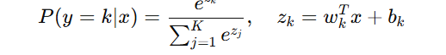
Testing minimizes cross-entropy loss, optimizing weights via maximum likelihood estimation. Logistic regression is advantageous for its efficiency, interpretable feature contributions, and probabilistic outputs that allow threshold tuning. Its main limitation is the linear decision boundary, which may fail to capture complex, non-linear attack patterns, motivating the use of ensemble methods for more sophisticated detection.

4.RESULTS
4.1 NSL-KDD Binary Classification Results
4.1.1 Training vs Testing Accuracy (Binary)
Model | Training Accuracy (%) | Testing Accuracy (%)
Logistic Regression | 97.85 | 81.88
Decision Tree | 99.84 | 86.48
Random Forest | 99.93 | 86.66
Gradient Boosting | 99.98 | 86.20

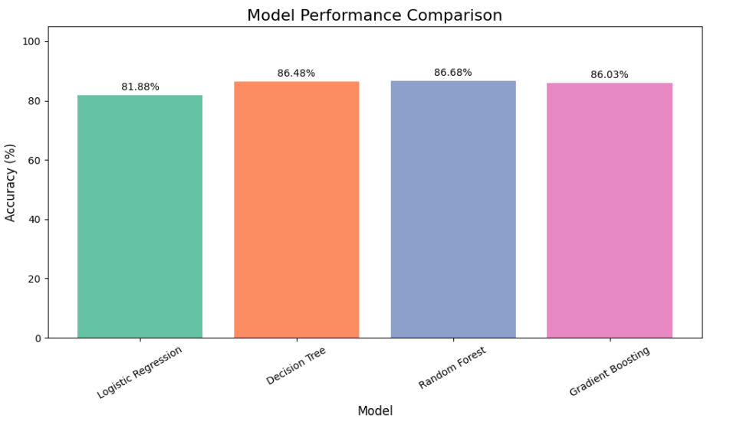
Figure 1: NSL-KDD Binary Classification: Model accuracy comparison

4.1.2 Macro Average Performance (Binary)
Table 4: NSL-KDD Binary Classification: Macro Average Precision, Recall, F1

Model | Specificity | Time Taken (s)
Logistic Regression | 0.9840 | 1.57
Decision Tree | 0.9977 | 0.72
Random Forest | 0.9997 | 2.73
Gradient Boosting | 0.9991 | 43.0

4.1.4 Confusion Matrix Explanation
The confusion matrix provides detailed insights into classification performance by breaking down predictions into four categories:
Table 6: Structure of a Confusion Matrix for Binary Classification (Normal as Positive Class)
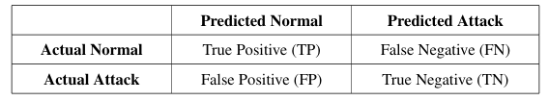

Interpretation:
• True Negative (TN): Correctly identified benign traffic as normal.
• False Positive (FP): Benign traffic misclassified as attack (false alarm).
• False Negative (FN): Attack traffic missed and classified as normal (dangerous miss).
• True Positive (TP): Correctly detected attack traffic.

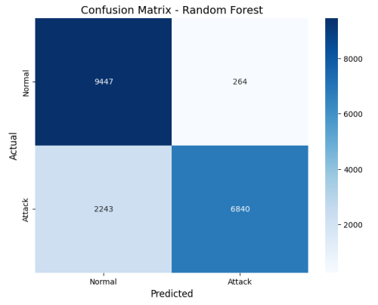
Figure 2: NSL-KDD Binary Classification: Confusion matrix visualization showing classification distribution, with emphasis on how well the models minimize false positives and false negatives.

4.1.5 ROC Curve (Binary)

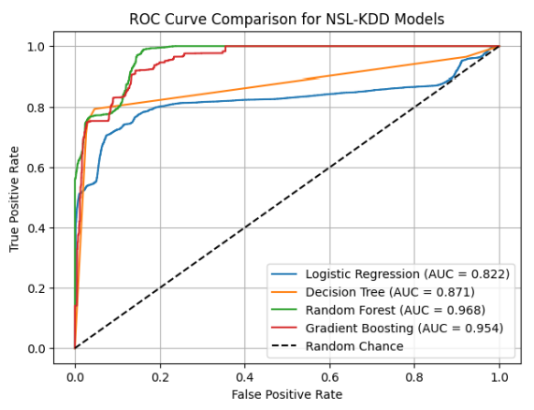

Figure 3: NSL-KDD Binary Classification: ROC curves showing the trade-off between sensitivity and specificity for each model, with Random Forest achieving the best balance.

4.1.6 Model Comparison Analysis (Binary)

The NSL-KDD binary classification shows that Random Forest achieves the best balance between accuracy and F1-score, while Gradient Boosting slightly underperforms compared to expectations. Logistic Regression remains interpretable but limited for complex non-linear attack detection.

4.2 NSL-KDD Multi-Class Classification Results
4.2.1 Training vs Testing Accuracy (Multi-Class)
Table 7: NSL-KDD Multi-Class Classification: Training and Testing Accuracies
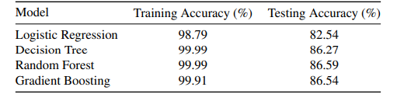

4.2.2 Macro Average Performance (Multi-Class)
Table 8: NSL-KDD Multi-Class Classification: Macro Average Precision, Recall, F1

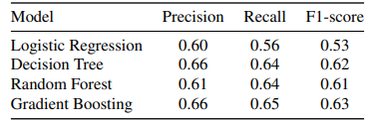

4.2.3 Macro Average Specificity and Time Taken (Multi-Class)

Table 9: NSL-KDD Multi-Class Classification: Macro Average Specificity and Time Taken (s)
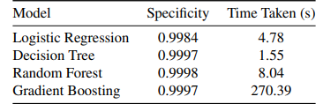
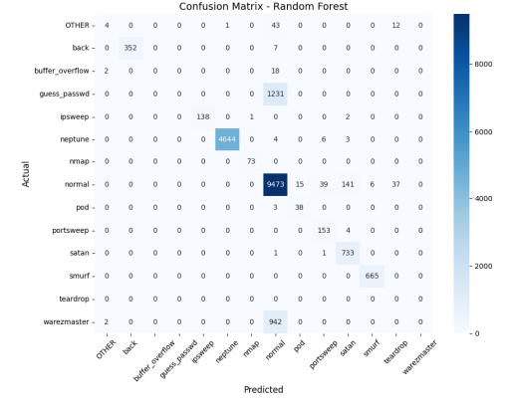
4.2.4 ROC Curve (Multi-Class)

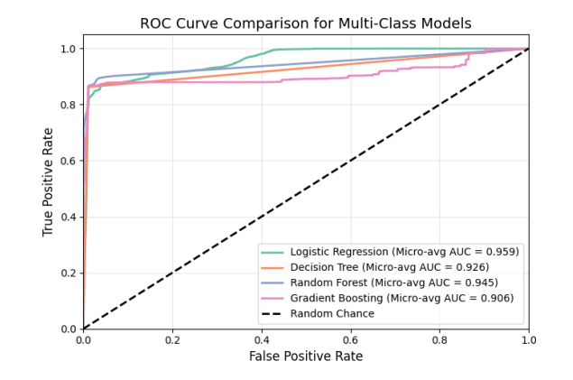
Figure 4: NSL-KDD Multi-Class Classification: ROC curves displaying the classification performance across multiple attack categories.

