

|  |  |  |
| --- | --- | --- |
|  | | |
|  | | |
| **ONLINE EXAMINATION**  **JANUARY 2023 SEMESTER** | | |
|  | | |
| **SUBJECT CODE** | **:** | **CPM399** |
| **SUBJECT NAME** | **:** | **ICT PROJECT MANAGEMENT** |
| **PROGRAMME** | **:** | **BACHELOR** |
|  | | |
| **INSTRUCTIONS TO CANDIDATES** | | |
|  | | |
|  | | |
| **1. Please read the instructions given in the question paper CAREFULLY.**  **2. Plagiarism in all forms is forbidden. Students who submit plagiarised Final Examination will be penalised.**  **3. This question paper consists of ONE (1) SECTION.**  **4. Answer ALL questions in the section.**  **5. You have ONE (1) day (24 HOURS) to complete the questions and please submit your answers BEFORE OR ON 15 APRIL 2023, 3.00 pm (Malaysia Time) or 2 pm (Indonesia Time). Please submit your answers via myAeU PLS (online submission).**  **6. ONLY ONE (1) time successful online submission is allowed.**  **7. Begin writing your answers using Microsoft Words template given at the last page of this**  **paper.** | | |
|  | | |
|  | | |
| **THERE ARE FOUR (4) PAGES OF QUESTIONS, EXCLUDING THIS PAGE.** | | |
|  | | |

**DECLARATION BY STUDENT**

I certify that this Final Examination answer is of my own work and is in my own words. The answers are written without any reference to any learning material. I also confirmed that I have kept a copy of this Final Examination answers.

Name : ___Putri Yasmina Rahma Zain_________

Student ID: ___C30109190085________________

Date: __14/04/2023___________________________

**SECTION A (Total : 100 Marks)**

**Please use the answer sheet provided.**

1. *There are several textbook definitions of the term ‘project’.*

Based on your understanding, summarise a project's basic features or attributes in common.

[4 Marks]

b) *“The tasks of project managers become more complex when ICT projects are*

*implemented within the government context”.*

Discuss **TWO (2)** challenges in implementing ICT projects for government agencies.

[6 Marks]

**[Total: 10 Marks]**

1. *“A large percentage of the costs of many Information Technology (IT) projects are human resource costs.”*

Do you agree with the above statement? Support your judgement with facts.

[6 Marks]

1. *“Many information technology professionals have a poor attitude toward project cost management.”*

Based on the above statement, discuss how this attitude might affect the poor track record for completing projects within budget.

[6 Marks]

**[Total: 12 Marks]**

Based on any ICT projects that you are familiar with,

a) Referring to the common project management phases, determine the phase where stakeholder analysis is the best to be performed.

[3 Marks]

b) Identify **TWO (2)** primary stakeholders and **TWO (2)** secondary stakeholders.

[8 Marks]

c) Explain the situation where a project management Office (PMO) should be created in a project.

[5 Marks]

**[Total: 16 Marks]**

Consider the following situations and determine tools and techniques that can be used. For each, elaborate on how it can be applied in quality management:-

1. Analyzing graphics displaying issues that might have caused a defect to determine whether the proper process was followed.

[2 Marks]

1. Looking at the project practices of comparable projects.

[2 Marks]

1. Comparing what was done to what was documented in the plans.

[2 Marks]

1. Looking for a tool that can demonstrate the relationship between events and their resulting effects.

[2 Marks]

1. Graphically representing a process to determine where a process that is achieving low-quality results might need adjustment.

[2 Marks]

**[Total: 10 Marks]**

By referring to any ICT projects that you are familiar with, discuss the needs of feasibility studies in project management. Your discussion should cover the areas of*customer issues, organizational issues, technological issues* and *cost-benefit analysis.*

**[16 Marks]**

Table 1

|  |  |  |
| --- | --- | --- |
| **Activity** | **Preceding Activity** | **Duration in Weeks** |
| Start | None | 0 |
| A | Start | 1 |
| B | Start | 2 |
| C | Start | 6 |
| D | A | 10 |
| E | B,C | 1 |
| F | C | 2 |
| G | D | 3 |
| H | E | 9 |
| I | F | 1 |
| End | G,H,I | 0 |

Based on the project activities in *Table 1*,

1. Draw a project network diagram.

[10 Marks]

1. Determine the critical path for the project based on the activities demonstrated in *Table 1.*

[2 Marks]

**[Total: 12 Marks]**

With appropriate examples in the context of ICT projects,

1. Provide **TWO (2)** examples of *intangible* and **TWO (2)** examples of *tangible*deliverables.

[4 Marks]

1. Explain **THREE (3)** types of reports for reporting on project implementation and progress.

[6 Marks]

**[Total: 10 Marks]**

A project ends when the project closure and product handover are undertaken.

1. Discuss the needs to ensure any projects or outcomes are integrated into regular operations and sustained.

[6 Marks]

1. Explain **FOUR (4)** questions that should be considered in the sustainability plan for a new product or system.

[8 Marks]

**[Total: 14 Marks]**

**END OF QUESTION PAPER**

**ANSWER SHEET**

|  |  |
| --- | --- |
| **STUDENT ID** | **C30109190085** |
| **STUDENT NAME** | **PUTRI YASMINA RAHMA ZAIN** |
| **IC / PASSPORT NUMBER** |  |
| **SUBJECT CODE** | **CPM399** |
| **SUBJECT NAME** | **ICT PROJECT MANAGEMENT** |
| **PROGRAMME** | **CBN** |
| **DATE OF SUBMISSION** | **15/04/2023** |
| **LEARNING LOCATION** | **JAKARTA** |

Begin writing your answers in this page (Font: Arial or Times New Roman, Size: 11 or 12, Lines Spacing 1.5);

**ANSWER**

1. Answer question number 1
   1. A project’s basic features and attributes at least must have:
      1. Purpose/objective: The purpose when making a project must be different from what that already exist. The purpose of a project can also be to make a change/benefits.
      2. Scope: A project need to have scope/limitation in the purpose to specify the project requirements, strategies, objectivity, and estimate the deadlines of the project.
      3. Cost/benefit: To make a project work is costly. Team/organization can seek funds from ventures/crowd-funding.
   2. Two challenges in implementing ICT projects for government agencies:
      1. Continuous and overarching development goals: Every work in a government ICT project is expected to be used by the general public. Hence, working with government agencies is a huge demand to work on a project that covers a region as a whole. Not to mention that the project is occasionally on a national scale.
      2. Tend to have a planned and scheduled project that has been arranged to achieve the goals and deadlines: Since particularly government projects are part of bigger environment/implemented development project, the aim of the plan is related and to support the organization objectives.
2. Answer question number 2
   1. I disagree with the statement. There are 6 (minimal) types of cost for an ICT project. Despite being an ‘small’ project because it did not require many kind of physical resources, ICT project is surrounded with unexpected and invisible obstacles. It could be form as tool malfunction, training to use new system, and even productivity loss. Due to this reasons, the most cost of a project usually goes to intangible cost.
   2. Project Cost Management is necessary because it sets a baseline for the project budget and helps predict the expenses and revenue of the business. The poor attitude toward project cost management can leads to over-budget expenses, which may effecting to the delay of the project or even project cancellation.
3. Answer question number 3
   1. Based on the project management phases, the right time to perform stakeholder analysis is at the planning phase, as the purpose of this phase is to establish all the initiate component and attributes of an ICT project, such as the scope of the project, stakeholders analysis, resourcing, cost analysis, programming framework, and system design that will be applied for the project.
   2. Primary stakeholders:
      1. Head of the projects,
      2. Project team members; since two of mentioned are directly affected by the project, they are considered as primary stakeholders.

Secondary stakeholders:

* + 1. Hardware supplier,
    2. Connection (internet) providers, secondary stakeholders means that they are the stakeholders who supplying/delivering services to the primary stakeholders.
  1. There is a condition where the project have a complex requirements, such as wide choices of resource, many stakeholders involved, and/or determine the best output of the project. That is where PMO needs; to maintains, sets, and ensures the project is stay on the track.

1. Consider these following situations and determine tools and technique used, and elaborate on how it can be applied.
   1. Analyzing graphics displaying issues that might have caused a defect to determine whether the proper process was followed: Cause-and-effect diagram (Ishikawa diagrams). This diagram trace complaints about quality problems of the product to find the root cause of a problem.
   2. Looking at the project practices of comparable projects: Scatter diagram, because this diagram work with comparing two variables. The closer the data point, it is more likely that the variables are similar/related.
   3. Comparing what was done to what was documented in the plans: Run chart. The aim of using this chart is to display the history and pattern used in the project since project start. It forms in line chart and shows the data points in time order.
   4. Looking for a tool that can demonstrate the relationship between events and their resulting effects: Quality control charts, this diagram work by display the data that will illustrate the result of the project. The aim of the diagram is to determine whether this processes is in control or not.
   5. Graphically representing a process to determine where a process that is achieving low-quality results might need adjustment: Flowcharts is the right technique for this case, at this chart is work by show the activities to process the data in order, decision point, and results.
2. The diversity of ICT project feasibility study is necessary to reach the final product viability. The objective and attributes of a project can determine the clear feasibility goals, such as:
   1. Customer: To handle any customer problem, it actually specifically divided according to the feedback from customer. However, legal feasibility mainly take a big role in this issue, such as public announcement or legal actions.
   2. Organization (internal): Organization issue is handled by operational feasibility by analyze the organization need and how to achieve it by completing the project.
   3. Technology: This issue is handled by technical feasibility. Just like the name, the goal of this feasibility is to maintain technology capacities used in the project.
   4. Cost and benefits: Economic feasibility involves in financial analysis of the project before the funds is allocated.
3. Draw the PERT diagram

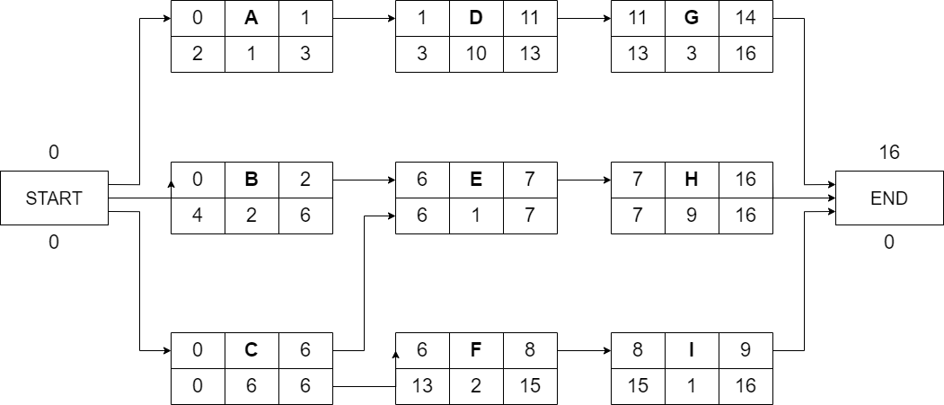

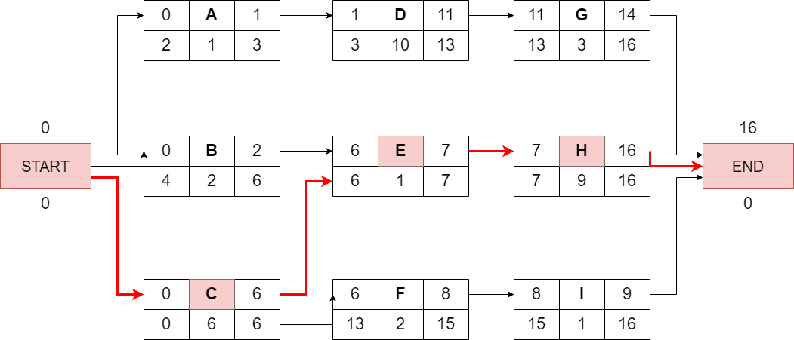

1. Answer question number 7
   1. Intangible deliverables:
      1. Number of devices that can login to the system at once.
      2. Runtime of the system/application.

Tangible deliverables:

* + 1. Specific hardware requirements.
    2. Framework and build tools used.
  1. The Three types of project implementation and progress reports:
     1. Inception report: Produced 1-3 months post-project release. The content of the report can be vary, from update of the first annual work plan, adjustment of the relevance of the project with nowadays, and even change of ownership.
     2. Progress report: Produced during the work of the project and reported on regular time (weekly, monthly, etc.). The report contains the summary of the project’s status and other remaining progress.
     3. Completion report: Should be prepared at the end of the project work, this report provide to cover all information of the product result. The aim of the report is to document some opportunity to advance the product or to give lesson and recommendations for the further project.

1. Answer question number 8
   1. Project closure is an important step as it mark the finalization of the project and the result is ready to launch. Furthermore, it includes all project documentation such as established procedures, project deliverables, project acceptance, and reasons for taking actions if an activity is terminated before project completion.
   2. 4 questions that should be considered in the sustainability plan for a new product or system:
      1. Are there any policies to support the continuity, maintenance, improvement of the product? :To ensure that the product have legal authorities and policy according to the country that will support the development.
      2. Is there infrastructure ready for the product? :Some ICT project is associated with infrastructure and facilities development, such as virtual payment by scanning QR code attached with the product.
      3. Are there units or group that will maintain the product? :A product need a continuous maintenance, hence it is important to have a managing group or units so that the product can run properly.
      4. Is there a need to connect the product to other system? :Some ICT product also need to connected to a system/device to run, such as personal desktop inside an office need to connected to LAN.