**TABLE OF CONTENTS (INFORMATION SYSTEM)**

DISCLAIMER………………………………………………………………………………………………………………………………………..I

ACKNOWLEDGEMENT……………………………………………………………………………………………………………………….ii

ABSTRACT………………………………………………………………………………………………………………………………………..iii

TABLE FO CONTENT…………………………………………………………………………………………………………………………iv

LIST OF FIGURES.....................................................................................................................................v

LIST OF TABLES.......................................................................................................................................vi

1 INTRODUCTION 1

1.1 Problem Statement 1

1.2 Objective 1

1.3 System Scope 1

1.4 Target User 1

1.5 Project Timeline………………………………………………………………………………………………………………..1

2 LITERATURE REVIEW 2

2.1 Introduction 2

2.2 Review on the Existing System 2

2.2.1 Exist 1 2

2.2.2 Exist 2 2

2.2.3 Comparison with the < New System Name> * 3

3 SYSTEM ANALYSIS 4

3.1 System Development Process 4

3.1.1 Project planning and oversight 4

3.1.2 System requirement analysis 5

3.2 System Modeling 5

3.2.1 Process Modeling 5

3.2.2 Logical Modeling 5

3.2.3 Data Modeling 5

4 SYSTEM DESIGN 6

4.1 Design Forms and Report 6

5 IMPLEMENTATION AND TESTING 7

6 CONCLUSION 8

REFERENCES 9

APPENDICES 10

Appendix A 10

Appendix B 10

**The Detail of the Table of Content**

|  |
| --- |
| **Disclaimer** |
| **Acknowledgement**  *< This is a brief acknowledgement of assistance given to the student in researching and writing the report. Its page is numbered with a consecutive lower-case Roman numeral. Times New Roman with font size 12 shall be used>* |
| **Abstract**  *< An abstract is a condensed version of a longer piece of writing that highlights the major points covered, concisely describes the content and scope of the writing, and reviews the writing's contents in abbreviated form.* *It is normally limited to 300 words.* *An abstract should be in a paragraph>* |
| **Table of Contents**  ***<*** *A table of contents (TOC) shows the starting page number of each major section and subsection in the report. The chapters to be covered in the report must be carefully selected and organized. The flow of the chapters to be presented is very important in order to guide a relatively novice reader in understanding the whole report. The TOC gives a quicker way of finding the interested information>* |
| **List of Figures**  *<With the similar purpose as the TOC, the lists of figures/tables is to find the illustrations, diagrams, charts, and tables in the report. Figures/tables must be numbered consecutively in order of appearance>*  *Sample :*  **LIST OF FIGURES**  Figure 1.1 Gantt Chart 3  Figure 2.1 Shoppee website 4  Figure 2.2 Lazada website 7 |
| **List of Tables**  *Sample :*  **LIST OF TABLES**  Table 2.1 Comparison systems between Shoopee, Lazada and proposed system 10  Table 3.1 XXXXX 24  Table 3.2 XXXXX 27 |

# CHAPTER 1

# INTRODUCTION

*<This section shall briefly state the purpose of the system to which this document applies. It shall describe the general nature of the system; summarize the history of system development, operation, and maintenance; identify the project sponsor, client, user, developer, and support agencies; identify current and planned operating sites; and list other relevant documents>*

## Problem Statement

*< This section shall explain the problems that overcome before the system has been developed>*

## Objective

<<Your objective here>>

## System Scope

*< This section shall be explained what you are going to cover and why >*

## Target User

< Explain who are the user for the system >

**1.5 Project Timeline**

<< state your implementation @ development plan – Gantt chart. The Gantt Chart can be attached as Appendix>>

# CHAPTER 2

# LITERATURE REVIEW

## 2.1 Introduction

*<This section is to discuss the theoretical aspects leading to the implementation of the project. Typically, this involves the historical background of the theories published in the research literature and the questions or ambiguities arose in these theoretical works. Citations for the sources of information should be given in the standard bibliographic formats (using square brackets with the corresponding number [1] that points to the List of References). Explore this background to prepare the readers to read the main body of the report. It should contain sufficient materials to enable the readers to understand why the set of data are collected, and what are the salient features to observe in the graph, charts and tables presented in the later sections. Avoid reporting any irrelevant issue.*

*Depending on the length and complexity of the report, the introduction and the theoretical background may be combined into one introductory section/chapter.*

*Warning: Do not copy any sentence from the sources of information.>*

## 2.2 Review on the Existing System

*< This section shall discuss about existing system that similar to propose system minimum 3 systems.>*

### 2.2.1 Exist 1

**<** *Describe the approach, features, benefits and limitation that being followed by the system>*

*< at least 2 existing systems>*

### 2.2.2 Exist 2

**<** *Describe the approach, features, benefits and limitation that being followed by the system>*

*< at least 2 existing systems>*

### 2.2.3 Comparison with the < New System Name> *

*<In this section, a summarize comparison between the existing and propose system should be done in a table.*

*A brief explanation of propose system and the context for the planning should be included, as applicable, an overview of :*

- *Requirements and constraints on the system to be developed.*

*- Requirements and constraints on project documentation.*

*- Position of the project in the system life cycle*

*-The selected program/acquisition strategy or any requirements or constraints on it.*

*-Requirements and constraints on project schedules and resources.*

# *-Other requirements and constraints, such as on project security, privacy, methods, standards, interdependencies in hardware and multimedia development, etc.>*CHAPTER 3

# SYSTEM ANALYSIS

*<* *The**chapter should contain two sections. First, the reason why you used the analysis or problem-solving methods that you did. It is important to describe the process by which the method is chosen to show that it is appropriate for the particular problem situation. Second, a narrative description of the application of the analysis method, indicating the problems that arose during this process and how they were identified and overcome.  Obviously, most projects will include models, charts or diagrams at this stage.  These may be included in the chapter or in an appendix.>*

## 3.1 System Development Process

*<This section shall describe the system development process to be used. The planning shall cover all  contractual clauses concerning this chapter, identifying planned builds, if applicable, their objectives, and the system development activities to be performed in each build.>*

### 3.1.1 Project planning and oversight

*<The project may be in one of the following nature:*

*(i)*                   *Experimental Research*

*(ii)*                 *Design synthesis of hardware/software*

*(iii)*                *Development and application of theory*

*Depending on the nature of the project, the approach can be described in one or more chapters.*

*For experimental research, explanations shall be given with regard to the equipment used to conduct the experiment, the function of each apparatus, how the configuration works to perform a particular measurement, sources of errors and how to minimize them, materials and ways to produce the sample.*

*For design synthesis of hardware/software, detailed descriptions on the techniques used shall be given.*

*For development and application of theory to solve a particular problem, the techniques used shall be explained in detail. Mathematical derivations that are too lengthy shall be given in appendices. Experiments conducted to verify the theory shall also be documented.>*

### 3.1.2 System requirement analysis

*<This section shall be divided into the following subsections to describe the approach to be followed for participating in system requirements analysis. The planning in each subsection shall cover all contractual clauses regarding the identified chapter.>*

*<Analysis of user input.>*

*<Concept brief.>*

*<System requirements.>*

## 3.2 System Modeling

**<***Draw supporting diagram based on your system requirement.>*

### 3.2.1 Process Modeling

**<***Draw context diagram, DFD level 0 and DFD level 1>*

### 3.2.2 Logical Modeling

**<***Draw decision tree, structured chart or flow chart>*

### 3.2.3 Data Modeling

**<***Draw Entity Relationship diagram (ERD)>*

# chapter 4

# SYSTEM DESIGN

*<The chapter should also include sections describing the form of the system >*

## 4.1 Design Forms and Report

*<<This section is used to design all the forms and reports from the system.*

*Sample :*

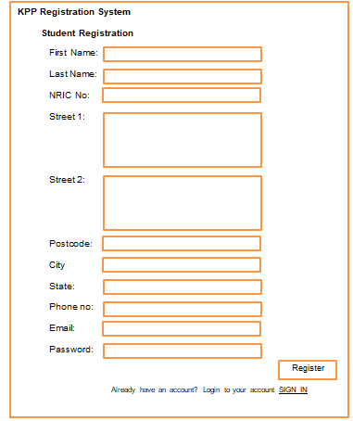

Figure 4.1 Registration Design Form

*Figure 4.1* shows the student Registration Design Form, whereby students are required to fill in their personal information in all fields. Once the students have filled in, they will clicked the Register button to submit to the system.

**CHAPTER 5**

# IMPLEMENTATION AND TESTING

**<** *The* ***Implementation*** *should show clearly how the solution to the problem is realized. As with the other parts of the project, the selection of the implementation method should be described and justified, and the nature of the solution will depend on the nature of the project and the award. State the hardware and software requirements>*

*Sample :*

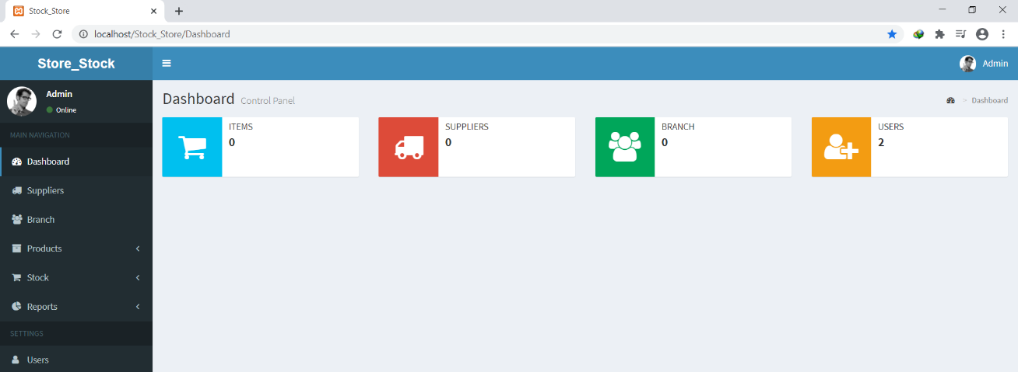

Figure 5.1 Dashboard

Figure 5.1 shows the dashboard will be displayed if the login is admin. There are 5 menus in the dashboard which are Suppliers, Branch, Products, Stock and Reports. Suppliers Menu is to be chosen if the admin wants to add new suppliers or edit the information of the suppliers. Branch Menu is to be chosen if the admin wants to edit branch data or add new branch. The admin will choose Stock Menu if the admin wants to add new stock or edit the stock information. The admin can click Reports Menu to get any report based on the admin’s requirement.

***<*** *The* ***Testing*** *should address the evaluation of the solution against its objectives and success criteria. The chapter should contain three sections. First, a description of the testing strategy used. Second the planning and application of the tests. And third, the conclusions drew from the results of the tests and any modifications to the design and implementation, which may be recommended. The testing should be shown in a table>*

# CHAPTER 6

# CONCLUSION

***<*** *The chapter is of crucial importance to the whole work.  It deals with the success of the project in academic terms, compared to the success criteria for the project. Even the best analysis, design and implementation will be 'let down' by an inadequate critical evaluation. The examiners are expected to look at this chapter most carefully in determining the success (or otherwise) of the project. Although the exact nature of the evaluation will vary between projects, it is possible to identify certain issues that should be addressed. First, the student's evaluation of the degree of success in carrying out the project. Second, what the student has learned by doing the project. Third, things the student would do differently if the project were to be repeated and any extra features, which the student would recommend if the project could be extended. And fourth, the value of the learning process to the student and the extent to* *which the project has added to the student's professional and academic expertise.>*

# REFERENCES

<<List of References @ citation here – APA styles>>

# APPENDICES

## Appendix A

## Appendix B