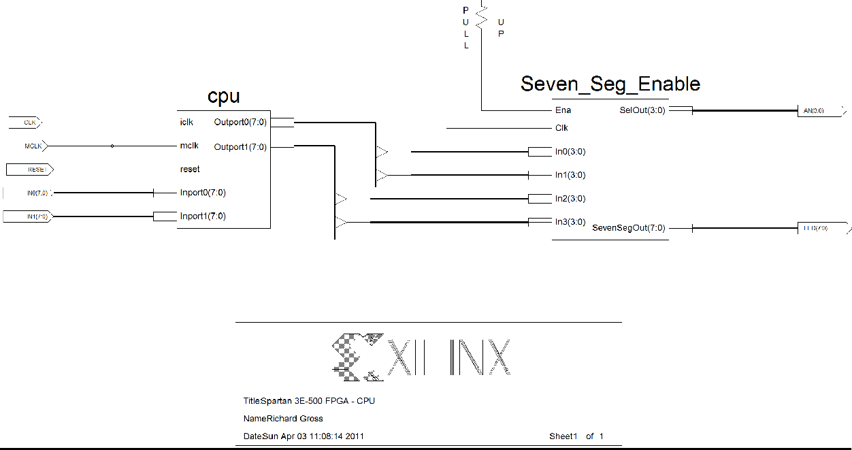

Description of Instructions:

BCDO: The binary coded decimal out instruction separates and decodes the 4 least-significant bits as well as the 4 most-significant bits. The BCD representation of the LSBs is displayed on the left-most seven-segment display, while the BCD representation of the MSBs is displayed on the seven-segment display to the right of the LSBs. Modifications to the given code started by creating a module called BCDO. This module looks at either register A or register B and decodes that data using a case statement. The seven-segment displays are multiplexed inside of the BCDO module. This instruction is a 2-phase instruction.

The instruction codes for BCDO are as follows: 100001R0 where R stands for either register A or register B.
Besides implementing the instruction code and creating the BCDO module, no other significant changes to the state machine were needed to implement BCDO.

The timing diagram for BCDO is shown in Figure 1.1.

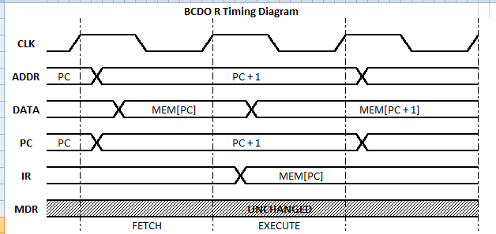

Figure 1.1: BCDO Timing Diagram
It is clear that BCDO is a 2-phase instruction. During the fetch stage, the DATA is assigned the value of the RAM at the location pointed to by the PC. One clock cycle later, the Instruction Register is assigned that same value. It is at this point, the instruction is finally executed.

RTL Description

IR 🡪 MEM[PC], PC = PC + 1 Fetch
BCD 🡪 R (A or B) Execute

Figure 1.2 shows, the real simulation results for this instruction for a test case in which register A was assigned 01110011 (73 in base-16).

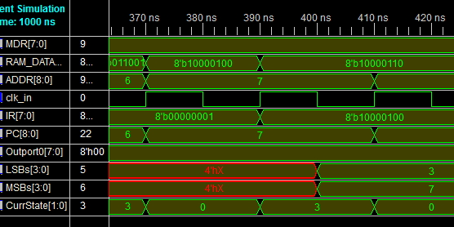

Figure 1.2: Actual Results for BCDO A (01110011 test-case)
BCD = R (A or B)
IR = MEM[PC] PC = PC +1
Execute
Fetch

You can see that the PC was 6 just prior to the fetch state. This was the RAM location at which the BCDO A instruction was present. On the first rising edge, the RAM data took on the instruction, and during the second clock cycle, the MSBs and LSBs were set accordingly after the instruction register received the instruction.

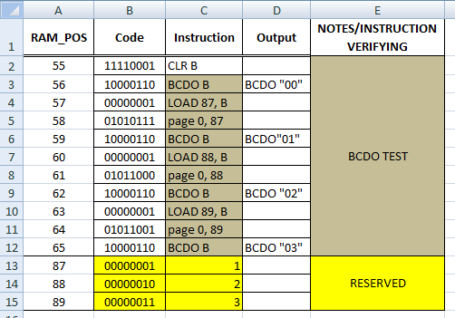

Architectural Modifications:

